’he Official Publication of ALOA—An International Association of Security Professionals

June 2005

wuuw.aloa.org

Security

Baldino’s Lock &  
Key Secures the  
U.S. Capitol

: I | I I I I 1

0 gpn$^ •>. %

‘5 U%^A\\

fitIII

i

PLUS!

mm m mm (nr- RLOH Moues to Easy Street

\ ALOA 05/

\ - ^ ^rjc Q0S^jey Breaks Douin

^ p**q^|«|** |^| p^ ^ **Tlu**o Unique Ruto Locks

„ Biz Tips to celebrate

IllSldc! ^ National Communications Month  
jHB Greg Perry reuieuis two neui safe locks

and the Scoop on RLOR 2005

3-D[Q[T 303

Breck H. Camp CML PO Box 47070 Atlanta GA 30362-0070

ll.ll.ll).l..ll..llll..l.lll..lllll.l.l.lll.l.lo.lll..lilllll

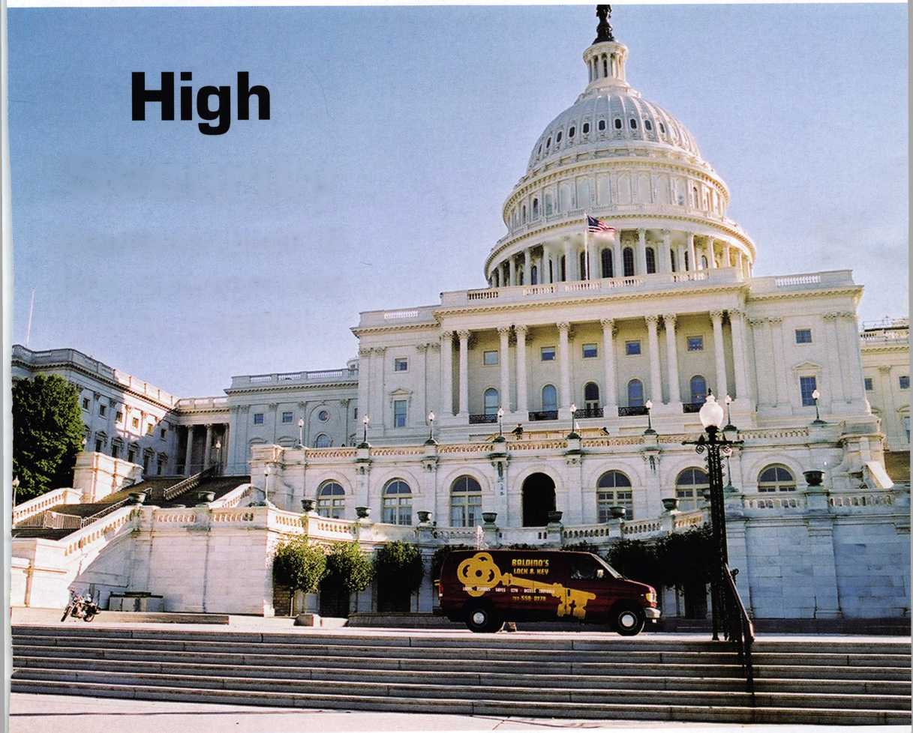

OUR STAND

**IT’S QUITE POSSIBLY YOUR MOST**

**TRUSTED SIDEKICK**

Keep it in Good Hands® with Allstate.

As a small business owner, there are few things you quick certificates of insurance, ID cards, assistance

rely on more than your vehicle to keep you going. with the claims process, and more. All from one of

Your local Allstate agent can help protect it and the most widely recognized names in the business,

your small business with services you need including Are you in Good Hands®?

LOCl<sitirHs

**Subject to availability and qudpcMtos Allstate Insurance(^jjp^WBtSSTridemnity Company, Northbrook, IL. Allstate County Mutual Insurance Company, Irving,TX. Allstate New Jersey Insurance Company,tBridgewater,,NJ,The,Cuflped{Hands" red service mark and U0ur Stand” is a service mark of Allstate Insurance f.nmnanv AiktatP Inciiranro Tni-rinam/ Mni-thhrnnU Tl**

1-800-859-0247

**CALL NOW TO LOCATE YOUR NEARBY ALLSTATE AGENT.**

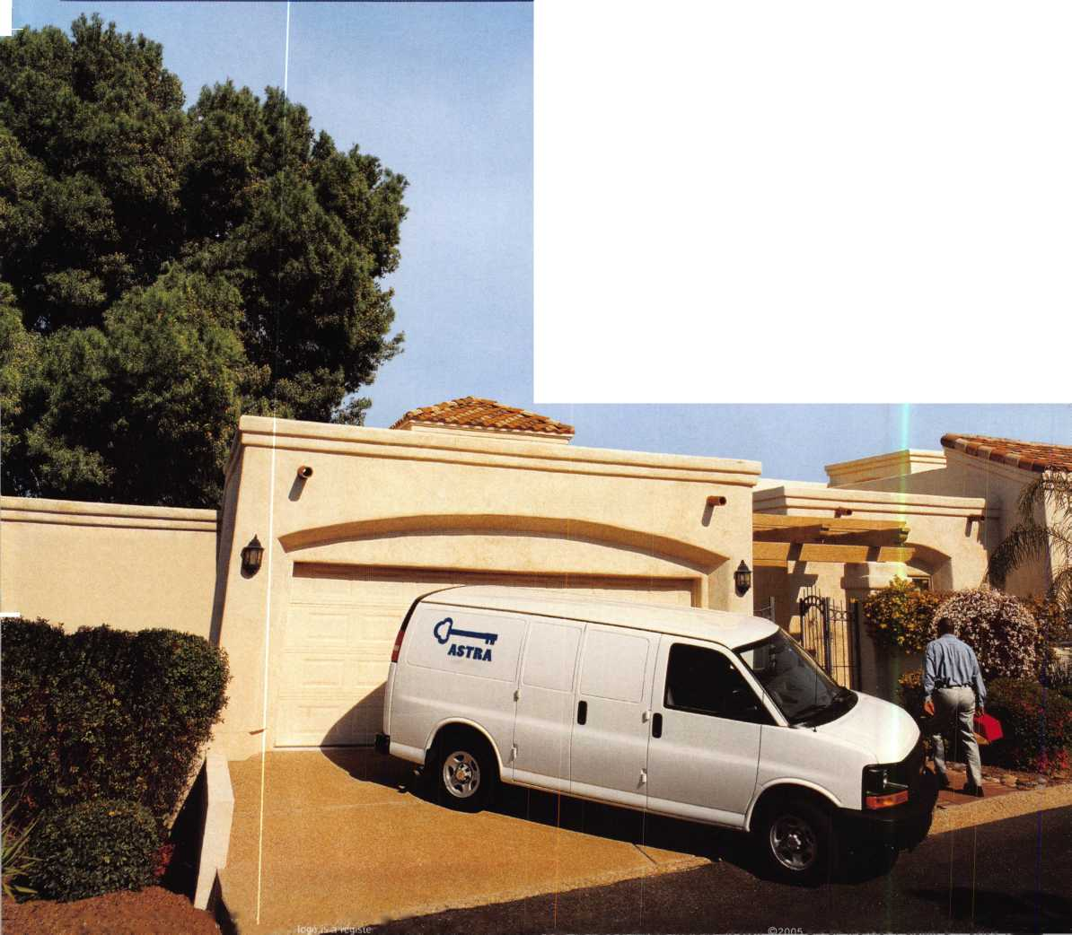

A Name You Know

As a business owner, you know the importance of a  
good name. Your name is your reputation. Your name  
stands for all that you offer in products and services.  
It’s a symbol of who you are. So, we thought you  
might like to know that Allstate, the name you know  
for insuring your personal vehicle and your home,  
also offers a business auto policy to help protect vehi-  
cles used in your locksmith business.

The following are coverages typically included in  
our business auto policy that might be important to  
you as a business owner:

Business Auto Liability coverage

* Higher limits up to $2,000,000 per occur-  
  rence.
* Protects you if you are legally responsible  
  for injuries and damages arising out of  
  the ownership, maintenance, or use of  
  business vehicles.
* Cost is based on several factors, including  
  garage location, type and use of vehicle,  
  and the violation and accident activity of  
  your drivers.
* Additional Insured coverage may be  
  required when you contract with govern-  
  mental agencies or bid on local  
  commercial jobs.
* Generally not available on a personal auto  
  policy.
* Usually is no charge to add an insured to  
  a Commercial Auto policy.

Hired Auto coverage

* Provides liability coverage for those  
  vehicles you rent, hire or borrow for  
  business use.
* The premium for hired auto liability  
  coverage is based on the estimated  
  annual rental cost.
* Tools and Special Equipment
* Provides protection to permanently  
  attached equipment on your vehicle.
* You will need to let your agent know the  
  value of the equipment to include in the  
  cost of the vehicle.

You’re good at your business. Your insurance com-  
pany should be the same way.

Contact an Allstate agent to discuss your business  
auto insurance needs. To be referred to an agent,  
please call 800.859.0247 or email

**[abisO@allstate.com](mailto:abisO@allstate.com).**

Subject to availability and qualifications. Insurance coverage  
is subject to policy terms.

Allstate Insurance Company

Allstate Indemnity Company  
Northbrook, IL

Allstate County Mutual Insurance Company  
Irving, TX

Allstate New Jersey Insurance Company  
Bridgewater, NJ

allstate.com

© 2005 Allstate Insurance Company, Northbrook, IL

BETTER  
THAN EVER.

Plus the option of the  
GRAND KIT with a fully

ured 7” and 17”

scope in one case. Or the  
economy minded LE model.

The red eyecup tells you that you have the scope made specifically for safe and vault professionals.

Available from Gradient Lens resellers to the safe and vault industry only.

This Hawkeye® Borescope

includes all of the latest upgrades for safe and vault professionals: Optics that deliver images that rival German scopes. A new mirror technology that resists scratches from insulation, asbestos, and burrs. And a mirror protection sleeve to ward off dust.

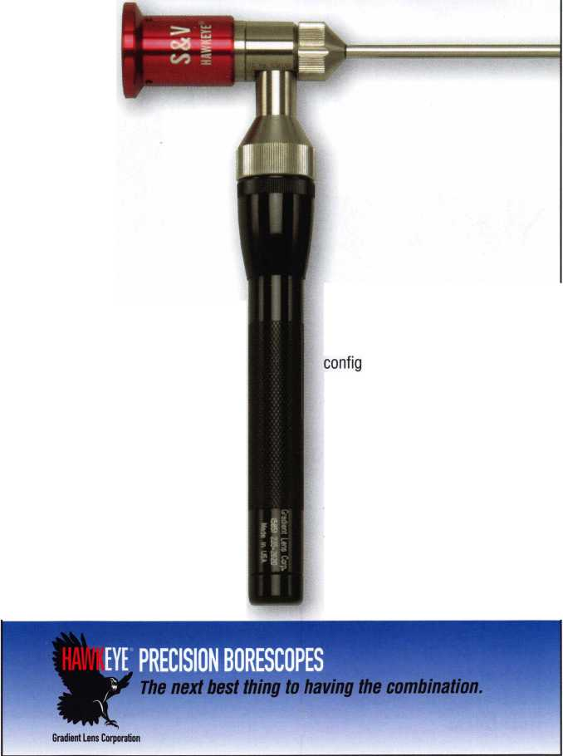

presidentia

**viewpoint**

Important

Notice

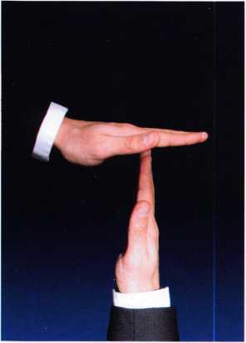

The Headquarters of the Associated Locksmiths of America HAS MOVED (see article on page 12). Please make note of the new address and phone numbers:

Associated Locskmiths of America 3500 Easy Street Dallas, TX 75247-6416

ALOA

(214) 819-9733 and (800) 532-2562

SAVTA

(214) 819-9771 Fax

(214) 819-9736 (main)

H Keynotes • June 2005

Dear Members,

My term is coming to an end as ALOA president and, these  
last few months have kept me very busy. Part of my job descrip-  
tion is to travel about and visit other locksmith associations, to  
explore ways that the associations can work together toward  
the advancement of the industry.

In April, I attended the European Locksmith Federation annu-  
al convention in Stockholm, Sweden. Jan Thorner, president  
of the Swedish Locksmiths Association ( SLR ), and his staff did

a marvelous job of hosting this event. The banquet was held in the Vasa Museum, which was  
built to house the Vasa, a 17th century warship that was raised from Stockholm Harbor in the  
early 1960's after being submerged for nearly 300 years. It was a spectacular setting! As  
many of you know, 31 Swedish locksmiths and safe technicians attended SAVTA in Lexington  
in March. I was very pleased that I and a few other Americans could return the favor and attend  
their show. SAVTA member, Sami Mockni was my tour guide in Sweden and, I am grateful to  
him for showing me around this beautiful Scandinavian city.

During the ELF convention, the presidents torch of that association was passed from Peter Ost-  
man of Finland to my good friend, Dave O'Toole of Ireland. Dave is one of the hardest work-  
ing and most concerned individuals in the industry and, I am sure that he will do a fine job of  
leading the European locksmiths.

I was back in Europe a few weeks later to attend the Master Locksmiths Association of the Unit-  
ed Kingdom, annual convention and banquet. The northern region of MLA hosted this event in  
Manchester, England and, Gary Eckersoll, Simon Griffiths, Chris Taylor, and the MLA staff put  
on a wonderful event. The exhibition and banquet were in the historic GMEX center, the restored  
central train station of Manchester. MLA was instrumental in creating the European Chapter  
of ALOA.

As you receive this issue of Keynotes, there should still be time (the election membership meet-  
ing is June 10) to submit your ballot. I cannot emphasize enough the importance of voting! This  
is your voice in the association. And please, consider the importance of the bylaws changes  
and vote "FOR".

Sincerely,

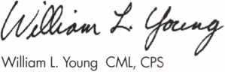

President

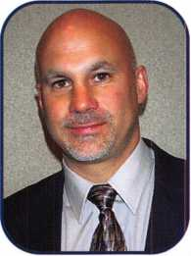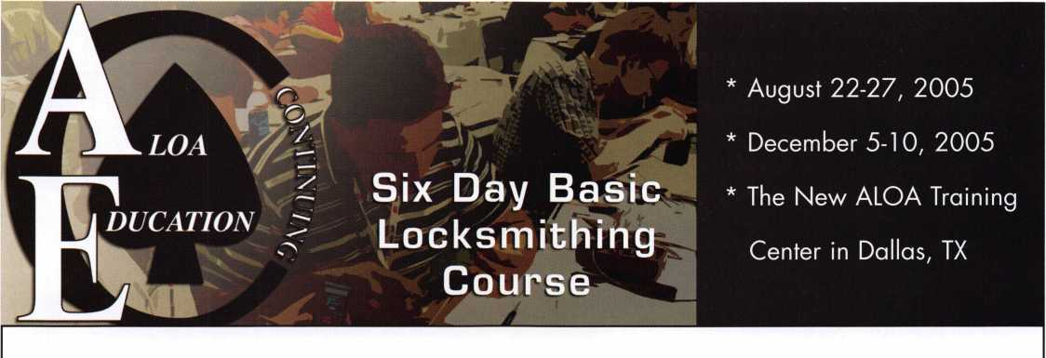

Course Description

The ALOA Continuing Education (ACE) 6-day Basic Locksmithing Course will provide you with basic hands-on knowledge of locks and security related hardware. Upon completion of this course, you will have the knowledge required to function as an apprentice locksmith who can perform the following tasks:

* identify and duplicate keys,
* service and adjust key machines,
* rekey a variety of lock cylinders,
* make original keys for a variety of locks by code, disassembly and impressioning,
* bypass and/or pick common locks,
* troubleshoot and service common cylinder and lockset malfunctions,
* identify common lock hardware finishes and functions,
* be familiar with Life Safety Codes and the ADA,
* design and key a simple master key system.

Students Receive:

* llco Key Blank Directory
* PRP Resource Guide which includes the ALOA Locksmith Dictionary
* A fully illustrated 561 -page reference manual.
* A Basic locksmithing tool kit that includes the following:

4-way screwdriver, soft face mallet, dial calipers, combination Tru-Arc pliers,

pin tumbler tweezers, plug follower, pin tray, shims, impressioning pliers, pippin file,

flat file, lock pick set, ice pick and universal pin tumbler pinning kit.

* An ACE Certificate attesting 48 credit hours of instruction.
* An RL certificate will be issued to those who successfully pass the written test at the end of the course.

|  |  |  |
| --- | --- | --- |
| Course Dates: | Course Price: | To register contact: |
| * August 22 - 27, 2005 | $1200.00usd | ALOA Education Department |
| * December 5-10, 2005 |  | 3500 Easy Street |
| Class Location: |  | Dallas, TX 75247 |
| ALOA Training Center |  | P-800-532-2562 xl 01 |
| 3500 Easy Street |  | F-214-819-9736 |
| Dallas, TX 75247 |  | [E-education@aloa.org](mailto:E-education@aloa.org) |

f e a t u res

HIGH SECURITY 2005

10

High Security at the U.S. Capitol

ALOA Member, Gary Baldino with Baldino's Lock & Key was recently asked to secure the US Capitol. The job came as a result of a major renovation to add a visitors center to the Capitol Building.

12

Smooth Move: ALOA Heads for Easy Street

Moving 50 years of ALOA history is no easy task but this move goes on without a hitch.

Jennifer Gilson-Gilliam



Automotive? It Gets Complicated

Very few people who can claim they are experts in auto­motive. Most everyone will admit that working on vehicle locks is a love/hate relationship.

by Eric Costley, CRL

**20**

Keeping Quality Employees... Communication is Key

This article is focused on retaining quality employees in a business through more effective communication.

by Claire Cohen, CML



Save Time/ Make Money

Have you ever looked for something and couldn't find it...gone to the place where you thought it should be and it wasn't there? We have so much on our minds each day that we can't seem to remember anything. But ask a lock­smith the pin size for a Schlage #1 cut or the number of change keys in a 5-pin master key system and we can recite either request without missing a beat.

by Jon Griswold, CML

Review: New Safe Locks



A couple of new safe locks have hit the market in the last few years. The newest is the LaGard 3370 lock. Corporate Safe Specialists is now importing a lock manu­factured by Rench. Both locks are designed and marketed to the lower end of the cost spectrum.

Greg Perry, CML, CPS

Are You Packin'?

Locksmiths Load Up Their Luggage as ALOA 2005 Takes Shape

Pack your bags for the 2005 ALOA Convention and Security Expo in Rosemont, Illinois- a big little city located just a train-ride away from downtown Chicago.

**Departments**

|  |  |  |  |  |  |  |  |  |  |
| --- | --- | --- | --- | --- | --- | --- | --- | --- | --- |
| Presidential |  | Execu | tive | 5 | Calendar | 8 | Classified | 36 | Legislative 40 |
| Viewpoint | 2 | Appli | cants .... | 6 | Core | 9 | Associate |  |  |
|  |  |  |  |  |  |  | Members | 38 |  |

|  |  |  |
| --- | --- | --- |
| r  AD INDEX  Allstate Inside Front Cover CIA 21 | | 1  Lockmasters 42 |
| Gradient Lens 1 Hinge Doctor | 23 | Kwik Jam 42 |
| Sodium Halogen 7 A&B | 25, 42 | T-Core 42 |
| Professional Masterlock | 27 | LocksmithUNL 42 |
| Business Products 15 Keedex | 32 | Videx Inside Back Cover |
| Kaba Total Access 17 Defiant Safe | 35 | CCL Back Cover |
| Clearstar 18 . . _ ,  Lectro Truck | 41 |  |
| D&D Technologies 19 |  | A |

Visit our NEW website at [www.aloa.org](http://www.aloa.org)

**executive**

Volume 51, Issue 6



Additional contact information for the ALOA Board and most Keynotes authors is  
available through "Locksmith Search"' on the ALOA Web site- [www.aloa.org](http://www.aloa.org) or by  
contacting the ALOA office at 3500 Easy Street; Dallas, TX 75247; (800)532-2562; FAX  
(214)819-9736; e-mail [aloa@aloa.org](mailto:aloa@aloa.org).

Editor

Betty Henderson [betty@aloa.org](mailto:betty@aloa.org)

Editorial Advisor

John Cannon, CML [jcannonl@cox.net](mailto:jcannonl@cox.net)

Advertising Sales

Kim Hammond voice: 817-645-6778

Fax: 817-645-7599 e-mail: [adsales@aloa.org](mailto:adsales@aloa.org)

Executive Director

Charles W. Gibson, Jr., CAE [charlie@aloa.org](mailto:charlie@aloa.org)

Associate Executive Director

David Lowell, CML, CMST [david@aloa.org](mailto:david@aloa.org)

Convention & Meetings Manager

Jo Anne Mims [joanne@aloa.org](mailto:joanne@aloa.org)

Operations/Membership Manager

Mary May [mary@aloa.org](mailto:mary@aloa.org)

Director of Creative Services

Betty Henderson [betty@aloa.org](mailto:betty@aloa.org)

IT Operations Manager

Greg Jackson [greg@aloa.org](mailto:greg@aloa.org)

Comptroller Kathy J. Romo

Membership Coordinator Shelly Jett

Convention & Meetings Assistant Karen Lyons

PRP/Education Coordinator Hope Rodriguez

Mail Room Coordinator Kevin Wesley

Creative Media Specialist Bryan Dease

Accounting Coordinator Tammye Chambers

Administrative Assistant Jen Gilson-Gilliam

Executive Assistant Sue Langford

Assistant Education Manager Bob Stafford

Contributors

Jerome Andrews, CML  
Paul Chandler, CRL  
Claire Cohen, CML  
Brian Costley, CML, CMST  
Eric Costley, CRL

Ray D'Adamo, CML Billy Edwards, CML Dan Graffeo, CRL,CMST Jim Hancock, CPL Jeff Nunberg, CML, CMST

Randy Simpson, CML, CPP Robert Stafford, CML Dave Thielen, CML Greg Perry, CML,CPS

Tom Seroogy

Charles Stephenson, CPS

Dennis Watanabe, CML, CMST

Mission Statement: The Associated Locksmiths of America, Inc. is dedicated to enhancing the professionalism, education and ethics among locksmiths and those in related sectors of the physical security industry. With approximately 10,000 members in the United States, Canada and the freeworld, ALOA is poised to help members obtain the knowledge, the strength, and the confidence to perform their role in the physical security field with pride and dignity. But it is only through active involvement and participation that ALOA can fully achieve its potential—and can help members to achieve theirs.

Policies: Keynotes® is the official publication of the Associated Locksmiths of America, Inc. (ALOA). Keynotes® acts as a moderator without approving, disapproving, or guaranteeing the validity or accuracy of any data, claim, or opinion appearing under a byline or obtained or quoted from an acknowl­edged source. The opinions expressed by the authors do not necessarily reflect the official views of ALOA. Also, appearance of advertisements and new products or service information does not constitute an endorsement of products or services featured by the Association. The Association does not accept responsibility for the inaccuracy of any data, claim, or opinion appearing in this publication, due to typographical errors on the part of the authors, Association staff or its agents.

Editor's Note: This publication is designed to provide accurate and authoritative information in regard to the subject matter covered. It is provided and disseminated with the understanding that the publisher is not engaged in rendering legal or other professional services. If legal advice and other expert assistance is required, the services of a competent professional should be sought.

Authors7 Payment: Payment for eligible submissions to Keynotes will be based on the following criteria: topic, time spent and past contributions. Authors who regularly submit to Keynotes® are generally paid a higher rate. The latter is especially true of authors who write to fit specific editorial needs and submit said copy by Keynotes® deadlines. As a general guideline: Average payment for a 750 word, business or light' technical article would be $200. Payment for a 1500 word article involving significantly higher time and research efforts would be $400.

Payment will not be offered for articles submitted by ALOA employees or members of the ALOA Board of Directors (unless material is of a technical nature), nor for articles submitted by a company that promote that company's products or services. ALOA reserves the right not to pay for articles sub­mitted by an individual(s) that promote a particular company's products or services.

Disclaimer: The Associated Locksmiths of America, Inc., (ALOA), reserves the right to refuse any article for any reason. Additionally, ALOA reserves the right to edit, amend or modify any article submitted for publication in order to preserve technical accuracy, clarity, fairness or grammatical cor­rectness. ALOA will make the best efforts to notify the author of any changes. The extent of ALOA's liability for any article or information contained therein will be a notice of correction or retraction in the next possible issue.

Keynotes® (ISSN 0277 0792) is published monthly except for the combined June/July issue by The Associated Locksmiths of America, Inc., 3500 Easy St., Dallas, TX 75247-6416. Telephone: (214) 819-9733; FAX (214) 819-9736; e-mail [aloa@aloa.org](mailto:aloa@aloa.org). Subscription rates for members—$15.00 per year. Periodical class postage paid at Dallas, Texas. POSTMASTER: Send address changes to: Keynotes, 3500 Easy St., Dallas, TX 75247-6416. © Copyright 2003, All rights reserved. No part of the contents may be reproduced or reprinted in any form without prior written permission of the publisher.

President

William L. Young, CML, CPS  
(610)647-5042  
[president@aloa.org](mailto:president@aloa.org)

Secretary

John Soderland, CML, CMST  
(414) 327-5625  
secreta ry@a loa.org

Directors, Northeast

Robert E. Mock  
(856) 8630710  
ned i redor@aloa. org

Peter Sarailian, CRL  
(973)890-9797  
[nedirector@aloa.org](mailto:nedirector@aloa.org)

Vernon Kelley, CPL  
(609) 771-3126  
nedi rector@aloa. org

Directors, Southeast

Tom Gillingham, Jr., CML, CPS  
(615)264-0747  
sed i rector@a loa .org

Ken Kupferman, CPL  
(813)961-5784  
sed i rector@a!oa, org

Director, North Central

Mark E. Blum, CML, CPS  
(517) 482-5809  
ncdirector@aloa .org

Director, South Central

CD Lipscomb, CML, CPS  
(903)874-3522  
[scdirector@aloa.org](mailto:scdirector@aloa.org)

Directors, Southwest

Gordon R. Racine, CML  
(719) 384-4707  
[swdirector@afoa.org](mailto:swdirector@afoa.org)

Julie McCfuney, CRL  
(714) 636-5652  
[swdirector@aloa.org](mailto:swdirector@aloa.org)

Director, Northwest

Jim Jeffries, CPS .  
(208)743-1101  
nwdirector@aloa. org

Director, European

Hans Mejlshede, CML  
(453)539-3939  
[eurdirector@aloa.org](mailto:eurdirector@aloa.org)

Director, Asian

Joe j. Lee, CRL  
(215)289-2404  
[asiandirector@aloa.org](mailto:asiandirector@aloa.org)

Director, Associate

Paul M. Justen  
(800)333-6953  
[asdirector@aloa.org](mailto:asdirector@aloa.org)

Trustees

[trustees@aioa.org](mailto:trustees@aioa.org)

Randy Simpson, CML  
(281 )240-5959

John J. Greenan, CML, CPS  
(773) 486.2030

Past Presidents

2001-2003 Randy Simpson, CML  
1999-2001 John Greenan, CML, CPS  
1997-1999 Dallas C. Brooks  
1995-1997 David Lowell, CML, CMST  
1993-1995 Breck Camp, CML  
1991-1993 Henry Printz, CML  
1989-1991 Evelyn Wersonick, CML, CPS  
1987-1989 Leonard Passarello, CPL  
1985-1987 Joe Jackman, CML  
1983-1985 Stanley Haney, CPL  
1981-1983 Louis LaGreco, CPL  
1979-1981 John Kerr, RL  
1977-1979 Clifford Cox, CML  
1974-1977 Charles Hetherington  
1972-1974 Gene Laughridge  
1970-1972 William Dutcher, RL  
1968-1970 Constant Maffey, RL  
1966-1968 Harold Edeistein, RL  
1964-1966 William Meacham  
1962-1964 Robert Rackliffe, CPL  
1960-1962 Edwin Toepfer, RL  
1956-1960 Ernest Johannesen

Keynotes • June, 2005



CA

Cotati

Vladimir Tchentsov

Lompoc

Robert Elliott

Sacramento

Bruce C. Coleman

Sponsor: William A. Alterman

CT

Storrs Mansfield

Joseph Clauson

Sponsor: Michael A. Beattie CML

FL

Vero Beach

Chad Anderson

Sponsor: Gerald R. Hiebert CRL

West Palm Beach

Debra Shonk

Sponsor: Frank R McGrath CRL

Michael Shonk

Sponsor: Frank P. McGrath CRL

Williston

Loren Henry Jr

GA

Atlanta

Marshall W. Jones

Sponsor: Tim W. Mealer

Chamblee

Lior Biton

IL

Chicago

Steve W. Kurek Jr

Sponsor: James E. Gruber CRL

Michael Brilla

Fairview Heights

Alex Leuty

Sponsor: Terry P. Smith

Woodstock

Kenneth Nowikowski

Sponsor: David M. Metz

Evansville

Rick R. Hartig

Sponsor: David A. Chessor

Highland

Elliot Lounsbury

Sponsor: Kelly J. Bates CRL

Indianapolis

Donald Runnels Gerald Ringvelski

Sponsor: Monte D. Salway CML

Fall River

Jacob C. Feinberg

Sponsor: Carl L Feinberg CML

Shirley

Alex Weiss

Sponsor: Kenny R. Carroll

MO

Gladstone

Steve Mayville

Sponsor: Larry D. Bowman

MS

Horn Lake

Bryan Cox

NC

Holly Springs

Jeffrey Thomas

NJ

Lin wood

Steven Zuccari

Sponsor: Robert E. Mock

Ring wood

Thomas Williams

NM

Albuquerque

Kenneth Liotta

Sponsor: Martin J. Carr

*APO,* AE

John Esposito

Sponsor: David J. Anderson

Brooklyn

Joseph Witkowski

Hamilton

Kirk W. B reiten stein

Sponsor: Jim Williams CRL

Staten Island

Carl Napolitano

Sponsor: Frank P. McGrath CRL

Jennifer Cannizzaro

Sponsor: Frank P. McGrath CRL

Ml

Grand Rapids

Scott Tuttle

IN

KY

Lexington

Charles Payne

Sponsor: Ronald G. Sloan CRL

MA

These applicants are scheduled for clearance as members of ALOA. The names are published for member review and comment within 30 days of this Keynotes issue date,  
respectively, to ensure applicants meet standards of ALOA's Code of Ethics. Protests, if any, should be addressed to the Membership Department and must be signed. Active  
Membership applicants (a) have worked in the industry two or more years. Allied Membership (AL) applicants are not locksmiths, but work in a security-related field.

Apprentice Membership (AP) applicants have worked in the industry less than two years.

Keynotes • June 2005

OH

SC

Wl

Cincinnati

Inman

Scott R. Meister

Sponsor: Jim Cronin

Cuyahoga Falls

Michael D. Teagle

Hudson

Jim Berghoff

PA

New Castle

Jon P. Sweet

Sponsor: Charles E. Batcke CRL, CPS Villanova

Paul W. Bonkoski

Sponsor: Michael A. DellaPolla

Bruce A. Lunsford Sr

Sponsor: William P. Grant CRL

TN

Sewanee

Melvin Morris

Sponsor: Charles E. Batcke CRL, CPS

Killeen

Keith Busby

Sponsor: Jim Lornklang

WA

Des Moines

PR

San Juan

Cesar Arroyo-Reyes

James W. Gibbard

Union

Stephen A. Skubinna

Sponsor: Charles E. Batcke CRL, CPS

Kewaskum

Dan Sauer

Canada

QC

Charlesbourg

Jacques Bussieres

Denmark

Copenhagen

Dan Hansen

Sponsor: Hans Mejlshede CML

Great Britain

Oxfordshire

Paul Hodgkins

Sponsor: Ken Dale

West Midlands

Lee Hyde

Sponsor: Ken Dale

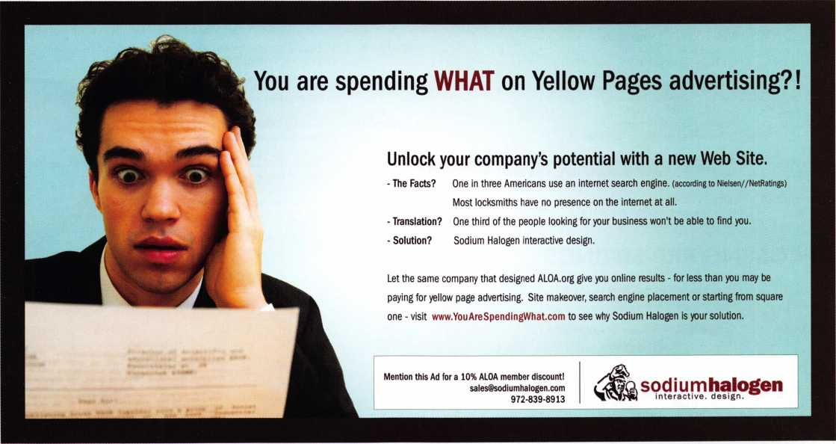

Keynotes • June 2005

u p c o m

events

i n g

|  |  |  |
| --- | --- | --- |
| 8-11 International Assocation of | 12 NJMLA Flea Market | 15 IDN Trade Show and Security Expo |
| Investigative Locksmiths Annual | Jeff Sitar at (973)777-0620 | Ypsilanti, Michigan For more |
| Conference Baltimore, Maryland | or Nick Hart at (201 )944-7547. | information Contact Ronald Weston, |
| Contacts: Don Shiles 410-674-772 | 1 | Marketing Manager 734-591-4828 |
| Lenny Podgorski 410-516-8269 |  | or Bonnie Weston 734-591-4821 |

17-24 ALOA2005 Convention and Security Expo 70 Full Day classes 35 half day classes & evening seminars - 3 days of exhibits

:s

*mMm*

UPCOMING ACE CLASSES

9/25/2005 Sunday 8:00 am • Houston, TX • Houston Safe Extraveganza

Ed Stites 979-240-9083

|  |  |  |
| --- | --- | --- |
| 7/17-24/2005 | Rosemont(Chicago), Illinois • ALOA 49th Annual Convention & Security Expo • David Lowell, CML,CMST 800-532-2562 xl8  70 full day classes • 35 half day classes & evening seminars | 10/02/2005 |
|  | 10/09/2005 |
| 8/22-27/2005 | Dallas, Texas • ALOA ACE Program  Hope Rodriguez 800-532-2562 x104  6 day basic locksmithing course | 10/13/2005 |
| 10/11-15/2005 | Portland, Oregon • Pacific Locksmths Association  Bill Botek, CRL 503-644-9881 | 10/14/2005 |
|  | Life Safety Codes w/L07 PRP  Fundamental Locksmithing (2 days)  Servicing Aluminum Storefront Doors  Safe Combination Lock Servicing | 10/30/2005 |
|  | Basic Electricity w/L13 PRP  Advanced Shop Management  Professional Impressioning Techniques | 11/10/2005 |

Sunday 8:00 am* Des Moines, IA • Iowa Locksmith Association  
Harry Russell 319-338-8735

Sunday 9:00 am • Orlando, FL • SERLAC 2005  
James Barnhardt, RL 813-689-5979

Thursday 9:00 am • Dallas, TX • ALOA  
Hope Rodriguez 800-532-2562

Friday 6:00 pm • Portland, Oregon • Pacific Locksmiths Association  
Bill Botek, CRL • 503-644-9881

Sunday 10am • Mt Laurel, NJ • GPLA  
Robert Schuetrumpf, CRL 856-486-9280

Thursday 9:00 am • Dallas, TX • ALOA  
Hope Rodriguez 800-532-2562

11/12/2005 Detroit, Michigan • Locksmith Security Association • Robert C.

Nobel, CML 810-385-9329 Large Format 1C w/L-39 PRP

11/12/2005 Saturday 8:00 am • Cary, NC • North Carolina Locksmiths Association

Granger L. Marley, CML 919-859-6060

12/5-10/2005 Dallas, Texas • ALOA ACE Program

Hope Rodriguez 800-532-2562 xl04 6 day basic locksmithing course

UPCOMING PRP SITTINGS

11/13/2005 Sunday 8:00 am • Baltimore, MD • Clark Security Products

Joan Emrick 619-718-7308

12/08/2005 Thursday 9:00 am • Dallas, TX • ALOA

Hope Rodriguez 800-532-2562

6/09/2005 Thursday 9:00 am • Dallas, TX • ALOA

Hope Rodrigue 800-532-2562

7/22/2005 Friday 6:00 pm • Rosemont, IL • ALOA 2005

Hope Rodriguez 800-532-2562

8/11/2005 Thursday 9:00 am • Dallas, TX ALOA

Hope Rodriguez 800-532-2562

9/08/2005 Thursday 9:00 am • Dallas, TX • ALOA

Hope Rodriguez 800-532-2562

9/25/2005 Sunday 8:00 am • Anaheim, CA • Clark Security Products

Joan Emrick 619-718-7308

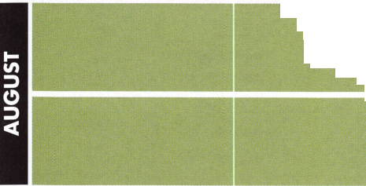

**core**



In Memory

ALOA member, Jessie C. Swann, RL will be remembered fondly by his family and friends. He was the owner/operator of Sevier Lock and Safe and was the hus­band of ALOA member, Marian Mester Swann, owner of F. M. George Safe and Lock of Knoxville, TN.

Gov. Perry Names Johnsen and Caldera To Texas Private Security Board

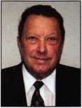

Gov. Rick Perry today announced the  
appointment of Howard Johnsen of  
Dallas and Stella Caldera of Houston  
to the Texas Private Security Board for  
terms to expire Jan. 31, 2011. This  
board licenses private investigation,  
security guard, burglar alarm, courier,

Johnsen Caldera armored car and access

control companies. It also approves training schools for security officers and instructors, and will soon license locksmiths.

This is a seven-member board within the Texas Private Security Bureau. Johnsen and Caldera are two of four public members appointed by the Governor of Texas to represent the general public for a term of six years.

Johnsen is chairman and CEO of Hans Johnsen Company and is a 28-year mem­ber of ALOA. He is director and former chairman of the Visiting Nurse Association of Texas. Johnsen is past president and director of Security Hardware Distributors Association and the Bicycle Product Suppliers Association. He received a bachelor's degree from the University of Texas.

Caldera is president and CEO of Etoile, Inc. She serves on the advisory board of Comerica Bank, the Houston Hispanic Chamber of Commerce, the Hispanic Chamber of Entrepreneurs, and Hispanics for Opportunity and Progress in Education. Caldera is also a member of the Latino Coalition, the Houston International Group and Hispanic Women in Leadership. She serves as sergeant- of-arms of the League of United Latin American Citizens' Educational Council 402 and was awarded the Triunfando Award for 2003 as the Hispanic Female Entrepreneur of the Year. Caldera is a graduate of Glassell School of Fine Arts.

These appointments are subject to senate confirmation.

In Memory

ALOA Member, George A Sharpley passed away on April 16, 2005. He retired as owner of George's Lock Service in 1995 and worked part time for Bob's Lock and Access Systems. He was a former member of the Air Force Precision Drill Team; Director of Security for several trucking companies, and a full-time lock­smith since 1972. He had been a member of the Associated Locksmiths of America since 1975 and was certified as a Master Locksmith in 1988. He was also the author of many articles in locksmithing journals.

He was a Charter Member of the Safe and Vault Technicians Association; the National Safeman's Organization, and the International Association of Investigative Locksmiths. He was also a past Director of the greater West Shore Chamber of Commerce and served as President of the Central Pennsylvania Locksmith Association for 1 2 years.

Surviving are his wife of 50 years, Margaret M. Sharpley; a daughter, Patricia S. Dilley; two sons, Dr. George A Sharpley Jr. and William J. Sharpley; two sisters, Jaqueline Papsin and Susan E. Sharpley; a brother, John A. Sharpley; and grand­son, Steven Brown.

Donations in Mr. Sharpley's memory can be made to the ALOA Scolarship Foundation of the Associated Locksmiths of America, 3500 Easy Street • Dallas, Texas 75247.

Ohio Valley chapter of ALOA Present Award to Lockmasters

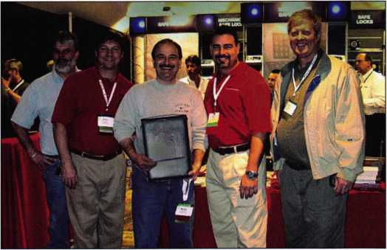

Mark Miller and Brian Lamb of Lockmasters receiving an Appreciation award  
from some of the members of Ohio Valley chapter of ALOA. The relatively small  
chapter has sent as many as 7 locksmiths each year to the ALOA convention and  
classes through a raffle. Lockmasters has been the biggest supporter for this  
cause. Picture from left to right : Rob Deck, Brian Lamb, Mehdi Zahedi,

Mark Miller, Glen Fessenden.

Locksmith Character in **Crash**

This new film features a cast of diverse characters includ-  
ing an hispanic locksmith. The events in the film take place  
over 36 hours, when all of the characters collide. Lions  
Gate Films1 CRASH takes a provocative, unflinching look  
at the complexities of racial tolerance in contemporary  
America. Exploring the diverse melting pot of post-9/1 1  
Los Angeles, this urban drama tracks the volatile intersec-  
tions of a multi-ethnic cast of characters1 struggles to over-  
come their fears as they careen in and out of one anoth-

er's lives. This feature brings a distinguished cast including: Sandra Bullock, Don  
Cheadle, Matt Dillon, Jennifer Esposito, William Fichtner, Brendan Fraser,

Terrence Howard, Chris "Ludacris" Bridges, Thandie Newton, Ryan Phillippe and Larenz Tate.

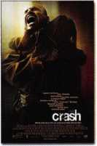

Keynotes • June 2005



ALOA Member Provides

]S8w*i n.-.M't fp minii1 «*

H f ft

v *

migf!

High Security at U.S. Capitol

i *1*11 i11*\T>-.*

ALOA Member, Gary Baldino with Baldino's Lock & Key was recently asked to secure the US Capitol. The job came as a result of a major renovation to add a visitors center to the Capitol Building.

The Capitol Visitor Center will make the U.S. Capitol more accessible, comfortable, secure, and informative for visitors. The constuction activities include relocation of utilities and visitor screening facilities, and the implementation of a comprehensive tree-preservation program. Major construction began in July 2002 and the project is presently on track for completion in late summer/early fall of 2006.

In November 1800, over 200 years ago, the U.S. Congress gath­ered in the first completed portion of the United States Capitol—in the small, cramped north wing. In the 1850s, major extensions to the North and South ends of the Capitol were authorized because of the great westward expansion of our nation and the resultant growth of Congress. Since that time, the U.S. Capitol and its stately dome have become international symbols of our representative democracy.

While the Capitol evolved with the changing and growing needs of Congress, it has failed to keep pace in its ability to accommo­date an ever-increasing number of visitors. In fact, just in the last few decades, tourism to our nations Capitol has increased from one million in 1970 to more than three million in 2000. After waiting in lines outside for timed-entry passes and then again for

the start of their tour, visitors often enter the Capitol tired, hun­gry, and with little knowledge of the workings of Congress. If a visitor arrives after all passes have been distributed, which often occurs by mid-morning, they are turned away.

The proposal for a CVC began to crystallize in the mid-1970s with the issuance of the Architect of the Capitol report "Toward a Master Plan for the United States Capitol." In 1991, Congress authorized funding for conceptual planning and design of a visi­tor center. In 1995, the design report was issued. Changes in security needs, as underscored by the tragic murder of two Capitol police officers in 1998, and other safety and accessibility considerations required revisiting and revalidating the 1995 report at that point. The updated plan was presented to the CPC members at a meeting on Oct. 15, 1999. Decisions by the CPC members led to the start of pre-construction activities in the fall of 2001. The events of 9/11 prompted Congress to provide all the necessary funding—an additional $ 100 million—to move the project into construction.

The CVC will be located underground below the East Capitol Grounds to enhance, rather than detract, from the appearance of the Capitol and the historic Frederick Law Olmsted landscape. When completed, the CVC will contain 580,000 square feet on three levels, requiring a 196,000-square-foot excavation, or "foot­print." (For purposes of comparison, the Capitol itself encom­passes 775,000 square feet.)

Keynotes • June 2005

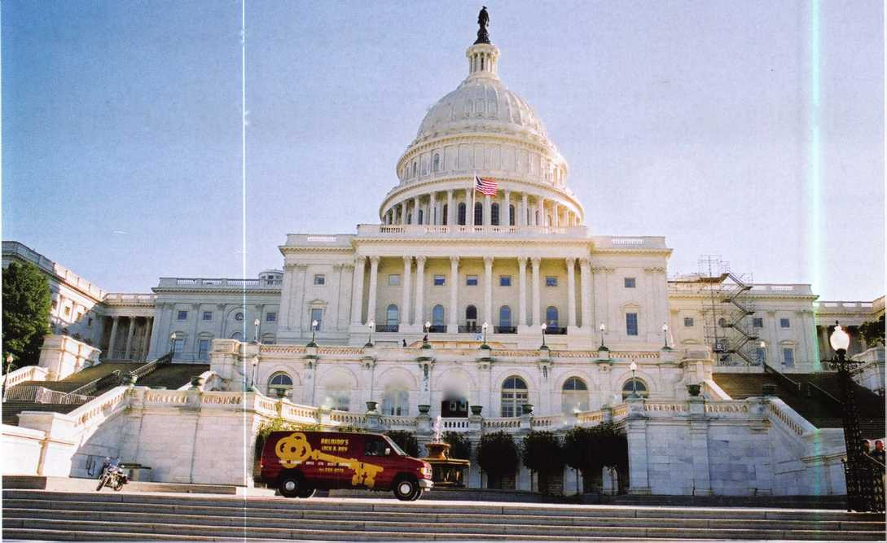

It is no surprise, with security being a top priority, that an ALOA member was chosen for the job. Gary Baldino has been an ALOA member for a large part of his career. His career story is impressive.

Gary Baldino and his brother, Mark, are second-generation lock­smiths. Their father started the business in 1961, when Gary was five years old. Gary took weekly correspondence lessons with his father from the beginning. After graduating from college, Gary began working full time in the family business. Today, that busi­ness has grown to include fifteen locations, an electronic security divisions, a wholesale division, and about ninety employees in the Washington/Baltimore region. Gary credits his company’s success to continuing education and a curosity for new informa­tion. (see page 3)

Gary believes that “knowledge is power” and stays informed by going to trade shows, reading trade magazines, studying manu­facturers catalogs, and interacting with factory salespeople. His bookshelves are full of catalogs. He also believes that product knowledge and application is ninety percent of the solution to solve a security need.

Knowledge of master keying and master keying software were essential to designing the U.S. Capitol system. An understanding of high security locks was also helpful on this project.

With over 2,500 cylinders installed, and more being added as the renovation to the Capitol goes on, ASSA cylinders were chosen for a number of technical reasons; 1) the size master key system that could be written with all of the special unique requirements needed, 2) the durability of the key and cylinder made ASSA an excellent choice because it was replacing a keying system that was 80-years-old and the new system needed to be able to last as long, if needed, 3) patent protection was a consideration for ensuring sure that the blanks would not be openly available around the DC area, and lastly, the ease of working on the cylin­ders made it the number-one choice for the locksmiths on staff.

There are many high security cylinders made today that have unique features and are patented that were considered for this project, but none were as superior as the ASSA system that was chosen for this facility. Cylinder offerings went from a standard 1 1/8 inch to a 3 inch mortise cylinder. Like all turn-of-the centu­ry buildings, jumbo cylinders also needed to be available so that the historic lock case could stay in place. Specialty locks that could be keyed into their system included Cam, Switch, Utility, padlock, and our grade 1 deadbolt. These locks offered the flexi­bility to secure the smallest and largest containers and cabinets.

The U.S. Capitol lock system features a unique end-user key and sidebar. This allows the U.S. Capitol staff locksmiths key control and flexibility with a large number of possible change keys. The Capitol system uses a key records management software to keep track of all the system data.

Since the U.S Capitol employs its own staff, Baldino did not install the hardware. His company designed the master key sys­tem and trained the capitol buiilding’s staff locksmiths on the specifics. The job has been an on-going project, with lock replacements occurring as renovations continue.

Just walking anywhere in the Capitol where are so much has occurred after **9/11** would give anyone a sense of awe, but Gary’s favorite place is actually outside on the west side overlooking the mall towards the Lincoln Memorial. This is where the U.S. President takes his oath of office and is a must-see attraction for visitors to Washington.

The public has been become more aware and educated on securi­ty since **9/11.** The locksmith’s challenge has been to keep current with technology and servicing the customer in timely manner.

Working on this job reminded Gary of another challenging proj­ect, “I had to install about two thousand interchangeable-core cylinders in a computer-semi-conductor-chip manufacturing plant. They had amazingly clean rooms and my team had to fol­low strict procedures regarding what we could do. In some loca­tions, our techs had to suit up in astronaut-looking suits to install the hardware. That was a challenge!”

Gary offers some advice to locksmiths who want to increase their bottom line, “Don’t be afraid to take on a large job. But remem­ber that planning and communication with the customer are essential and will minimize any surprises. Also, don't hesitate to ask for help from your distributor or a factory representative.”

He further states that the best way of selling to the public is to educate them on their choices and offer a good solution. The locksmith gains respect from his or her knowledge as it is passed down to the customer.

With over forty years experience in this business, Gary notes some staggering changes in the field. As prices come down on new technology, it is showing up in the common products that locksmiths sell and service. Electronics is being incorporated into every product type and the challenge is to keep current on all the new developments.

With that in mind, he offered his opinion on the future of lock- smithing, “I think we won't see the disappearance of mechanical locks in our lifetime, but their importance and popularity will certainly be declining with electromechanical and electrical devices as the price points for these items decrease. Just look at the automobile! There will keyless cars soon.”

Gary loves the challenge of solving new problems everyday. The feeling of accomplishment keeps him loving his job and coming to work every day. His main responsibilities today are keeping abreast of and analyzing new products, product applications on projects and inventory control along with all general business concerns of operating a large business.

11

Keynotes • June 2005

Smooth Move

ALOA Heads for Easy Street

By: Jennifer Gilson-Gilliam

Let’s face it, moving can be a daunting task. Packing things up, calling the utility company, and submitting change-of-address forms are a few of the many things to be done before the big day. Of course, there is also the physical move itself, which is no easy task. No matter how organized and meticulous things are, there always seems to be something forgotten. Sound familiar? Well, not so at the ALOA headquarters. ALOA joined forces with a commercial moving company to assist with the move and it couldn’t have gone smoother.

Here are some of the positive changes that will directly affect ALOA members:

Creative Services: New technology will help the Creative Services Department (Publications) continue to provide exciting new products and services for ALOA Members. A cost-saving photo studio is now located on the premises. This new studio will facilitate the creation of many projects including a new secu­rity image library. The images created will be made available to members for use in their own advertising.

Separate Spaces: The Robert Bell Library and A. J. Hoffman Museum will have their own unique areas at the new ALOA Headquarters location. This will be beneficial to the expansion of the Library. The new space will allow ALOA to properly display the many locksmith items and documents denoting the rich and vast history of the profession in an organized and pleasing manner.

A Fresh Start: The new building offers a spacious floor plan with plenty of room to grow. The space is an aesthetic showplace wor­thy of this prestigious professional association. These bright, clean offices will encourage staff productivity, increasing support for ALOA members.

Location, Location, Location: The new building is centralized to downtown Dallas. It is convenient and accessible, just off Highway 183 and Mockingbird Lane. Now you can miss some of the traffic and one-way streets, yet still be close enough to local area shops and the famous Dallas nightlife. The ALOA staff encourages members to visit, so the next time you’re in the area, be sure and stop by!

The Big Deal...the CLASSROOMS! The ALOA Education Department can now offer classes YEAR ROUND in addition to the 200+ classes presented nationally every year. The entire first floor has been dedicated to education, helping to further the locksmithing profession with enticing seminars and workshops. The new facilities are equipped with the latest technology and AV presentation equipment, making the class offerings exciting and dynamic. Keeping abreast of the latest in continuing educa­tion is crucial to your business and ALOA is proud to make that our business.

The ALOA Move: Fun Facts

Did you know?

* This move required five 18-wheeler trucks.
* Materials in the museum were moved using 6 large gondolas.
* The staff used 375 large moving crates.
* 1000 square feet of bubble wrap were utilized.
* 5900 staff hours were spent packing, organizing and moving

Finally, to celebrate the past and embrace the future growth of ALOA, the outdoor plants have been moved from the Live Oak address to the Easy Street address. Since the new building was once a commercial greenhouse, the staff is confident that ALOA and the Live Oak plants will flourish in the new space.

Let’s keep growing towards the future!

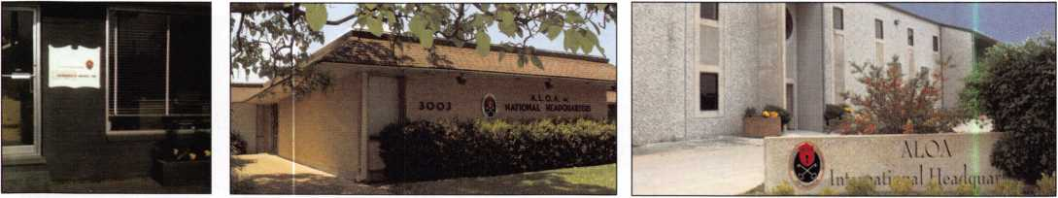

1956-1972

1972-2005

2005 and Beyond

Kathy Romo gleefully packs.

The museum is missing!

Heave...Ho... and away we go!

The movers navigate the stairs.

The heat index  
on move day was 109°!

Karen settles into her new space.

ALOA relics were treated with care.

4 Easy Street...during construction ~

Note: Associated Locksmiths of America • 3500 Easy Street • Dallas, Texas 75247-6416  
ALOA (214) 819-9733 and (800) 532-2562 • SAVTA (214) 819-9771 • Fax # (214) 819-9736 (main)

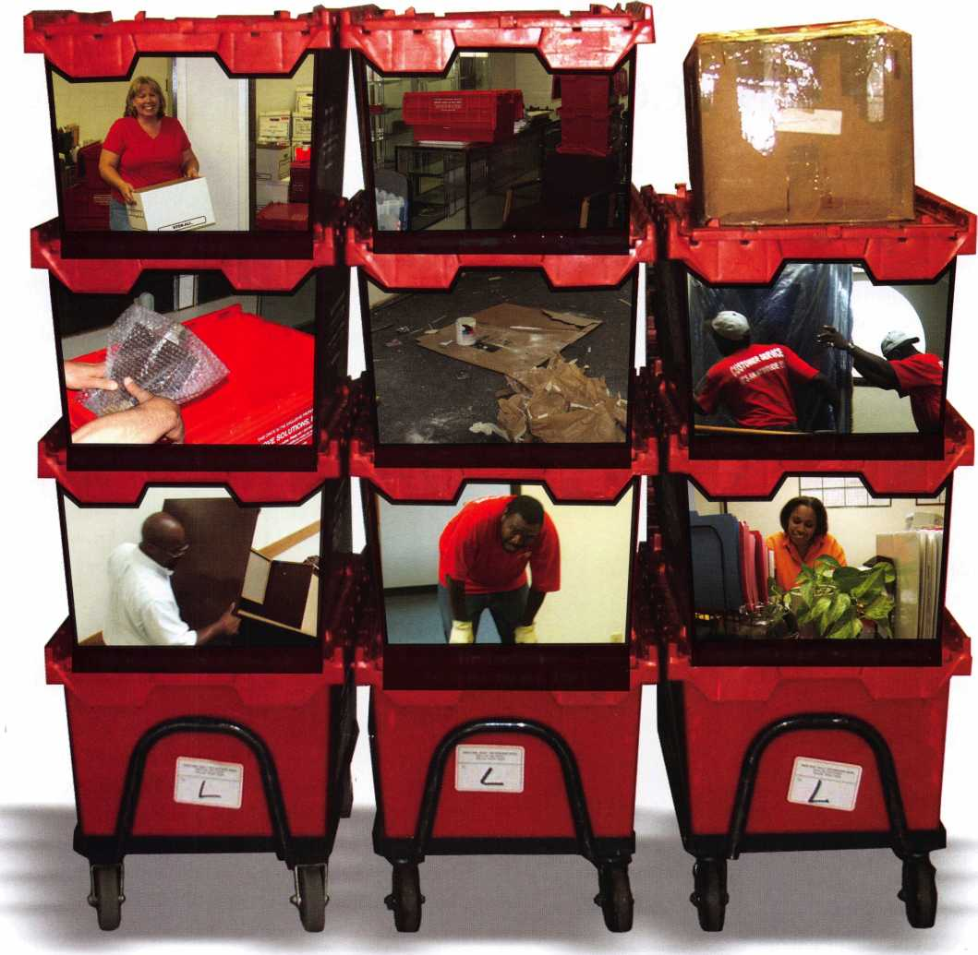

Automotive?

It Gets Complicated

A look at a 1969 MGC and a Czechoslovakian Sidecar lock

By Eric Costley, CPL

Someone recently asked me if automotive was “in my field  
of expertise”. I smiled a little grease-monkey smile and  
said, “No.” I know very few people who can say they are  
experts in automotive. I know a few who specialize in  
automotive lock work, but most everyone will admit that  
working on vehicle locks is a love/hate relationship. When  
things go smoothly, you love it. When they go haywire,  
you hate it. Its kind of like getting shots: the more you

get, the thicker your skin gets. As it turns out,

my skin is pretty thick.

I grew up watching

my dad do  
incredible things  
to the car in the  
garage. He would  
pull the head and  
work on valves and

rocker arms. I wish now  
that I had paid a lot  
more attention. Most of  
my automotive experience  
was earned the hard way:

stuff broke. I had to fix it or  
pay someone else to do it.

When it came to incorporating

auto into my locksmith abilities, I  
didn’t hesitate to jump in. Sometimes, I regret  
that impulsiveness.

A few days ago, the stars mustve been crossed. I got a dou­ble whammy that left me fairly sleepless that night. It was late in the afternoon and a motorcycle roared up to the shop. The leather-clad, graying gentleman sauntered in and handed me an unusual lock. “Can you make a key for

this?”, he asked. I grimaced and asked what it went to.

The answer? A Czechoslovakian motorcycle sidecar. It’s the  
lock that attaches the sidecar to the bike. Turns out, it was  
a 1978 Jawa/Velorex sidecar.

I spun around to the keyboard and started sampling blanks  
to see what might slide in. Instinctively, I

started within the Yale area. Unknown  
European stuff? Yale is always a good place

to start. I found a blank that started into  
the keyway, although it was too wide to

enter fully. I told the biker that I  
could probably take care of it, but

he would have to leave it for a few  
days, it wouldn’t be cheap, and I

needed him to fill out a claim  
check. He didn’t hear me. His

back was turned. Now that’s a  
hardcore biker!

Once he had left the shop, I  
put the lock and blank in a

bin and took it to the “in-shop”  
shelf. It was quitting time, and I was headed

for the van. The phone rang, and the boss grabbed it.

At the same time, the front door opened and an elderly lady walked in. I decided to wait on her before I headed out.

“I have a 1969 MGC, and I seem to have misplaced my only key. Can you help me?”, she asked. I started with the Ilco Auto Truck Key Blank Reference. The only reference in the 2005 edition is for the 1981 model. If you go back to the 1999 edition, it stretches back to 1970. My hand went next to the Autosmart Advisor, which doesn’t even contain a single reference to MG. I told the lady that I

Keynotes • June 2005

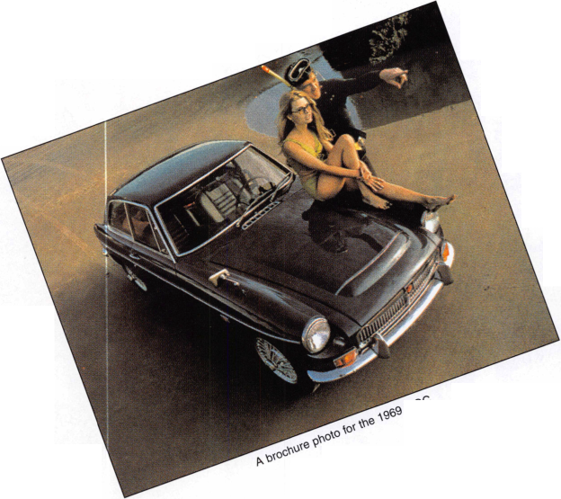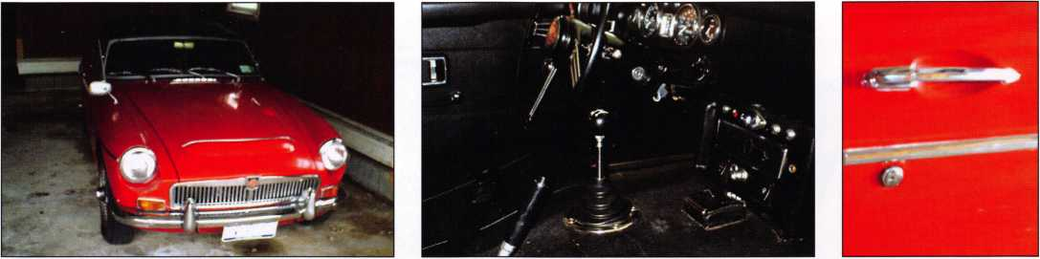

The 1969 MGC gleamed as I arrived on the scene. Take a look at the column-mounted pin-tumbler ignition lock. Here’s a look at the door lock,

which began to wobble slight-  
ly as I tried to impression it.

Now, I don’t know about you, but its practically all I can do to manage to slink into one of these miniature cars. The thought of trying to disassemble a column, (or even a door panel) on a vintage car in pristine condition makes me shudder. Customers also tend to discourage this. After all, these vehicles are usually their pride and joy. The alternative is to impression the keys.

I was fortunate enough to have a great tutor when it came to impressioning. Perry Apking ran a shop in Wilmington, NC where I worked for him for two years. His impressioning skills probably still put me to shame, but I learned a great deal. One of the great things about impressioning is that you do not have to

CALL m **1-800-355-6322** For More y ^ Information '

yAtoERV>5

Professional Business Products

We donate 5% of all sales to the  
**ALOA Scholarship Fund**Buying from NEBS®?

We offer lower prices on invoices/work orders, checks,  
repair tags, magnets, business cards, key tags and more.

Visit our booth #1617 In Chicago July 2005  
**[www.pbp2000.com](http://www.pbp2000.com)**

could probably help her out, but it would be expensive, and I would have to do some serious research in the “cata­combs” of the basement, where we keep a wealth of infor­mation that we don’t often need. She scheduled the call for the next day. As I left the shop, I looked for strange signs in the sky.

In the morning, I dug out Lynn Hawkins Euorpean Auto Lock Service Manual. This is one of a 3-volume set: the other two are Asian and German. They were published in 1986, and contain a wealth of pictures and instruc­tions on disassembling and fitting keys to various non-domestic vehicles. I started by snatching 4 of each blank listed in the beginning of the MG section.

Of course, there was information on the MG Midget and the MGB, but no reference to an MGC. The other thing was that it was clear that there would be no code anywhere on the ignition. In addition, the service procedure called for removing the column from the vehicle, which requires two people, one in the car and one under the hood.

remove, disassemble, or otherwise disturb the lock. The trick is to be gentle and patient, especially on something vintage and rare.

When I arrived at the residence, the garage was open and the MG gleamed. The customer told me she wouldn’t be home but to proceed anyway and take the keys back to the shop. That produced a sigh of relief. The last thing you need when working on something unfamiliar is someone standing over you making comments or asking questions.

**ADVERTISE WITH**

**OUR**

**WEATHERPROOF**

**LABLES**

Keynotes • June 2005

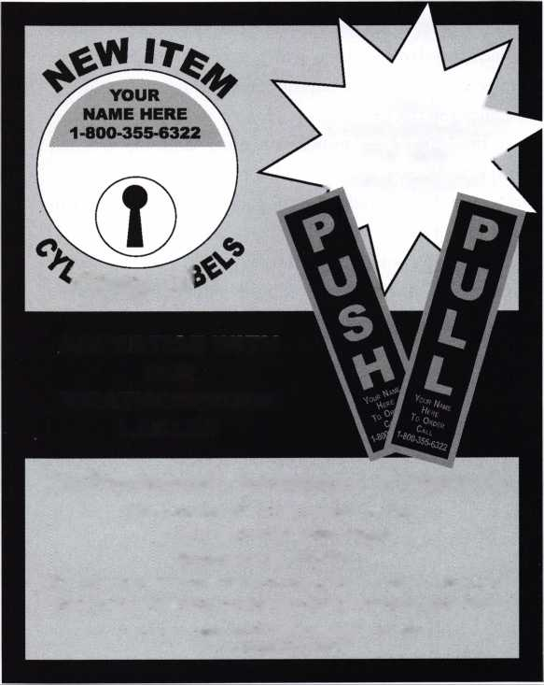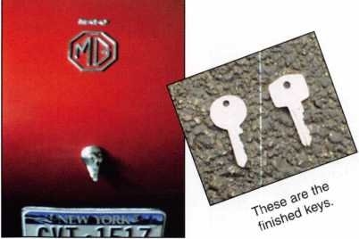

This is the trunk lock. Notice  
the MG logo on the trunk.

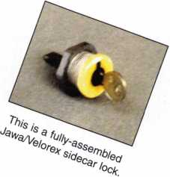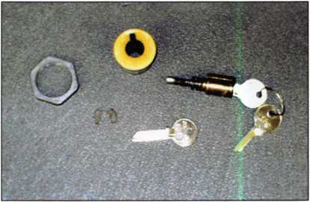

The Jawa/Velorex lock has been disassembled here to show  
its various bits and pieces.

I started by selecting the proper blank and preparing the blade. She told me that it was a “fair weather car” and that it remained parked in the garage all winter.

No wonder! A rocket like this would have about as much steering in the snow as a saucer sled: none. I was relieved to see that it was in excellent shape.

Both the door and ignition used single-sided keys. The ignition uses a pin tumbler, and the doors and trunk use wafer locks. Small euro-ignitions which use pins are fragile, like the old single-sided Ford locks and over twisting can shear the plug, ruining your whole day. The same is true of the old Chrysler door locks which have a number 1 cut in the first position: The composite metal plug can wallow out, allowing the pin to twist sideways in if s chamber. To avoid the “game over” music, remember: only apply enough pressure to get the needed marks on your key! Novices in the art tend to get impatient and over-torque in an effort to finish. I was happy that, in this case I had quoted a high enough price and that could take my time.

It was probably only twenty minutes before I had a work­ing key for the ignition. At this point, I poured myself out of this time capsule and tried to stretch for a few minutes.

Since the customer said that she had lost her “only key”, I knew she probably never had a door/trunk key. I started on the passenger side door lock, (normally the one lock of the three which receives the least amount of wear) and found that the blank slid in easily. (Lack of use can cause locks to “set up” with corrosion. Indeed, this car was in pristine condition.) The lock started to wobble slightly from side to side in the panel, and I decided to move to the trunk to finish this off. After all, caution first! Once I had a key

which worked in these two, I moved to the drivers side, which was so close to the wall of the garage that there was barely room to stand.

The key would not enter this lock. I retrieved a light from the van. It initially looked as if a key was broke in the lock. Closer inspection proved that the shutter cover which was designed to move sideways had been jammed inward toward the keyway, preventing it from sliding sideways. Efforts to fish it back proved fruitless. I knew that if I could make this work, it would be a feather in my cap.

Now that there was a door/trunk key, what would prevent the customer from thinking that this was damage that I had caused? (Customers tend to assume the worst, even when you are trying to help them!) I finally decided that I could drill a tiny hole near the edge of the shutter cover and probably fish it back. Although it remained perma­nently open, the lock was now perfectly functional, and the job was complete. When I called the customer to tell her that she now had two sets of keys waiting for her and that she could now lock the doors and trunk, she said it was the best news she’d heard all day. She smiled when she wrote the check.

For those of you who are curious, the ignition used a 62DG blank, (round key,) and the doors and trunk used the S71B, (rectangular head.) After the job was all finished, it was brought to my attention that the Ilco Auto Truck “Limited Edition” Classic Key Blank Reference, (which covers the years 1940-1975,) listed these as “late 60’s” MG blanks. For some reason, I had been under the impression that this reference was strictly domestic. I stand corrected!

6

Keynotes • June 2005

flJ

IP

7100 Series

j

H

HI J

1M Deadbolt

.■ 1

Manually relocks

Backset: 23/

23/4"

^1 1

c*

Kaba Access Control continues to offer you a simple,  
strong and secure pushbutton lock alternative, even  
in today’s high tech world. With over 40 years of  
proven performance, you can count on Simplex to  
handle all of your access control needs.

* Keyless convenience no keys or cards
* Easy to install no wiring or computers
* Easy to maintain no batteries to replace
* Easy to manage one code, can be changed  
  in seconds

The Simplex 7100 Series light commercial and  
residential locks provide an economical solution for  
restricting access to private or security sensitive

areas. A streamlined housing with integrated  
pull makes the lock ideal for front and rear  
doors, garages, conference rooms, offices,  
utility rooms and workshops.

Installation is quick and simple thanks to the  
7100 Series’ field reversible design, and new wider  
body that retrofits ASA 161 door preparations  
without additional trim.

5/s" Rim Mounted  
Deadlocking Latch

*mmm*

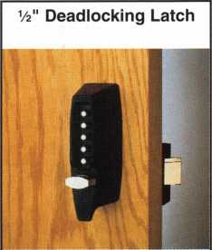

Backset: 2 3/s"  
Automatically relocks  
Latch holdback

Automatically relocks  
Adjustable Backset:  
23/s" to 2 Vi"

Simplex 7100 Series is available in a variety of durable finishes to match any decor, including a lifetime Bright Brass PVD Finish, Antique Brass and Satin Chrome. Additional powder paint finishes include Antique White, Antique Copper, Gold Vein, Silver Vein and Black.

5i§Tsl

S

Once this job was completed, I had some time to tackle the sidecar lock. I started by slimming the width of the blank ( an Ilco J997MR) down from its original width of .290 an additional .020 of an inch, and trimming the tip until the blank would enter fully to the shoulder stop. Since the housing for the cylinder was a threaded plastic-type material, I decided to gently pry the clip off the back. This allowed me to extract the cylinder and inspect it. There was no clip on the back of the cylin­der itself, and there were openings in the bottom of the cylinder housing which made me suspect that the bottom pins were loaded in a fashion similar to American pad­locks. However, attempts to shim the cylinder proved use­less. I suspected at this point that the last of the 5 pins was probably just a spring-loaded pin or ball bearing which acted as a ball detent or stop position. Picking the cylinder revealed that it would only turn clockwise 90 degrees. Once again, it was time to impression. After about 30 minutes I had a working key and I headed for the duplica­tor to make the second key. I didn’t notice it at the time, but it became immediately apparent that the duplicate key would not even enter the keyway. I checked the blanks, and every blank we had was manufactured by Ilco.

However, some of the blanks had “Ilco” stamped in large letters on one side of the blank and the number was stamped on the reverse side. Newer blanks had “Ilco” and the blank number stamped on the same side. Close inspec­tion revealed that the milling of the blanks were, indeed, slightly different! The initial blank that I had used was one of the older blanks and we had only two, which the cus­tomer cheerfully left the shop with. I warned him not to lose these keys, as I probably couldn’t even manage to duplicate another for him!

This was a day for success in the automotive field. There are many other days that I have cried, “Uncle!” or called in for back-up. (You don’t actually think I’d tell you about those, do you?)

Automotive is indeed a specialty field, and fewer and fewer of us remain “in the loop”. The advent of transponder technology in the mid 90's caused a lot of locksmiths to pull their hat out of the ring entirely.

Some of us only work on onboard programmable cars, and simply make mechanical keys for the rest, waiting for the dust to settle and the technology to stabilize or standardize. However, after some 10 years, things don’t seem to have changed much.

Automotive locksmithing will stretch your abilities, and cause you to dip into virtually every arena of knowledge that you have access to. Research is often the key to success. And remember, before anything else, the most important question should be, “What’s the year, make, and model?” Beyond that, if you hap­pen to befriend a competent mechanic, don’t ever do anything to compromise that friendship! I have a great friend who lives 5 states away who I tend to lean on regularly. He also tends to ask a lot of questions about locks. Call it a symbiotic relationship.

It seems to work well for both of us.

Beyond that? Do your research first. Knowledge is power, or at the very least, a great advantage.

The books and manuals that I have mentioned here can help you immensely. Classes and courses can help you keep your edge. After all, if you haven’t learned something new today, the day has been a waste! Get your grease-monkey smile on. You’re ready!

You need it When? :-)

**How about now!?**

☆

ClearStar  
Security

Network

Another Discount Special  
Value-added Benefit to your

ALOA Membership! Click here

r-

www. cl ea rsta r. co m / ALO A

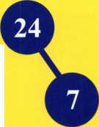

**GATE SECURITY SELLS**

**Hardware for gates, doors & storage**

Reviewing gates around a residence should be part of every security audit.

* High quality & value = customer satisfaction
* Increased opportunities for business = additional income
* D&D products are quick, easy and profitable to install
* Consumers can re-adjust products in minutes

Quality

Endorsed

Company

g dfcd tecliiiolEiiiiEs

The Ultimate Security Gate Latch

Just one of the security products in our range, the Lokk’Latch PRO® is the most sophisticated privacy and security gate latch ever devised. It is **the** privacy latch that locksmiths and security businesses have been raving about!

This quality, patented latch can be operated and locked from either side of the gate!

Lokk*Latch PRO is uniquely constructed to work effectively in both residential and commercial gate applications. The "External Access" component fits to the outside (street side) of the gate post to provide convenient, key-lockable access.

It uses a standard 6-pin key-in-knob style lock cylinder. This cylinder can be keyed-alike, maison-keyed and master-keyed, or can be replaced with a higher security cylinder.

**When it comes to increasin**g **your business,** a gate **latch is as** pr**ofitable as a door lock!**

**Safety, Privacy & Security**

***"Selling D&D's products makes good business***

**7731** Woodwind Drive, Huntington Beach, **CA 92647 Tel: (800) 716-0888 Fax:(800)464-6400 E-mail:** [info@ddtechusa.com](mailto:info@ddtechusa.com) **Web:** [www.ddtechglobal.com](http://www.ddtechglobal.com)

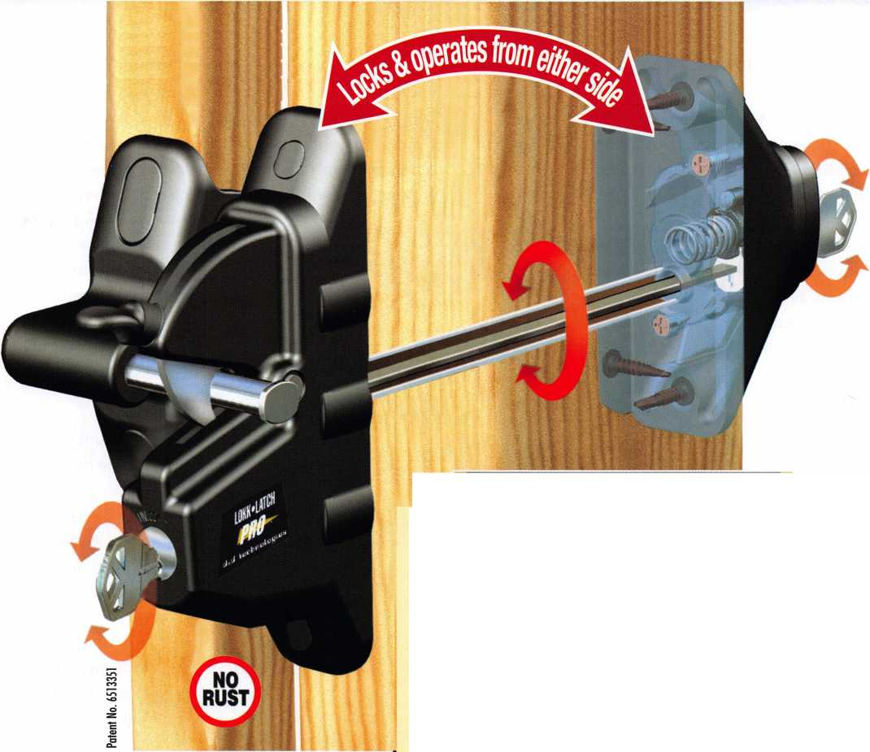

Keeping Quality Employees... Communication is the Key

By Claire L. Cohen, CML

June is “Effective Communications Month”—a good  
reminder that the most important component in any busi-  
ness relationships is communication. Active listening, ver-  
bal and written communication skills are the core of how

humans relate to  
each other both  
personally and pro-  
fessionally. This  
article is focused  
on retaining quali-  
ty employees in a  
business through  
more effective  
communication.

The loss of a tal-  
ented employee is  
always difficult for  
almost any busi-  
ness. The technical  
knowledge that is  
lost may be  
extremely difficult  
to replace. But  
more than that  
may be the “corpo-  
rate culture” that it  
lost. What is cor-  
porate culture? At

its most basic, it is described as the personality of an  
organization, or simply as “how things are done around  
here.” Every business is unique and has its own culture or  
value set.

So how can you keep your quality employees for as long as possible? COMMUNICATION. The process begins with

hiring. Be critical about hiring. Look for a particular type  
of person who will “fit” into your organization, regardless  
of the job category. Look for attitudes that are positive and  
for people who will provide positive feedback to your busi-

ness. Look for peo-  
ple who are inter-  
ested in performing  
as a team and take  
joy in team results  
as well as those of  
individual accom-  
plishment.

Right from the start  
with the interview  
process, communi-  
cate the corporate  
culture. Rather than  
just covering bene-  
fits, rules and vaca-  
tion time, the most  
important part of  
the orientation  
process needs to  
focus on your busi-  
ness, how you work  
and communicate  
with one another,  
how employees

receive education and training, and some information on  
your client base. Spend less time on rules and more on  
your type of business and individual development. Many  
times people hire the skill set first and the attitude second,  
but it needs to be the other way around. You can teach  
skills, not attitude. COMMUNICATE!

w

Daily Beatings  
will continue

until morale  
improves.

The Management



Keynotes • June 2005

>£Mtes qj

Technical Security Officers

CIA Technical Security Officers configure, deploy and maintain a variety of security systems, regularly working with US- and overseas-based Security Officers to coordinate programs. They also perform administrative duties, as well as working with and lifting heavy equipment. After a few years’ experience, you may be asked to serve in an overseas assignment.

Minimum requirements include a bachelor’s degree in engineering or an associate’s degree in electronics technology. In lieu of a degree, a certificate of completion for equivalent military, commercial or industry-recognized electronics school or training programs, or comprehensive work experience, may

be accepted. Candidates must be proficient in the field of electronics, or in an electromechanical environment. Knowledge of electronic and/or mechanical safe/lock servicing, alarms, CCTV, and experience working as a locksmith are ideal. Several years of service in the corporate security field are also preferred. Overseas experience is desired but not required.

For additional information and to apply online, please visit: [www.cia.gov](http://www.cia.gov) and view under “CIA Careers” —“Engineers and Technology”— “Technical Security Officers.”

All applicants must successfully complete a thorough medical and psychological exam, a polygraph interview and an extensive background investigation. US citizenship is required. EOE

THE WORK OF A NATION. THE CENTER OE INTELLIGENCE.



Recruiting and training an employee can be a difficult task. While only a few individuals stay with one employer their entire career, it is hoped that an employee can be retained for more than a few years. A supervisor needs to empha­size how individual job performance and responsibilities impact the total company’s success. COMMUNICATE!

To reinforce focus, set goals and objectives and then com­municate them clearly throughout the entire organization. Limit the list to two or three realistic goals, rather than an extensive list of items. This focuses everyone on the most important items. Show appreciation by rewarding individ­uals who expand their capabilities, can focus on business goals and communicate effectively with supervisors and co­workers. Communicate to employees how they contribute to new goals. What do the staff members need to do to continue to growth with the company? What skills do they need? What attitude do they need to adopt? What personal investment do they need to make? How will the organization support that in terms of auxiliary training, formal classes, certifications and professional memberships? Will additional compensation reward success? While some businesses only cover these issues once a year, these should be communicated on a regular basis.

Stay involved with every employee on a very regular basis. All staff members need to have confidence in management and believe that honest conversation can occur. Through good communication, convey future plans for each staff member, and discuss a means to accomplish the goal. Take an interest in what they do to be happy and healthy out­side of work.

Provide workers with responsibility—and then let them use it. One of the greatest sources of employee pride and satis­faction is the feeling of accomplishment that comes from having—and exercising—responsibility. Express pride in their accomplishment.

Businesses that truly value their employees earn more than gratitude—they win enhanced dedication and productivity as well. So be sure to show your employees through actions and words how much you respect and value their contribution to the entire organization. Show them how much you care.

Recognize the whole person. Good employees are more than 9-to-5 people. Everyone has lives, interests, friends and family outside the office—and most are constantly struggling to balance increasingly hectic schedules.

Listening to their concerns, and making concessions, where possible, can pay huge dividends in the long run.

Mark out a clear path to growth. Some employees are con­tent to remain where they are in an organization, but most want to grow in their careers over time. By contrast, busi­ness owners who wish to increase worker satisfaction tend to look past formalities and establish genuine growth paths for all their employees.

Trends toward increasing job dissatisfaction can be reversed, and even employees with low morale can become motivated and enthusiastic again. But it takes work—effec­tive communications—on the employer s part.

Even though you may be able to hire an equally-skilled replacement for less money, the knowledge your organiza­tion loses when an employees leaves is extremely difficult to replace. Start by communicating a corporate culture or mindset in your organization, and then develop goals that everyone can focus on. Let your employees know how they contribute to those goals and the organizations success. Reward their successes. Offer training and a path to further opportunities in the company. Finally, stay involved with every employee and encourage open conversations with supervisors/owners to build relationships. When you follow these steps, you will create a corporate culture that inspires your employees to stay with your organization long into the future. Bottom line: Stay in touch with each and every employee. COMMUNICATE!

22

Keynotes • June 2005

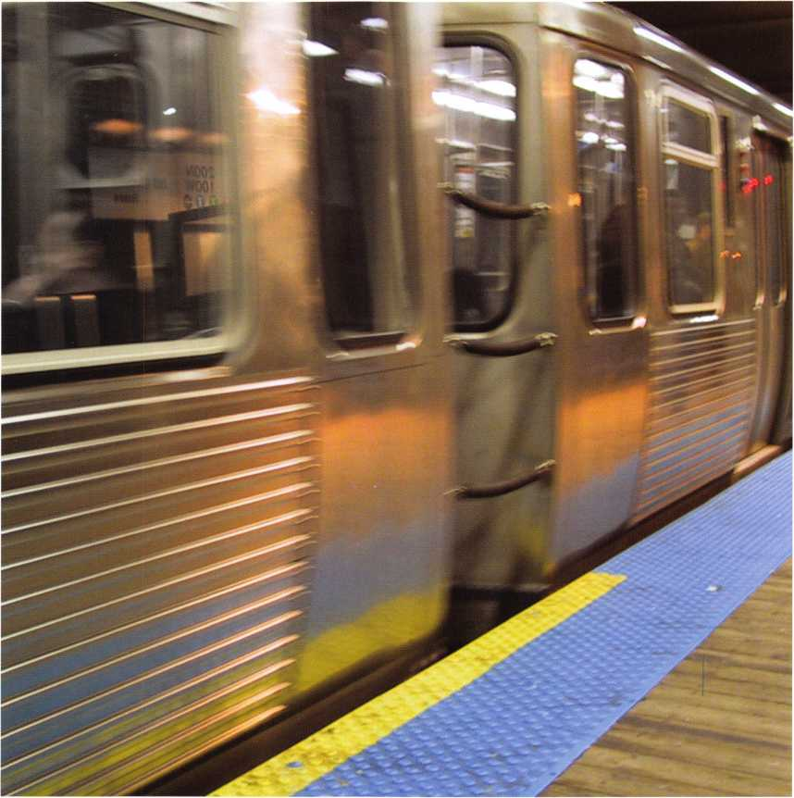

The **RLOR Conuention and Security Expo • July 1 7-24, 2005**



Suieet Home Chicago

Full Steam Ahead!

Make your plans noiu to attend RLOR’s  
49th Annual Conuention and Security  
Expo. Our shorn always features cut-  
tiny-edye classes for euery type of  
security professional, and this year is  
no exception. UJorld-class instructors  
will deliuer top-notch RCE classes on a  
uast menu of security topics to par-  
ticipating students. Take a quick trip  
across the show floor at RLOR’s  
Security Expo to discouer who’s who  
in the world of security product man-  
ufacturing. Don’t miss the hot deals to  
be had at euery new turn. The latest and  
greatest is always yours at the annual  
RLOR show. It’s the biggest security  
bonanza in existence and we’re pulling  
in to the Chicago area once again. It’s  
just one more reason to celebrate  
how far we’ue all come-as well as

where we’re going.

The Hyatt Regency O’Hare offers the  
optimum in comfort and conuenience  
with luxunj-leuel rooms, data ports, a  
heated indoor pool and a complete  
health club. To top it off, the Rosemont  
Skybridge Network connects you con-  
veniently and comfortably from the  
hotel to the conuention center and

parking.

Rnd don’t miss out on the fine dining  
and entertainment options that  
Chicago has to offer. Shop at the  
world-famous Magnificent Mile.

Eat at Morton’s of Chicago or  
Harry Carry’s Italian Restaurant.  
Uisit the Nauy Pier or catch a ball  
game. The options are endless  
when you register today for the  
single-most important euent  
in the locksmith/security industry.

Baby, you know  
you want to yo!

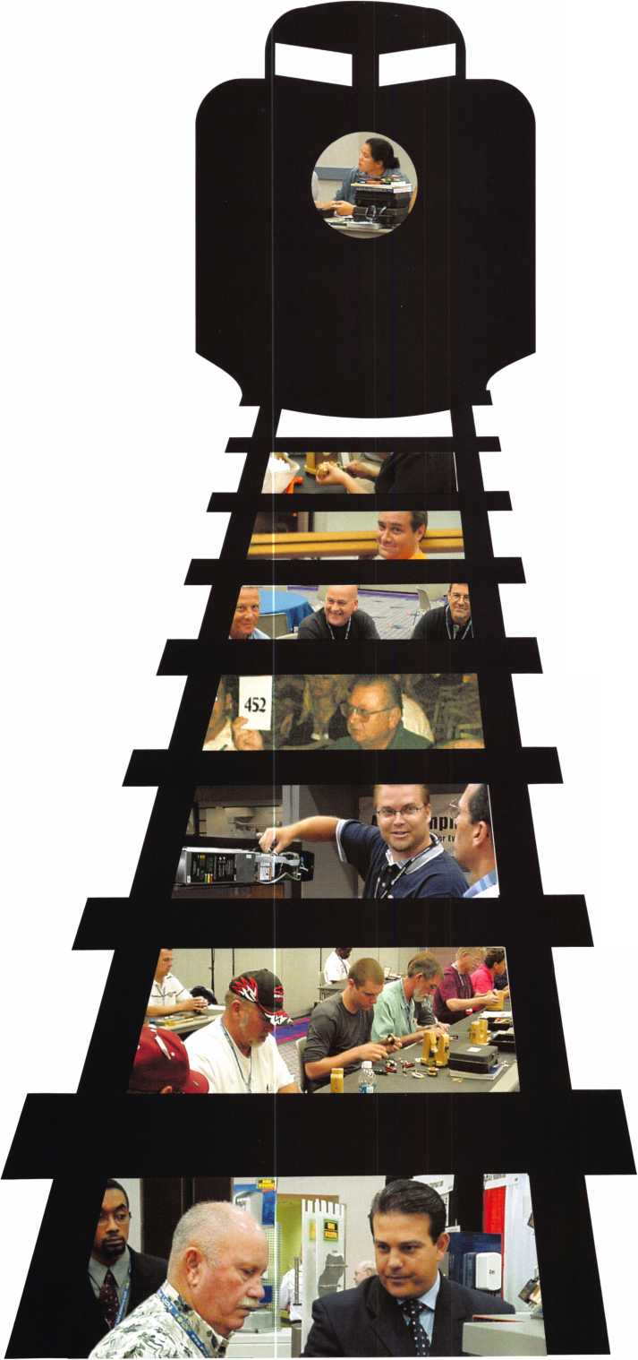

Contents

General Information 5

Transportation

Accommodations

Parking

Help/Questions Spouse/Guest Lounge ALOA 2005 Security Expo ALOA Open Golf Tournament

ALOA Scholarship Foundation Kickoff Party/Live Auction

CML Breakfast

ALOA Membership Meeting

Legislative Action Network Luncheon

State of the States Roundtable

Van Raffle

ALOA Dinner Banquet

Daily Schedule of Euents 9

Classes and Seminars 11

Registration Instructions 21

Registration Policies 22

RLOR 2005 Sponsors

and Exhibitors 23

Conuention Registration Form 24

Class and Seminar Registration 25

PRP/STPRP Registration Form 26

Hotel Reseruation Request Form ... 27

Car Rental Information 28

RLOR Membership Application 29

LEGEND

■ HOTELS

1. Hyatt Regency O'Hare

• FACILITIES/TRANSPORTATION

1. Allstate Arena
2. CTA/RTA Rapid Transit Station to  
   Airport/Chicago
3. Conference Center
4. Donald E. Stephens  
   Convention Center
5. Donald E. Stephens  
   Museum of Hummels
6. Entertainment District
7. O'Hare International Airport
8. Parking Garage
9. Parking Garage

1 2. Rosemont Skybridge Network

1. Rosemont Theatre
2. Rosemont Village Hall
3. Willow Creek Health Club

2005

Associated Locksmiths  
of America, Inc.

3500 Easy Street  
DallasTX 75247  
(800) 532-2562  
(214) 827-1701  
Fax: (214) 827-1810  
E-mail:[convention@aloa.org](mailto:convention@aloa.org)

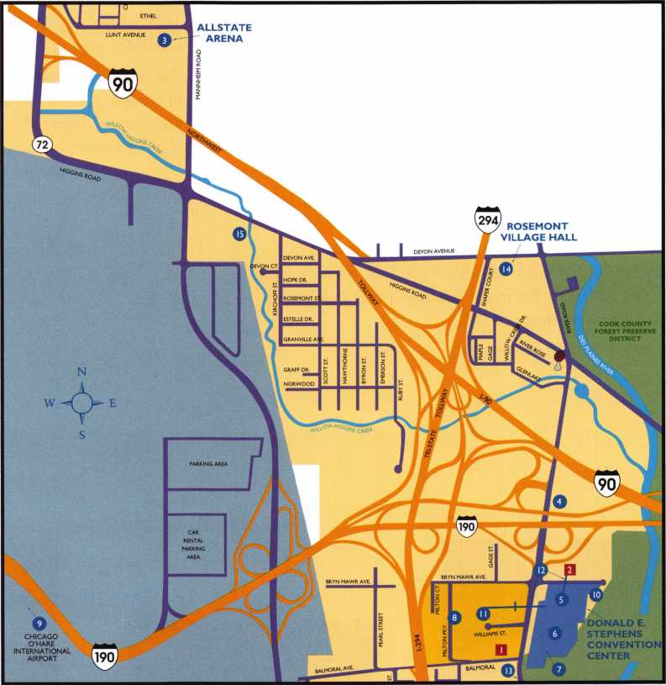

Uillage of Rosemont

General Info

**Tour**

Many visitors and Chicagoans alike say that the best way to really see the city's magnificent profile is on a 90 minute Chicago River architectural cruise. As depicted by a spe­cially trained architectural guide, learn how in the 19th Century the modern city grew from a trading post to become the world's fastest growing metropolis. Travel on the same river route over which two centuries ago passed Father Marquette, Louis Jolliet and Jean Baptiste Point du Sable. Marvel at how the early Chicago architects over­came forces of nature and technology to create the first modern buildings in the nineteenth century. Find out how the Chicago School, Prairie School, International Style and Postmodern movements influenced all modern architecture. View an extraordinary palette of great structures including Lake Point Tower, Wrigley Building, IBM Building, NBC Tower, Tribune Tower, Civic Opera House, Sears Tower, Marina City, Board of Trade, and scores more.

After the river tour your guide will conduct a close-up motor coach inspection of buildings both seen and not seen on the river tour. Following the motor coach tour guests will be dropped off on the corner of Rush Street and Superior Street where there are several restaurants to enjoy lunch. The guide will direct guests in the right direc­tion. At 2:00 p.m. the motor coach will pick guests up where they were dropped off.

The cost is $55.00 per person.

**Tentatiue Timeline**

8:45 a.m. Bus departs the Hyatt O'Hare,

9300 Bryn Mawr Ave., Rosemont IL

3:00 p.m. Return to Hyatt O'Hare

**Accommodations**

Guest room blocks with discounted guaranteed rates have been reserved at the Hyatt Regency O'Hare as the official Host Hotel for ALOA 2005 attendees. Reservations can be made by calling the Hyatt at: (847)696-1 234 or you can Fax the form in this brochure to the hotel at (847)696- 141 8 or make reservations for the Hyatt online at [www.aloa.org](http://www.aloa.org).

You must make reservations prior to the cut-off dates in order to receive the special discounted ALOA rates. Reservations made after the cut-off dates will be filled on a space-available basis and rates are subject to change.

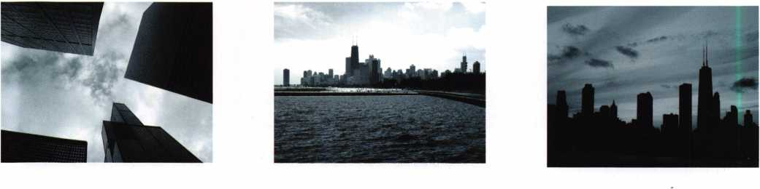

**5**

**Hyatt Regency O’Hare**

This world-  
class conven-  
tion hotel is  
the official  
host hotel for  
the ALOA  
2005

Convention.  
It's conve-  
niently locat-  
ed adjacent

to the Donald E. Stephens Convention Center, just 5 min­utes from the Chicago O'Hare International Airport.

This beautiful hotel boasts 1,100 tastefully decorated soundproof guestrooms with 5 restaurants and lounges to choose from, including: the world-famous Ventana's restau­rant with panoramic views from a revolving rooftop restau­rant and lounge. The hotel has a full-service business cen­ter for your convenience, as well as a gift shop, and com­plimentary transportation to and from Chicago O'Hare International Airport, only minutes from the commuter train to downtown Chicago. The hotel also features a fully-equipped healthclub, with an indoor swimming pool, and a redwood sauna for your enjoyment.

Minutes away from O'Hare International Airport,

Hyatt Regency O'Hare in Rosemont, Illinois is the premier Chicago airport hotel for conventions and meetings or individual travel.

Hyatt Regency O'Hare is connected by skywalk to the Donald E. Stephens Convention Center and offers convenient access to Allstate Arena and Rosemont Theatre. Our world-class convention hotel is just 15 miles via expressway or train to downtown Chicago and the Magnificent Mile; 10 miles via expressway to both the Oakbrook Center and Woodfield shopping malls.

With over $11 million in renovations and Wi-Fi high­speed Internet in all 1099 guestrooms, this O'Hare airport hotel is a standout among Hyatt hotels in Chicago.

Room Rate: $135 Single/Double

For Reservations call: 1-847-696-1234

or use Form #4 on page 25

Cut off date: Monday, June 24, 2005

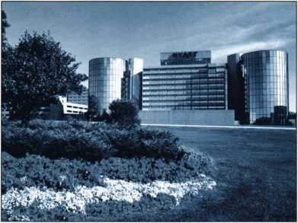

**Parking**

Parking for the Donald E. Stephens Convention Center is located across the street from the Center directly behind the Embassy Suites. It is located West of the main entrance to the Center on Williams Street off of North River Road. (Garage parking is $11)

Parking is also available at the Hyatt hotel for $16 per day (with in-and-out privileges) for registered guest and $22.50 per day for non-guests. Valet parking is also available at the Hyatt hotel.

**Handicapped Parkiny**

Handicapped-accessible parking for the Convention Center is available on the 1st level (lower level) of the Convention m Center parking garage. A handicapped-acces-

>lr\ sible shuttle is available for direct service to the main entrance of the Convention Center. Handicapped-accessible parking is also avail­able at both hotels.

**Help/Questions**

If you have any questions, concerns, or special needs,  
please call (800) 532-2562 Ext. 27 or (214) 827-1701, x  
27. Monday-Friday, 9 am-5pm (Central Time)

**HL0R 2005 Security Expo**

Don't miss the latest information, products and services for  
the locksmithing and

security industry at  
the 2005 Security Expo.  
This internationally-  
renowned blockbuster  
security show wi II be  
held at the ever-popular  
Donald E. Stephens  
Convention Center  
located right next door  
to the Hyatt. The show

will be located in Hall F of this grand facility.

The show schedule is:

Friday, July 22 12 noon-5 pm

Saturday, July 23 1 2 noon-5 pm

Sunday, July 24 12 noon-4 pm

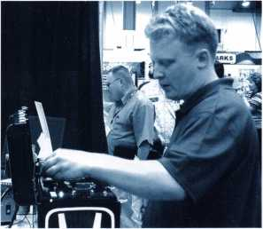

**6**

General Info

**Kick-Off Party/Liue Huction**

Thursday, July 21

Kick-off Party 7-8pm • Live auction 8 pm

The ALOA Scholarship Foundation will again be the host of this year's Annual Kick-Off Party and Live Auction at the Hyatt-Regency O'Hare. All registrants are encouraged to attend and enjoy fabulous food and fun. Great items will be offered for your bidding pleasure at ALOA's 6th annual live auction. This is a great place to meet old and new friends while enjoying the opportunity to purchase fantastic items and outstanding bargains-with the proceeds going to a great cause! Sponsors for this event are IR Security & Safety and ASSA Inc.

**RLOH Membership Meeting**

Friday, July 22 • 10-11 am

ALOA members are encouraged to attend the 2005 Annual Membership Meeting at the Hyatt Regency O'Hare. The achievements of the past year will be reviewed and the goals for the future stated. Don't miss this great opportunity to be an integral part of your association! Continental Breakfast will be served.

**Legislatiue Hction Network Luncheon (LRN) and State of**

**the States Roundtable**

Saturday, July 23 • 1 lam-Noon

To show appreciation to the members of the Legislative Action Network and Council, ALOA is hosting a meeting at the Hyatt Regency O'Hare. This by-invitation-only event will be the perfect way to celebrate the legislative victories enjoyed this year.

The State of the States Roundtable at the Hyatt Regency O'Hare, is designed as a forum for ALOA chapters and local/state/regional locksmith associations and affiliates to meet and share information and ideas about the state of locksmithing in the various regions. Primarily for the Chairman, President and Legislative Representative from each organization. These discussions will provide the per­fect opportunity to learn what's going on the industry across the nation.

**CML Breakfast**

Friday, July 22 • 8:30am-10am

ALOA will host an invitation-only breakfast at the Hyatt Regency O'Hare honoring recipients of ALOA's highest level of locksmith certification.



RLOR Open Golf Tournament

Thursday, July 21,6:30AM-3PM

The ever-popular ALOA Open Golf Tournament will be held at the Chalet Hills  
Golf Club. Transportation will depart from the Hyatt O'Hare at 6:30am and  
return at 3pm. The registration fee is $150 and includes transportation, green  
fees, golf cart, and beverages throughout the course, lunch and prizes for all  
players. Yale Security Group, Inc. once again will serve as the main sponsor  
of the Tournament, joined this year by Amsec, Lucky Line Products and  
STRATTEC Inc. Proceeds will benefit the ALOA Scholarship Foundation.

**7**



Sweet Tjome Chicago Gangster Right

Saturday, July 23, 2005 • 7pm-l 1pm (see page 28 for more information)

**CLASSES**

**Schedule**

**SUNDAY**

**July 17, 2005**

1. ***5pm***

***REGISTRATION***

***Hyatt***

***8am-5pm***

***FULL-DAY***

***EDUCATIONAL CLASSES  
Hyatt***

**MONDAY**

**July 18, 2005**

***7am-5pm***

***REGISTRATION***

***Hyatt***

***8am-5pm***

***FULL-DAY***

***EDUCATIONAL CLASSES  
Hyatt***

**TUESDAY WEDNESDAY**

**July 19, 2005**

***7:30am-5:30pm***

***REGISTRATION***

***Hyatt***

***8am-5pm***

***FULL-DAY***

***EDUCATIONAL CLASSES  
Hyatt***

**July 20, 2005**

***7:30am-5:30pm***

***REGISTRATION***

***Hyatt***

***8am-5pm  
FULL DAY***

***EDUCATIONAL CLASSES  
Hyatt***

|  |  |  |  |  |
| --- | --- | --- | --- | --- |
| 001: Instructor Training | r | 101: Instructor Training | 201: Instructor Training (Day 3 of 4) | 301: Instructor Training (Day 4 of 4) |
| 002: Fundamentals of Locksmithing (Day 1 of 5) | | 102: Fundamentals of Locksmithing (Day 2 of 5) | | | 202: Fundamentals of Locksmithing (Day 3 of 5) | 302: Fundamentals of Locksmithing (Day 4 of 5) |
|  |  | 103: Master Keying Methods & Formats (Day 1 of 2) | 203: Master Keying Methods & Formats (Day 2 of 2) | 303: Advanced Topics in Master Keying (P-31) |
|  |
|  | 104: Keyless Mechanical Lock Servicing | | 204: Exit Devices & Exit Alarms (P-16) | 304: Servicing Aluminum Storefront Doors |
|  | 105: Door Hardware 101 | | 205: Comprehensive Safe Deposit Lock Servicing (Day 1 of 3) | 305: Comprehensive Safe Deposit Lock Servicing (Day 2 of 3) |
|  |
|  | 106: Investigative Locksmithing 1 | | 206: Investigative Locksmithing II | 306: Investigative Locksmithing III |
|  | 107: Comprehensive Time Lock Servicing | | 207: Time Lock Servicing (Day 2 of 4) |  |
|  | 108: CPS Prep Class | | 208: Combination Lock Manipulation (Day 1 of 2) | 308: Combination Lock Manipulation (Day 2 of 2) |
|  | 109: Basic Automotive Lock Service | | 209: Intermediate Automotive Lock Service | 309: Steering Column Service and Repair (Day 1 of 2) |
|  |
|  | r | 110: Defense Against Methods of Entry (Day 1 of 2) | 210: Defense Against Methods of Entry (Day 2 of 2) | 310: Defense Against Methods of Entry (Day 1 of 2) |
|  |
|  | 111: Basic Elecric Locks (P-13) | | 211: Fundamentals of Access Control | 311: Professional Lock Picking |
|  | 112: Advanced Shop Management | | 212: Life Safety Codes w/ADA (P-07) | 312: Alarm Design and Development |
|  | 113: Electronic Safe Lock Servicing & Defeat (Dayl of 2) | | 213: Electronic Safe Lock Servicing & Defeat (Day2 of 2) | 313: Medeco3 Factory Certification |
|  | (P) 114: Safe Combination Lock Servicing & Troubleshooting | | 214: Wiring Techniques for the Electronic Locksmith | 314: Basic Electricity & Electric Locks (P-13) |
|  |
|  | 115: Mechanical Closers & Door Controls | | 215: Electrified Closers and Door Controls | 315: Basic Exit Device Servicing |
|  | |  | 216: Motorcycle Lock Servicing (P-22) | 316: Advanced Automotive Lock Service (P-03) |
| NOTl | | 217: Financial Management for Locksmiths (Day 1 of 2) | 317: Financial Management for Locksmiths (Day 2 of 2) |
| f | |  |  | 318: Small Format Interchangeable Core (P-38) |
| MULTIPLE-DAY | | |  |  |
|  | | ARE | Evening Seminars | Evening Seminars |
| CLASSES  a aa^+a aa a | | 221: Electric Lock Site Survey & Design | 321: Introduction to Access Control with Cyberlock |
| munuumtu  IN COLOR | | | 222: Key Control Policies - Design & Implementation | 322: Replacing Lost Keyless Entry Remotes - an Untapped Market for Automotive Locksmiths |
|  |  |
|  | |  |  |  |
|  |  |

***7-9pm***

***EVENING SEMINARS  
Hyatt***

***7-9pm***

***EVENING SEMINARS  
Hyatt***

***8am-3pm***

***ARCHITECTURAL RIVER CRUISE  
AND COACH TOUR***

9

**THURSDAY**

**July 21, 2005**

***7:30am-5:30pm***

***REGISTRATION***

***Hyatt***

***8am-5pm  
FULL DAY***

***EDUCATIONAL CLASSES  
Hyatt***

**FRIDAY**

**July 22, 2005**

**1*0am-5pm  
REGISTRATION  
Convention Center***

***NO CLASSES THIS DAY***

**SATURDAY**

**July 23, 2005**

***7am- 1 2pm  
CLASS REGISTRATION  
Hyatt***

***8-11 am***

***HALF-DAY CLASSES  
Hyatt***

***10am-5pm***

***SECURITY EXPO REGISTRATION  
Convention Center***

**SUNDAY**

**July 24, 2005**

***7am-12pm  
CLASS REGISTRATION  
Hyatt***

***8am-11 am  
HALF-DAY CLASSES  
Hyatt***

***10am-3pm***

***SECURITY EXPO REGISTRATION  
Convention Center***

|  |  |  |  |
| --- | --- | --- | --- |
| 401: ACE Instructor Refresher | 500: 5:30-10PM; PRP/STPRP Exam; Complete form #3 on pg. 24 | 601: Master Padlock Certification | 701: American Padlock Certification |
| 402: Fundamentals of Locksmithing (Day 5 of 5) | 602: l-Que Elec. Access Control Certification | 702: Videx Cyberlock Advanced Training |
| 403: High Security Cylinder Servicing (P-08) |  | 603: Detex Access Control Solutions | 703: Mul-T-Lock |
| 404: Hollow Metal Door & Frame Servicing |  | 604: Medeco Keymark Certification | 704: Medeco New Product Update |
| 405: Comprehensive Safe Deposit Lock Servicing (Day 3 of 3) |  | 605: Primus/Everest Update | 705: Alarm Lock Trilogy Certification |
| 406: Forensic Locksmithing |  | 606: Kaba E-Plex Access Control | 706: Complete Guide to Electronic Strikes |
| 407: Time Lock Servicing (Day 4 of 4) |  | 607: ASSA High Security Product Certification | 707: ABLOY PROTEC High Security Locks |
| 408: SafeWizard Electronic Access Control Certification |  | 608: Omnilock Access Control Systems | 708: Auditcon Series 2/LC Safe Locks |
| 409: Steering Column Service and Repair (Day 2 of 2) |  | 609: Corbin Russwin Pyramid Certification | 709: Taking the Mystery Out of Electrified Hardware |
| 410: Defense Against Methods of Entry (Day 2 of 2) |  | 610: KABA llco Transponder Forum 2006 | 710: Peaks Classic and Peaks Global Certification |
| 411: Professional Impressioning Techniques |  | 611: Automotive Servicing Techniques | 711: Scorpion CX-5 High Security Lock |
| 412: Alarm Design and Development |  | 612: Professional Tools for the Professional Locksmith | 712: Software for the Professional Lockshop |
| 413: Simplex Unican Certification |  | 613 Keyless Remote Certification |  |
| 414: Fundamentals of Access Control |  |  |  |
| 415: Schlage Cylindrical Lock Servicing |  |  |  |
| 416: STRATTEC 2005 Update |  |  |  |
| 417: Business Planning |  |  |  |
| 418: (P-L-39) Large Format Interchangeable Core |  |  |  |

|  |  |  |  |
| --- | --- | --- | --- |
| 6:30am-3pm | 8:30-10am | 11:00-Noon | 12Noon-4pm |
| ALOA OPEN | CML BREAKFAST | LAN LUNCHEON | SECURITY EXPO |
| GOLF TOURNAMENT | Hyatt | STATE OF THE STATES | Convention Center |
| CHALET HILLS GOLF CLUB | 10-11 am | ROUNDTABLE |  |
| 7-11pm | MEMBERSHIP MEETING | Hyatt |  |
| KICK-OFF PARTY/ | Hyatt | 12Noon-5pm |  |
| LIVE AUCTION | 12Noon-5pm  SECURITY EXPO Convention Center  5:30-10pm  EVENING PRP EXAM  Hyatt | SECURITY EXPO |  |
| Hyatt | Convention Center  7-11pm  ALOA GANGSTER  DINNER BANQUET  Hyatt |  |

**Full-Day Classes**

★

The symbol to the left indicates that a class has been PRP Certified. Students may elect to take the exam for the PRP elective designated at the end of the class for an additional fee. PRP-Certified class exams will take place immediately following the end of class from 5-5:30 pm with 20 minutes of actual exam time allowed. The single elective exam option is available to pre-registered ALOA members only.

**SUNDAY, JULY 17, 2005 • 8cim-5pm**

1. Instructor Training (Day 1 of 4)

Instructor: Monte Salway, CML

Gordon Malczewski (Four-day class)

This class is the first step to becoming an ALOA Certified Instructor. Information will be presented on standardized methods of instruction and motivation. The class consists of lectures, discus­sion, exercises, and presentations that will assist the student in organizing both their instruction methodology and their general business career.

Upon completion of the course, the student will be able to develop a class outline, prepare a lesson plan, prepare the necessary training aids, evaluate instruction material, motivate students, and effectively instruct an ACE class.

The student should not plan on an 8 am to 5 pm class every day. This class may run into the evening, and some homework will be required.

1. Fundamentals of Locksmithing (Day 1 of 5)

Instructor: James Hancock, CRL,

J. Casey Camper, CML,CPS

This is a comprehensive five-day hands-on course in Fundamental Locksmithing Techniques. The student will develop the ability to identify common key blanks, adjust key cutting equipment, use key duplicating and code cutting equipment, disassemble, service and originate keys for common lock cylinders using methods such as shimming, picking, impressioning and code cutting. Lockset servicing, functions and finishes will be covered.

**MONDAY, JULY 18, 2005 • 8am-5pm**

1. Instructor Training (2 of 4)

Instructor: Monte Salway,

Gordon Malczewski

See class #001 for description

1. Fundamentals of Locksmithing (Day 2 of 5)

Instructor: James Hancock, CRL,

J. Casey Camper, CML,CPS

See class #002 for description.

1. Master Keying Methods & Formats (Day 1 of 2)

(Two-day class)

Instructor: Jerome V. Andrews, CML,

Jack Hobin, CPL

This is a fast-paced, comprehensive course in split pin master key­ing based on the ALOA publication Fundamentals of Master Keying. Topics include the standard key coding system, expansion

specification, site survey, record keeping, selecting top master keys, the TMK register, basic mechanical and historical problems in master keying, dividing the key for symmet­rical systems, use of incidental masters for asymmetrical systems, principles for cross keying, and parity.

Students do single-step and two-step progression exercises in both total position progression and rotating constant method. Exercises are done in all three industry bitting list formats; list format, stan­dard progression format and matrix format. Also included is an explanation of how to reverse engineer an existing system using matrix format, and how to select top master keys and Controls for small format I Core.

Upon completion of this course the student will be able to perform a site survey, design and properly maintain a multiple level mas­ter key system.

Note: There is a $40 lab fee required for the class text to be retained by the students. If you already have a copy of Fundamentals of Master Keying by Jerome Andrews, this fee will be waived. Students must have a copy of this text for use during class.

The information presented will be useful in preparing for PRP Section L-31.

1. Keyless Mechanical Lock Servicing

Instructor: David Thielen, CML

8 hours

The student will learn the proper terminology, function, applica- & tion, installation and service of keyless mechanical locks. The major brands of Keyless mechanical locks including Simplex/Unican, Preso-Matic, Digital Door Lock Systems, Supra, as well as the various brands of keyless padlocks and cam locks will be emphasized. You will become familiar with mounting characteristics, combination changing and common service mal­functions.

Reference Material:

Manufacturers' literature from: Simplex, Preso-Matic Keyless Locks, Digital Door Lock Systems, Supra, Master Padlock and CCL

The information presented will be useful in preparing for PRP sec­tion L-20.

ALOA members who pay the additional lab fee for the test may take PRP Section L-20 at the end of the class.

1. Door Hardware 101

Instructor: Carl Rollison

This class covers the various types of locks, hinges, closers, doors, frames and related hardware that a locksmith should be familiar with in order to properly service any door opening. Upon com­pletion of this class the student will be able to identify and service the various types of hardware used on doors and frames.

1. Investigative Locksmithing I

(Three-Day Class)

Instructors Don Shiles, RL, CFL ,

John Dorsey, CML, CPS, CFL

This class is an introduction to investigative/forensic locksmithing;  
it's history, who is involved in the profession and the possibilities  
for the locksmith. Photos and slides of various locks, pin tumblers  
and disc tumblers that have been picked are shown. The tools of  
the forensic locksmith are listed and detailed. Discussion of the  
Standards for Forensic Locksmiths and Code of Ethics is detailed.  
The Crime Scene is discussed detailing the preservation of evi-  
dence, documentation of the scene, working with local law enforce-  
ment, preservation of all evidence, the "chain of custody" and  
appropriate packaging in evidence collection. Investigative  
Photography is briefly discussed along with an introduction to some  
of the tools of the trade.

Note: A lab fee of $75.00 is required to cover the costs of the  
Forensic Locksmithing Tool Kit and Manual that will be retained  
by student.

Prerequisite: Basic Locksmithing.

1. Comprehensive Time Lock Servicing

(Day 1 of 4)

Instructor: Dan Graffeo, CMST, RL

Join the "Master of Timelocks" in this comprehensive four-day  
course designed to meet the needs of the technician, who services  
time locks or locksmith who wants to explore this lucrative service  
opportunity. The program will introduce the technician to the vari-  
ous types, styles and function of timelocks used over the last one-  
hundred years. Emphasis will be placed on service, with seg-  
ments devoted to troubleshooting and diagnosis. Application  
engineering and service contract writing discussions will round  
out this comprehensive, four-day program. The course will  
include: Design and Function; Service considerations; Hand-  
Cleaning a Timelock Movement; Ultrasonic Cleaning a Timelock  
Movement; Disassembly and reassembly of Mosler, Diebold,

S&G, TMI and STB type movements; Basic low-voltage electricity;  
Electronic movement service and troubleshooting; Multi-meter  
usage; Timing machine usage; Contract/Service Agreements.

Students who pass the exam at the end of the class will receive a  
certificate of completion and credit for L-26 of the PRP exam.  
Students who do not pass the exam will receive a certificate of  
attendance. Prerequisite: Basic Safe Lock Servicing

Lab Fee: $300.00 for the Timelock Tool Kit, Multi-meter and  
Course Manual.

1. CPS Prep Class

Instructor: Dennis Watanabe, CML, CMST

Frances Watanabe

Students will participate in a day of fast paced instruction and hands-on training, covering a wide range of topics related to safes and safe locks. Basic and advanced, theory and operation of safes and safe locks, construction, ratings, container classifica­tions, servicing and defeat methods are just some of the subjects covered in class. Students will also learn the proper way to scope a change key hole, lock defeat methods and drill point options, how to pull various dials, locks and safe door handing, lock-out diagnostics, the correct way to drill and transfer and much more.

Prerequisite: Safe Lock Servicing and Troubleshooting

Lab Fee $100.00 for the class manual

The information presented will be useful in preparing for PRP sec­tion L-24, L-33 and STPRP section S-00 and S-01

1. Basic Automotive Lock Service

Instructor: Ed Woods, CPL, CPS

Students already familiar with basic lock service will be intro­

duced to the tools, skills and information, critical for beginning  
professional automotive lock service. All fundamental topics will  
be covered. Learning the basic terminology and procedures of  
automotive cylinder and key service is the theme throughout the  
day. Hands on clinics will include key blank identification, refer-  
encing and cutting keys by code, function and operation of com-  
mon automotive cylinder types, basic lock manipulation, disas-  
sembly and re-assembly, keying and re-keying, general cylinder  
repair service and fitting first keys.

Materials needed: selection of hand tools, such as screwdrivers,  
an awl, files, lock picks, possibly a small clamp-on vise, a small  
hammer and any additional tool you feel will be helpful for bench  
work.

Prerequisites: Basic Lock Service or equivalent experience

The information presented will be useful in preparing for PRP  
Section L-03 & 04

1. Defense Against Methods of Entry  
   (Day 1 of 2)

Instructor: Harry Sher, CML, CPS

This class will cover specific methods of entry under these broad  
categories: forced entry, surreptitious entry and covert entry. This  
class is designed for locksmiths who need to neutralize locks,  
security consultants who need to identify weaknesses and recom-  
mend solutions, as well as forensic locksmiths, law enforcement,  
and intelligence personnel who need to make entry or identify the  
method of entry. Material from classes such as Professional  
Bypass Techniques, Tricks of the Trade, and Operations Methods  
of Entry will be covered. Comparisons will be drawn applying a  
specific method to various areas of locksmithing such as safe and  
vault, automotive, residential, safe deposit, etc. The will learn to;  
identify the weak points in any locking device (including unfamil-  
iar locks), determine the most likely and best methods of attack,  
make entry in a professional manner, and determine how to best  
defend against these methods of entry.

1. Basic Electricity & Electric Locks (P-13)

Instructor: Adam Black, CRL

This course begins with fundamental electric theory and focuses  
on those aspects of electricity that apply to modern access control  
and electric locking systems. A review of electric lock hardware is  
included.

Materials to bring to class: a digital multi-meter and small tools.

The information presented will be useful in preparing for PRP  
Section L-13.

ALOA members who pay the additional lab fee for the test may  
take PRP Section L-13 at the end of the class.

1. Advanced Shop Management

Instructor: Thomas Demont, CML, AHC

This is a must class for the management professional of the 21 st Century. The areas covered will include hiring employees, drug and alcohol abuse, compensating employees, training, advertis­ing, bids and proposals, and growth with a purpose. Hear how Tom built his company to the area's leader in ten years and sold it for three million.

1. Electronic Safe Lock Servicing and Defeat Methods (Day 1 of 2)

Instructor: Michael Yarberry, CML, CPS

This two-day class focuses on real-world defeat and opening techniques of the industry's most popular electronic safe locks.

Also included will be the basic servicing and troubleshooting of these locks from a Safe Technician's point of view. Over 20 differ­ent electronic safe locks will be thoroughly covered. (E.g. AMSEC, GlobaLoks, llco, Kaba-Mas, LaGard, S&G and many others). This is a one of a kind class, not offered by any other school in the



12

industry today. Mike details most all of his information and tech-  
niques in this class, so be sure to bring pen, paper, and a willing-  
ness to learn! (Photography and digital recording devices are  
permitted in this class.) Class size is limited so register early.

Prerequisite: Must be bonded ALOA or SAVTA member, basic  
safe opening experience and knowledge of basic electricity is  
useful but not required.

Lab Fee $15.00 covers both days

1. Safe Combination Lock Servicing &

Troubleshooting

Instructor: Greg Perry, CML, CPS

This course will feature the basics of combination locks as well as a  
discussion on the different makes and models. Students will also  
learn how to disassemble and reassemble combination locks. They  
will also learn to change combinations and what numbers should  
or should not be used. There will also be hands-on troubleshoot-  
ing. When the student leaves this class they should feel confident  
about changing combinations, proper servicing of the lock and be  
able to do some troubleshooting.

Materials students should bring to class: Medium size common  
and #2 Philips screwdrivers, diagonal pliers and pencil and  
paper for any notes they want to make.

The information presented will be useful in preparing for PRP  
Section L-24.

ALOA members who pay the additional lab fee for the test may  
take PRP Section L-24 at the end of the class.

1. Mechanical Closers & Door Controls

Instructor: IR Security & Safety

This class gives the student an overall understanding of mechani­cal door closers, stops, pivots, holders, and other accessory hard­ware. The focus is selecting the right product for different applica­tions. The student will learn to; apply the basics of door closers and door control, specify the right grade of closer for each appli­cation, select and apply different types of concealed closers, select manual door controls that comply with ADA requirements, apply products that meet local life safety codes, equip vandal-prone applications with heavy duty products, specify and apply various types of stops to protect doors and surrounding areas from dam­age, recognize and resolve conflicts between overhead stops and door hardware, balance aesthetics with functional requirements and differentiate applications requiring pivots from those requir­ing hinges.The student will also receive templates, instructions, tools, catalogs, and parts lists.

**TUESDAY, JULY 19, 2005 • 8<im-5pm**

1. Instructor Training (Day 3 of 4)

Instructors: Monte Salway

Gordon Malczewski

See class#001 for description

1. Fundamentals of Locksmithing (Day 3 of 5)

Instructor: James Hancock, CRL

See #002 for description

1. Master Keying Methods & Formats (Day 2 of 2)

Instructor: Jerome V. Andrews,

CML, John Hobin, CPL

See class #103 for description.

1. Exit Devices & Exit Alarms (P-16)

Instructor: Dave Thielen, CML

This class is updated to include delayed exit devices that comply with  
NFPA101. A wealth of information is covered on exit devices includ-  
ing: types, functions, ratings, options, installations, repairs and serv-  
icing. Hands-on practice as well as slides, videos and handouts are  
provided. Upon completion of this class, the student will be able to  
properly remove, service, troubleshoot malfunctions and retrofit  
many of the popular exit devices.

Materials to bring to class: Common and Phillips screwdrivers  
and an Allen wrench set.

The information presented will be useful in preparing for PRP  
Section L-16.

ALOA members who pay the additional lab fee for the test may  
take PRP Section L-16 at the end of the class.

1. Safe Deposit Lock Service, Repair and

Key-Fitting (P-25)

Instructors: Michael McMannis, CPL

Curtis Robison, CML, CPS

Formulated and designed to meet the ever-increasing needs of the  
average locksmith, institutional based service technician and the  
experienced bank service technician. This program starts with the  
basics of design, function, nomenclature and the theory of use in  
both the banking world and industry. Emphasis placed on devel-  
oping the technician's skill level in bypass, key fitting and identifi-  
cation of the lock from the outside of a locked container with  
intensive hands on applications.

Students will learn using an interactive format, allowing for con-  
tinuous evaluation. By the end of the third day, students will have  
achieved a skill level that will allow them to service, open and  
repair approximately 80% of the safe deposit locks now in serv-  
ice. Students who pass the exam at the end of the class will  
receive a certificate of completion and credit for L-25 of the PRP  
exam. Students who do not pass the exam will receive a certifi-  
cate of attendance.

Prerequisite: Basic Locksmithing

Lab Fee $250.00 for the Nose and Door Puller Kit, Pick-Key,  
Multi-blade screwdriver, and Student Manual.

1. Investigative Locksmithing II

Instructors: Don Shiles, RL, CFL

John Dorsey, CML, CPS, CFL

Investigative Locksmithing I is briefly reviewed. This class includes  
hands on exercises using a hand microscope to examination vari-  
ous locks and cylinders, to determine if they have been picked or  
bypassed. Basic Macro & microphotography is discussed. The stu-  
dent is introduced to the Stereo Microscope and its value to exami-  
nations. Court testimony, appropriate legal and insurance terminol-  
ogy and demeanor in the courtroom will be covered. Developing a  
report of findings, building an investigative locksmithing resume  
(CV), marketing techniques along with some basic tricks of the  
trade are covered.

Prerequisite: Investigative Locksmithing.

Note: You must have the Forensic Locksmithing Tool Kit and  
Manual for this class or pay a $75.00 lab fee.

1. Time Lock Servicing (Day 2 of 4)

Instructor: Dan Graffeo, CMST, CRL

(See class 107 for class description)

1. Combination Lock Manipulation (Day 1 of 2)

Instructor: Dennis Watanabe, CML, CMST

Frances Watanabe

This course will present a review of mechanical combination locks including the theory of operation, determining the



13

209

210

211

212



number of wheels, and how to determine the manufacturer. Methods to determine if a lock should be manipulated will be pre­sented. Students will be presented with the theory of manipulation and extensive hands-on practice manipulating Group 2 locks. When the student leaves this course they should not only be able to manipulate locks, but also through the knowledge gained about locks, be able to open many locks that they have not been able to, including some Group I locks. Students should have a thorough knowledge of servicing locks andcombination changing prior to taking this class.

Materials students should bring to class: Medium size common and #2 Philips screwdrivers, diagonal pliers and pencil and paper for any notes they want to make.

Prerequisite: Combination Lock Servicing or Pretest.

Students must be bonded.

The information presented will be useful in preparing for PRP Section L-33 and STPRP Section S-00.

Intermediate Automotive Lock Service

Instructor: Ed Woods, CPL, CPS

This course is for students already familiar with basic automotive lock service, who wish to learn about servicing the more advanced, two dimensional mechanical and electromechanical security systems found in today's vehicles. Some examples of the topics covered are system identification & electromechanical inte­gration, intermediate lock, linkage & electromechanical manipula­tion, air bag & basic transponder key service, special tools, trou­bleshooting, effecting repairs and fitting fully functional first keys.

Materials needed: selection of hand tools, such as screwdrivers, an awl, files, lock picks, possibly a small clamp-on vise, a small hammer and any tool you feel will be helpful for bench work.

Prerequisites: Basic Automotive Lock Service or equivalent experi­ence.

The information presented will be useful in preparing for PRP Section L-03 & L-04.

Defense Against Methods of Entry Day 2

Instructor: Harry Sher, CML, CPS

See class #110 for description

Fundamentals of Access Control

Instructor: Adam Black, CRL

This class is designed to give an overview of electronic access con­trol. To properly understand any electronics requires an understand­ing of terms, circuits, proper use of test equipment and the interrela­tionship of voltage, amperage and resistance. By the end of this class students should have a basic working knowledge of electronic access control installation and troubleshooting.

The information presented will be useful in preparing for PRP sec­tion L-41

Life Safety Codes w/ADA (P-07)

Instructor: Thomas Demont, CML, AHC

This is a mandatory class for the security professional of the 21 st Century. The areas covered will include the new International Code Council Model Building & Fire Code ICBO-2000, Underwriters Laboratories listings for hardware, Accessibility, Doors, N.F.P.A. 80- 1999, 101 -2000, Door and Hardware Institute guide to the ADA Act of 1990. Lab Fee $40.00 for the class manual.

The information presented will be useful in preparing for PRP Section L-07.

ALOA members who pay the additional lab fee for the test may take PRP Section L-07 at the end of the class.

213: Electronic Safe Lock Servicing and Defeat

Methods (Day 2 of 2)

Instructor: Michael Yarberry, CML, CPS

See class #113 for description

1. Wiring Techniques for the Electronic Locksmith

Instructor: Tom Foxwell

In this class you will learn all the "trade secrets" and tools used in  
professionally wiring and installing an electronic access control  
system. See how these methods can make the job go quicker,  
easier, more cost effective and end up with a professionally  
installed system that will pass any code inspection.

1. Electrified Closers and Door Controls

Instructor: IR Security & Safety

This class gives the student an overall understanding of mechanical  
door closers, low energy power operators, and life safety codes  
and products that dictate the type of electrified product required  
for specific doors. The student will learn to; select power operated  
door controls that comply with ADA requirements, apply products  
that meet local life safety codes, perform field adjustments and  
understand factory adjustments of electrified door control products,  
specify magnetic holders where applicable and perform routine  
maintenance on electrified closers and door controls. There will be  
an open book test, which is administered with class interaction.

The test also serves as a reference guide for troubleshooting prod-  
ucts in the field.

Prerequisite: Obtain and review a current LCN catalog, price list,  
and parts list before attending.

1. Motorcycle Lock Servicing (P-22)

Instructor: Ray D'Adamo, CML

Students already familiar with basic automotive locksmithing will  
be introduced to the tools, skills and information that are critical  
for beginning the practice of professional and profitable motorcy-  
cle locksmithing. Students will disassemble, inspect, service and  
reassemble motorcycle ignition, helmet, tank, fork and auxiliary  
compartment locks. Participants will also familiarize themselves  
with both common and unique characteristics of each manufac-  
turer. Major Asian, European and domestic motorcycle manufac-  
turers will be covered. Students will also practice the fastest meth-  
ods of key making and service for each product. The class will  
conclude with a short test.

Materials to bring to class: Selection of screwdrivers, lock picks,  
an awl, a small clamp-on vise, and any other hand tools they feel  
necessary for the class.

The information presented will be useful in preparing for PRP  
Section L-22.

ALOA members who pay the additional lab fee for the test may  
take PRP Section L-22 at the end of the class.

1. Financial Management for Locksmiths (Day 1 of 2)

Instructor: Virl Mullins

This class is designed for those who are responsible for the finan­cial success of the business. This would be owners or managers. However, anyone can learn much that would help him/her to understand the complexities of running a profitable business. You will learn: The difference between owners and managers, what is meant by "managing", how to read, understand, and use a financial statement as a tool to make your business more prof­itable and how to budget. Wouldn't you like to know how much money you are going to make next year before next year even starts?

Materials needed: Students will need a copy of their financial statements and a calculator.



14

**Tuesday Evening, July 19, 2005; 7:00-9:00PM**

1. Electric Lock Site Survey & Design

Instructor: Mark McBroom - Securitron

This seminar is designed to cover all aspects of putting together  
an electric locking system. Topics discussed are: site survey and  
walkthrough tips to ensure proper system design. Course atten-  
dees will leave with an understanding of problem areas, life safe-  
ty code concerns and the processes of product selection for elec-  
tric locking systems.

1. Key Control Policies - Design & Implementation

Instructor: Gordon Malczewski

Learn how to recommend and implement a comprehensive key  
control system that will provide security for keys and increase the  
life of a master key system. Participants will learn what products,  
policies and procedures are required to establish an effective key  
control program. The class will cover: the role of patents, the  
ANSI/BHMA A156.30 High Security Standard, what to include  
in a key control policy manual, effective tracking procedures,  
proper record keeping, how to establish internal policies and pro-  
cedures. Retail locksmiths can use this information as a value-  
added service that can be sold end users. Institutional locksmiths  
can use the sample Key Control Policy booklet as a template to  
write a customized key control policy for their facility. Students  
will receive a Key Control Policy manual, Key Tracking demo soft-  
ware, Key Management System file box and a package of Key  
Record envelopes. Limit 50 students.

**Wednesday, July 20, 2005; 8 am - 5pm**

1. Instructor Training (Day 4 of 4)

Instructor: Monte Salway

Gordon Malczewski

See class#001 for description

1. Fundamentals of Locksmithing  
   (Day 4 of 5)

Instructor: James Hancock, CRL

See class #002 for description

1. Advanced Topics in Master Keying (P-31)

Instructor: Jerome V. Andrews, CML,

Clyde Roberson, CML,CPS

Not an introductory course. Topics include: selective master keys,  
multiplex key systems, principles for Medeco Biaxial, designing  
systems for small format 1C, Corbin Russwin, KABA and Sargent  
interchangeable cores, the rules for Corbin Russwin master ring  
and mixing master ring and conventional cylinders, master keying  
at the control shear line, tips on using incidental masters in stan-  
dard progression format, the modified key coding system, and an  
introduction to positional master keying. Students are invited to  
bring their keying problems to the class.

Prerequisite: Master Keying Methods and Formats, MK101  
or equivalent.

The information presented will be useful in preparing for PRP  
Section L-31.

ALOA members who pay the additional lab fee for the test may  
take PRP Section L-31 at the end of the second day of class.

1. Servicing Aluminum Storefront Doors

Instructor: Dave Thielen, CML

Learn about aluminum storefront doors and frames, and their unique hardware. Door and frame construction, locks, closers, pivots, and other hardware will be presented with an emphasis on installation, servicing, adjustments, and retrofitting techniques.



Improving security on these doors will also be discussed. Some hands-on will be involved.

Upon completion of this class the student will be able to use the proper techniques to remove, service and install aluminum store­front locks, pivots and closers.

Materials to bring to class: Allen wrenches and a set of screwdrivers. Prerequisite: Basic Locksmithing

1. Comprehensive Safe Deposit Lock Servicing (Day 2 of 3)

Instructors: Michael McMannis, CPL

Curtis Robison, CML, CPS

See class #205 for description.

1. Investigative Locksmithing III

Instructors: Don Shiles, RL, CFL

John Dorsey, CML, CPS, CFL

Brief review of Investigative I & II. Includes a hands-on examina­tion of various lock cylinders (pin and disc) using a 10 X 30 power stereomicroscope to determine possible evidence of pick­ing, etc. Tool marks and problems in examination of lock mecha­nisms are discussed along with data on arson investigations in both vehicle and commercial applications. Advanced by-pass methods in use, macro & microphotography of evidence that a forensic locksmith must look for as well as report writing will be covered. A mock trial is conducted with students participating in expert witness testimony at a trial. Trial preparation and develop­ing an investigative locksmithing business will be discussed time permitting.

Prerequisites: Investigative Locksmithing I & II.

Note: You must have the Forensic Locksmithing Tool Kit and Manual for this class or pay a $75.00 lab fee.

1. Time Lock Servicing (Day 3 of 4)

Instructor: Dan Graffeo, CMST, CRL

See class #107 for description.

1. Combination Lock Manipulation (Day 2 of 2)

Instructor: Dennis Watanabe, CML, CMST

Frances Watanabe

See class #208 for description.

1. Steering Column Service and Repair (Day 1 of 2)

Instructor: Ed Woods, CPL, CPS

This is a two day class. You know all about the lock cylinders in the steering columns, but what do you do if the rack is broken. Why turn the job over to a mechanic. You are already half way to making the repair. When the student completes this hands-on class, they will be able to perform an upper column overhaul on the standard GM Tilt Column. In addition to having an understanding of the lower column. Vats, Mats,

Passkey, Beretta, Alpha Tech, Modular columns and Airbags.

Prerequisite - Prior experience in domestic automotive ignition lock service.

Lab Fee - $30.00 for class manual (GM Steering Column Repair, A Guide for the Locksmith).

1. Defense Against Methods of Entry (Day 1 of 2)

Instructor: Harry Sher, CML, CPS

This is a repeat of class #110, See class #110 for description.

15

Professional Lock Picking

Instructor: Adam Black, CRL

Lock picking is a necessary acquired skill that every locksmith should possess. This class will cover the theory, techniques and practice of "picking." Raking, rapping and pick guns will be cov­ered as well as some bypass techniques.

Upon completion of this class the student will be able to apply the knowledge and techniques of lock picking using various methods on pin and disc tumbler cylinders.

The information presented will be useful in preparing for PRP Section L-00

Alarm Design & Development (P-42)

(Day 1 of 2)

Instructor: Ed Streski, Jr., CML

This class will introduce students to the various aspects of burglar alarm design and development. Students will learn about the various types of detection equipment including contacts, glass break sensors, passive infrared detectors, dual-tech detectors and smoke and heat detectors. The student will learn about the appli­cations of hardwired and wireless systems. The student will learn about the various specialized tools and labor saving devices used in burglar alarm system installation. Installation in existing appli­cations and pre-wire for new construction is discussed. Control Panels, installation of a PC board in an enclosure; programming, communication formats and monitoring station procedures will be covered.

Upon completion of the class the student will be able to identify the various types of detection equipment and utilize the proper tools to properly install a hard wire or wireless alarm system.

A Lab Fee of $175.00 includes a control panel, keypad, motion detector, interior siren and a back-up battery that the student can take home for continued learning or sell to a prospective customer to offset the cost of the lab fee.

The information presented will be useful in preparing for PRP Section L-42.

ALOA members who pay the additional lab fee for the test may take PRP Section L-42 at the end of the second day of class.

Medeco3 Factory Certification

Instructor: Sam Wilson

Join the proud group of over 10,000 locksmiths who have already been Medeco factory certified. This comprehensive class now includes Medeco's brand new patented 3rd generation prod­uct, Medeco 3 and will teach you how to quickly and proficiently service Medeco door hardware and cam lock cylinders. You will have an opportunity to take apart and reassemble a Medeco mortise cylinder, decode a Biaxial key, pin a switch lock plug, and master key a mortise cylinder. You will learn about key and pin specifications, MACS, lubrication, rules for pinning high secu­rity 1C locks, trouble shooting and servicing tips and how to read a master key matrix. Students will receive a certificate directly from Medeco, pocket protector, screwdriver, key decoder, techni­cal manual and product catalog. In recognition of ALOA's role in facilitating quality education, Medeco will also provide each par­ticipant of this class a free Biaxial mini pin kit with a retail value of $336. Student must be present for the entire class to receive this offer.

Material required: Basic tools will be provided but you may want to bring your favorite pair of tweezers and reading glasses or a magnifier if you have trouble seeing small parts.

Prerequisites: Students should have a basic understanding of how a pin tumbler lock operates and have previous experience pin­ning a common pin tumbler lock.

The information presented will be useful in preparing for PRP Section L-08

314

Basic Electricity & Electric Locks (P-13)

Instructor: Greg Perry, CML, CPS

This course begins with fundamental electric theory and focuses  
on those aspects of electricity that apply to modern access control  
and electric locking systems. A review of electric lock hardware is  
included.

Materials to bring to class: a digital multi-meter and small tools.

The information presented will be useful in preparing for PRP  
Section L-13.

ALOA members who pay the additional lab fee for the test may  
take PRP Section L-13 at the end of the class.

315 Basic Exit Device Servicing

Instructor: IR Security & Safety

This class is for locksmiths who install and service exit devices as well as security managers who need to understand the cost of maintaining exit devices. The student learns basic servicing of Von Duprin 98/99 and Monarch 18 series devices. In the hands on portion you will learn to: disassemble and reassemble the Von Duprin 99 Series rim device, change the hand and replace the shear pin in Von Duprin 992 trim, convert the function of Monarch 18 and Von Duprin 98/99 devices to storeroom, class­room, and passage, convert the function back plate of a Von Duprin 88 center case between knob, storeroom, and thumb- piece, and change the hand of Von Duprin 370 series and Monarch LE and SE trim.

Prerequisite: The student should have a working knowledge of exit devices or a thorough review of Von Duprin and Monarch catalogs. Familiarity with Life Safety Codes and NFPA 80 is recommended.

316: Advanced Automotive Lock Service

(P-03)

Instructor: Ray D'Adamo, CML

This course is designed for students already proficient in intermediate automotive lock service, who are ready to reach beyond two dimen- 5 ^ sions and enter the world of three dimensional automotive lock serv­ice. During this course, the fuzzy realm of Lexus, Saab, Mercedes Benz, and all the others come into focus. Hands on clinic highlights include duplication a key and decoding a cylinder and fitting a fully functional first key. Students groups will study the entire lock package of a particular system to get the big picture, and then pass it along to receive another set. Individual students will disassemble, re-assem- ble, key and re-key different system cylinders and effect repairs to damaged units where feasible. Many other topics, such as alarm systems, valet systems; air bag and transponder systems will also be covered. The afternoon session will include an intense product review, during which students will identify the unique characteristics of each manufacturer and practice the fastest methods of key mak­ing and service.

Materials needed: selection of hand tools, such as screwdrivers, an awl, files, lock picks, possibly a small clamp-on vise, a small ham­mer and any additional tool you feel will be helpful for bench work.

Prerequisite: Basic & Intermediate Automotive Lock Service or equivalent experience.

The information presented will be useful in preparing for PRP Section L- 03 and L-04.

ALOA members who pay the additional lab fee for this test may take PRP Section L-03 at the end of the class.

317 Financial Management for Locksmiths (Day 2 of 2)

Instructor: Virl Mullins

See class #217 for description

16

318 Small Format Interchangeable Core (P-38)

Instructor: William Lynk

This class covers the principles and techniques applying to all  
Small Format Interchangeable Cores including Arrow, Arrow  
Flexcore, Arrow CHOicE, BEST, BEST Premium, Falcon, Kaba  
Peaks, KSP, Medeco KeyMark, Yale KeyMark, Schlage Everest,  
ULTRA and Sargent XC. Product characteristics related to con-  
struction, operation and keying are discussed, explained, and  
shown by exploded views and sample cores. These are important  
products for commercial and institutional applications.

Students will learn to select TMK's and control keys, calculate pin-  
ning for A2, A3 and A4 systems, write and apply system specific  
pinning charts, and measure keys to determine which increment  
system has been used.

Students will examine the cores mentioned above, as well as con-  
struct an A2 system pinning chart and pin a core according to  
that chart. Students will execute exercises in decoding cores, com-  
binating cores and manipulating cores. Manufacturer-specific  
details will be presented. Information on SFIC-specific tools and  
troubleshooting will also be addressed.

Prerequisite: The student must have a solid understanding of basic  
master keying.

Materials to bring to class: tweezers, plastic or rawhide mallet  
and key caliper/micrometer.

The information presented will be useful in preparing for PRP sec-  
tion L-38.

ALOA members who pay the additional lab fee for the test may  
take PRP Section L-38 at the end of the class.

**Wednesday Evening, July 20, 2005; 7:00-9:00PM**

1. Introduction to Access Control  
   with Cyberlock

Instructor: Barb Newton

This seminar provides and introduction to the Videx intelligent  
access control systems: CyberLock and TouchAccess. The seminar  
will cover the basic design concepts of each system, with a  
detailed description of the hardware and software components.  
Students will see how the locks and keys are programmed, access  
schedules are created, and access events are downloaded and  
viewed on the computer.

1. Replacing Lost Keyless Entry Remotes - An  
   Untapped Market for Automotive Locksmiths

Instructor: Michael Laranang

This presentation will cover factory (OEM) keyless entry systems  
and opportunities for automotive locksmiths. We will first cover  
both theoretical and practical concepts related to the components  
making up an automotive keyless entry system with a primary  
focus on remote transmitters and receivers. We will then discuss  
the current market for this service and the monopoly position  
enjoyed by auto dealerships. Lastly we will reveal how automo-  
tive locksmiths can enter this market with little to no investment  
and provide customers with a level of value and convenience  
unmatched by the local dealerships.

**THURSDAY, JULY 22, 2005 • 8am-5pm**

1. ACE Instructor Refresher

Instructor: Monte Salway, CML

This class is designed for the experienced instructor who wants to learn about the latest instruction techniques and equipment. This class also will recertify instructors who have already taken the ALOA Instructor Training course in the past or who have met the qualifications to be an ACE instructor by other means.

1. Fundamentals of Locksmithing (Day 5 of 5)

Instructor: James Hancock, CRL

See class #002 for description.

1. High Security Cylinder Servicing (P-08)

Instructor: Clyde Roberson, CML, CPS

Jerome Andrews, CML

This one-day class will present an overview of high security cylin-  
ders from around the world. Different manufacturer's unique solu-  
tions to the design, production, and distribution of high security  
cylinders; what constitutes "high security" and some of the advan-  
tages and disadvantages to each approach will all be discussed.  
N. American high security cylinders will also be discussed as a  
background for comparison and to assist in the preparation for  
the PRP elective. No hands-on disassembly will be done, but sam-  
ples and AV material showing operation and disassembly will be  
shown.

The information presented will be useful in preparing for PRP  
Section L-08.

ALOA members who pay the additional lab fee for the test may  
take PRP Section L-08 at the end of the second day of class.

1. Hollow Metal Door & Frame Servicing

Instructor: Dave Thielen, CML

This class will introduce the student to Hollow Metal Doors and  
Frames, including nomenclature, design, installation, repair, and  
servicing techniques of various types of doors and frames.

There will be a demonstration of tools as well as lecture, discus-  
sion and videos of troubleshooting and repair techniques.

The hands-on portion will give the student some valuable experi-  
ence in installing locks, repairing hinges, retrofitting hardware,  
preventing door collapse, cutting doors, and other  
profitable skills.

Materials to bring to class: an assortment of screwdrivers and  
Allen wrenches.

1. Comprehensive Safe Deposit Lock Servicing  
   (Day 3 of 3)

Instructors: Michael McMannis, CPL

Curtis Robison, CML, CPS

See class #205 for description.

1. Forensic Locksmithing

Instructor: Hans Mejlshede, CML

Most forensic locksmithing is done by police technicians in crime  
labs. These labs are connected to police headquarters in different  
states. However, our society needs more service in this field than  
the police are able to give. That is where you come in the picture.  
Through your daily job, you are very skilled in picking locks, and  
are very familiar with the locks in your local market. The insur-  
ance companies and the court system need you, but before you  
can start charging them, you must learn something about the sub-  
ject. The class provides information on the equipment needed to  
trace lock picking in most locks and how to photograph the facts  
you find. Discussion will cover recording and archive systems,  
layouts of reports, and appearance in court. Actual experiments  
with picking and tracing will be done in class.

Prerequisite: Basic knowledge of lock picking.

1. Time Lock Servicing (Day 4 of 4)

Instructor: Dan Graffeo, CRL, CMST

See class #107 for description



17

1. SafeWizard Electronic Access Control Certification

Instructor: Tony Naniaci

American Security Products Co. is proud to present an in-depth certi­fication class on the latest in Safe Access Control Systems, the SafeWizard. The project developer, Tony Maniaci, will give this full day class from a highly technical perspective, covering: Capabilities, Options, Programming, Application Techniques, Troubleshooting, Diagnostics, and much more. With rapid acceptance in the market­place, the population of SafeWizard installations has skyrocketed. Join us and become a part of our network of Certified Electronics Technicians.

1. Steering Column Service and Repair (Day 2 of 2)

Instructor: Ed Woods, CPL, CPS

See class #309 for description

1. Defense Against Methods of Entry (Day 2 of 2)

Instructor: Harry Sher, CML, CPS

This is a repeat of class #210, See class #210 for description.

Prerequisite 110 or 310

1. Professional Impressioning Techniques

Instructor: Adam Black, CRL

Learn the theory behind impressioning, what differences there are between disc tumbler and pin tumbler impressioning. Then, be pre­pared to impression the day away on disc tumbler and pin tumbler locks, domestic and foreign with discussions about those pesky high security locks. Not only will your instructor discuss all of the tools required (including types of files) but the special preparation of key blanks as well.

The information presented will be useful in preparing for PRP Section L-00

1. Alarm Design & Development (P-42) (Day 2 of 2)

Instructor: Ed Streski, Jr., CML

See class #312 for description

1. Simplex Unican Certification

Instructor: Thomas Nazziola

In this hands-on edition of Simplex/Unican education, we will explore the many mechanical features and troubleshooting procedures of these unique and versatile keyless locksets. The class will include training on the new Simplex 5000 and 3100 series locks and will incorporate the disassembly of the Simplex NL/DL auxiliary locks and Unican 1000, 3000 and LI 000 series locks and highlight applications for these in today's marketplace.

Upon completion of this class the student will be able to correctly speci­fy, install, change the combination and service common malfunctions on Unican mechanical pushbutton locks. A factory certificate of achievement will be awarded to each student for the completion of this course.

Note: A $40.00 lab fee is required to cover the cost of a combination chamber that the student will retain.

The information presented will be useful in preparing for PRP Section L- 00 and L-20

1. Fundamentals of Access Control

Instructor: Greg Perry, CML, CPS

This class is designed to give an overview of electronic access control. To properly understand any electronics requires an understanding of terms, circuits, proper use of test equipment and the interrelationship of voltage, amperage and resistance. By the end of this class students should have a basic working knowledge of electronic access control installation and troubleshooting.

The information presented will be useful in preparing for PRP section L-41

1. Schlage Cylindrical Lock Servicing

Instructor: Bruce Eagan, CML

If you need to repair, disassemble, and troubleshoot heavy duty com-  
mercial locksets, this is the class for you. You will learn to install D series  
locksets, dismantle and reassemble D series locksets, specify the proper  
lock function for each door, change functions, build special functions  
not catalogued, diagnose and solve installation problems and perform  
minor repairs.

1. STRATTEC 2005 Update

Instructor: STRATTEC

A full day, hands-on course with STRATTEC, covering: 2005/6 General  
Motors, Chrysler, Ford, Mitsubishi and Saturn updates. The class will  
also include hands-on pinning. All of the locks are yours to keep. Other  
topics include PASSLock theory and service, transponder theory and  
service and more as time permits.

1. Business Planning

Instructor: Virl Mullins

Most small business owners spend more time planning their vacation  
than planning for their business. This class will provide you with a plan-  
ning model, forms and process to make a business plan to take your  
business where you want it to go. Who should attend: Business owners  
or managers.

Materials needed: Two years financial statements useful, but  
not required.

1. Large Format Interchangeable Core (P-39)

Instructor: Bill Lynk

This class covers the principles and techniques applying to most Large  
Format Interchangeable Cores, including Yale, Corbin Russwin,

Medeco, Schlage, Sargent, Kaba and ASSA. These are important  
products for commercial and institutional applications.

Product characteristics related to construction, operation and keying are  
discussed, explained, and shown by exploded views and sample cores.  
Students will learn rules for selecting TMK's and control keys, as well as  
work through pin stack calculations. Manufacturer-specific rules for  
master key systems using their cores will also be covered.

Class exercises include hands-on work disassembling/reassembling  
cores, calculating pin stacks and pinning select cores from Schlage,  
Corbin Russwin Sargent, Medeco, Kaba, ASSA and Yale. In addition,  
combinating cores will take place. Students will also receive technical  
handouts and manufacturer-specific information, useful in servicing  
LFIC's.

Prerequisite: The student must have a solid understanding of basic mas-  
ter keying.

Materials to bring to class: tweezers, plastic or rawhide mallet and key  
caliper/micrometer.

The information presented will be useful in preparing for PRP section L-  
39.

ALOA members who pay the additional lab fee for the test may take  
PRP Section L-39 at the end of the class.

**Half-Day Classes**

**Friday, July 22, 2005; 6PM**

500 PRP/STPRP Exam

You must fill out the form on page 22 to register for the PRP/STPRP exam. You must be at the PRP lest location at promptly 6PM with one form of identification (ALOA membership card or drivers license).



18

**Saturday, July 23, 2005; 8-11AM**

1. Master Padlock Certification & Product Update

Instructor: Billy Edwards, CML

Students will learn how to rekey and service the ProSeries® product line as well as the Weather Tough® and High Security, iron shroud­ed, rekeyable padlocks. Intent on providing locksmiths with greater ease and flexibility, Master Lock designed the padlocks to provide locksmiths greater ease and flexibility using standard components across the line. The student will also learn about the recently added extensive interchangeable core and door hardware cylinder options, that create maximum options for padlock integration into facility padlock and door lock systems.

1. l-Que Electronic Access Control Certification

This class is designed to take the participant through all aspects of the new l-Que electronic single-door access control lock by Marks USA. This is a hands-on course where you will be installing the lock on a wooden mount and using the programming functions to solve real life security situations. All necessary tools will be provid­ed but feel free to bring your own. Door prizes and a raffle will be held at the end of class.

1. Detex Hardware and Access Control Solutions

Students will learn about the latest hardware and access control products from Detex including the Advantex life safety and securi­ty hardware for high-use/high-abuse doors that require an attractive appearance. Keyed Removable designed for use with rim exit devices on standard and fire rated pairs of doors. The easy to install, rugged Value Series alarmed rim exit devices which are ideal for Life Safety and Security applications and the DTX-1000 series access control system The DTX-1000 series Access Controls which provides a flexible and affordable choice for single door security applications.

1. Medeco Keymark Factory Certification

Students will learn about a Keymark cylinder's design and opera­tion along with pin and key specifications. An overview of the product line will be given along with servicing tips. Written exer­cises for cylinder pinning and hands on cylinder pinning will be covered. Students who successfully complete the class will receive a certificate direct from Medeco, a mini pin kit, Pinning block, pin ejector, capping punch, key decoder, pocket protector and screw­driver, with a retail value of over $225.00.

1. Primus & Everest Certification

This class provides information to correctly order and service Schlage's two premier cylinder products: the Primus high security cylinder and the Everest patented key cylinder. Participants will learn about changes in the product line, new service procedures, key cutting, keyway availability and related locksmith topics. Participants will have a chance to completely assemble and Everest conventional and Primus cylinders. Everest cylinders with open (non-restricted) keyways are now the standard furnished in Schlage locksets.

Prerequisite: Completion of the basic cylinder servicing class or have basic cylinder servicing skills such as loading top pins and calculating master pin sizes. Please be prepared to work with lubricated lock parts and have (corrected) vision good enough to read "E Pluribus Unum" on a penny.

Materials in this class will be helpful in preparing for category L- 08, L-l1 and L-39 of the PRP

1. Kaba E-Plex Access Control

Instructor: Thomas Nazziola

This hands-on class expolores the new E-Plex electronic pushbut­ton lock. The E-Plex is built on over 40 years of pushbutton lock experience. The new E-Plex is strong, durable and reliable - com­bining ease of use with the added security of electronic access

control. New LectroBolt design provides easy installation with no wiring through the door. Upon completion of this class the student will be able to correctly specify, install, add / delete users and service E-Plex. Each student receives an E-Plex 5000 Series lock, mount, and software - and listing on the E-Plex web site as Factory Trained Dealer - over a $1,000 value.

Limited to 25 students.

Lab fee $125.

1. ASSA High Security Locks Product Review and Certification

This is a must class for the security professional of the 21 st Century. The areas covered will include the ASSA standard Twin, Twin Exclusive, Twin Pro, and Twin V-10 keying systems. Mortise, rim, cabinet, desk, 1C, and utility lock cylinders.

At the conclusion of the training program, the student will be famil­iar with all aspects of the ASSA keying system and the various dif­ferent kinds of cylinders keyed into the ASSA system. COURSE MATERIAL: ASSA Technical Manual $ NC / Provided

1. Omnilock Access Control Systems

Instructor: Rick Rasmussen

The OMNILOCK training seminar is designed to prepare lock­smiths and security professionals for management, maintenance, and presentation of OSI Security Devices's exciting standalone access control systems. Come and see why OMINLOCK is the sys­tem of choice for Disney, Sony Picture, Harvard, USC, LA Housing Authority, the Rand Corporation and many others. Attendees will view real-life installations and learn how to overcome any access control challenge. Class time will be spent with the system soft­ware and attendees will get hands-on training with the hardware that is associated with all OSI systems. Users who bring their own laptop computers will have all 2000 Series software loaded on them. Additionally, all attendees will receive copies of all OSI sys­tem installation instructions, illustrated parts manuals and sales literature. OSI will provide laptop computers to those individuals who choose not to bring one along. Class is limited to 30 stu­dents.

1. Corbin Russwin Pyramid Certification

Students will learn Corbin Russwin Pre-system 70 specifications on key depths, spacing and progression methods for which Pyramid master key systems are built. A hands on combinating exercise will be included, students will gauge cut Pyramid keys to determine the correct bitting. All attendees will receive a technical manual incorporating up-to-date information for all Corbin Russwin cylinder types. Students will receive a Pyramid certifica­tion upon completion of this class

1. Kaba llco Transponder Forum

Learn first hand from locksmiths with field experience, llco factory instructors will team up with locksmiths who specialize in transponder technology service. Information on key blanks, tools and supplies as well as service techniques plus vehicle procedures will be presented. Transponder key duplication, cloning and code origination will all be covered. The class will also include Transponder technology for "On Board" Programming of a key to a vehicle as well as programming directly into the vehicle's con­trol module

1. Automotive Servicing Techniques

A-l Security Manufacturing Corp.

This class features hands-on instruction for picking General Motors double-sided (in-dash and column mounted), Ford, and Chrysler. These methods cover the newest models and some older model ignitions.

19

Specialized tools and picks will be available for the class.

Students are not required to supply any tools.

1. Professional Tools For the Professional Locksmith

HPC

This class will present a wide variety of tools and equipment that make a locksmiths' job easier and more professional. Join us to experience hands on how the everyday tasks that you perform as a professional locksmith can be made more efficient with the proper tools. Tools covered will be cylinder servicing tools, decoders and micrometers, lights and scopes, safe deposit lock tools, safe lock tools, stamping, impressioning and filing tools and many more.

1. Keyless Remote Certification

Students will have hands on instruction and practice program­ming the various types of keyless automotive remote control devices which are becoming an integral part of the automotive locksmithing industry.

**Sunday, July 24, 2005; 8-11AM**

1. American Padlock Certification and Update

Billy Edwards, CML

This workshop focuses on the interchangeability of the various American Lock products and students will work with changing and servicing the various models of this very popular locksmith product line. Students will also learn about the changes that have come about since Master Lock Company acquired American Padlock.

1. Videx CyberLock Advanced Training

This seminar provides advanced training on the Videx CyberLock intelligent lock system. It is recommended for students who have already taken the introductory course, or who are already familiar with CyberLock. The course will cover all CyberLock cylinders avail­able, and will thoroughly present the features of the CyberLocks, CyberKeys, and CyberAudit software. The group will create a vari­ety of applications on the computer, program the locks and keys, and retrieve the access events.

1. Mul-T-Lock

This class will be a hands-on certification course in the Mul-T-Lock product line. It will cover product overview, keying, master key­ing, and trouble-shooting. New products for the year 2003 will be introduced.

1. Medeco New Product Update

This class will cover the design and operation of Medeco's new mechanical and electronic products developed in the last 12 months. Changes made to existing products will also be covered. This class is especially well suited for existing Medeco dealers, but all locksmiths are welcome. Students will receive the most recent catalog and price list along with a free sample lock.

1. Alarm Lock Trilogy Certification

Alarm Lock

This class will cover the application, installation, keypad program­ming, software programming, time zone & holiday scheduling along with helpful tips & tricks on the Trilogy Stand Alone Access Control models. All students attending this class will perform hands-on programming using mounted Trilogy push button locks. Alarm Locks' intuitive software, DL Windows will be presented and a mini access control system will be designed using real application scenarios.

1. Complete Guide to Electric Strikes

This course will provide participants with a basic understanding of

electric strikes and various other electronic locking devices. Typical door applications, ADA, fire and life safety codes, and electric strike standards are examined, as well as electric strike installa­tion and troubleshooting tips. Designed for the installer, specifier, integrator or end user, this session will furnish the skills necessary to select and install the appropriate electric strike for any access control system.

1. ABLOY PROTEC High Security Locks

ABLOY is proud to introduce the newly patented worldwide key and cylinder system ABLOY PROTEC. The newly patented all metal key is cut on two dimensions, angled cuts that are also var­ied in height. This factory hands-on course will cover all aspects of keying the easier to assemble ABLOY PROTEC cylinder, includ­ing discs, key cutting, master keying and new locksmith exclusive Elite PROTEC dealer program.

1. Auditcon Series 2/LC Safe Locks

Kaba Mas

Kaba Mas will present the Auditcon 2 and LC Series electronic safe locks. Training will include features and benefits of both locks with special emphasis on the new Auditcon 2, including new cable and connectors, faster power up and software application. Students will be provided a lock for use in the class, which is theirs to keep upon completion. Class size is limited to 24 stu­dents.

1. Taking the Mystery Out of Electrified Hardware

An introduction to electrified hardware, it's advantages, and applications andwhy locksmiths need not avoid this trend toward additional security. The four operating components the four descriptive elements, and basic electric systems are described in detail to insure proper installation. Upon completion, the attendee should be able to identify the requirements of an electrified hard­ware system and make appropriate recommendations to the end- user.

1. Peaks Classic and Peaks Global Certification

Peaks® certification class covers the following topics: The value of patents and what they provide to patented key system applica­tions; understanding the .140" and .150" spacing systems; key cutting and MACS specifications; pinning conventional cylinders, interchangeable cores, and removable cores to the same key; selecting top master keys (TMK) and control keys (CTR); specifying expansion issues related to key control; product line and cylinder for a key system; and dealer contract obligations and key records procedures. Students receive technical handouts and list pricing. There is a take home exam of 30 questions. Certificates are sent from the factory upon receipt of an exam with a grade of 70% or higher.

711: Scorpion CX-5 High Security Lock Certification

The class covers keying, master keying, identifying side bar key­ing requirements, security procedures and marketing potential. Upon completion students will receive a Scorpion CX-5 lock cylin­der, training materials and the factory will issue a certificate of certification.

712 Software for the Professional Lockshop

HPC

Join us for an overview of the various software programs that are available to bring your professional lock shop into the 21 st centu­ry. There will be hands on demonstrations of many types of soft­ware such as master keying, code retrieval for various types of platforms, key tracking and management, depth and spacing, auto opening database, key blank cross reference, code card making and interactive training.

20

**Registration Instructions**

**Registration Checklist**

* Complete Form 1.
* Complete Form 2 if you are attending classes
* Complete Form 3 if you are taking the PRP or STPRP evaluations.
* Send registration Forms 1, 2, and 3 with a check to:

P.O. Box 972143 Dallas, TX 75397-2143

or if paying by credit card, fax to 214-827-1810 or mail to 3500 Easy St. • Dallas, TX 75247

* Complete Form 4 and submit by mail or fax to:

Hyatt Regency O'Ha re/ALOA 2005 9300 West Bryn Mawr Avenue Rosemont, Illinois 60018 Fax: (847) 696-1418 Phone: (847) 696-1234

or you can make reservations online at our website at:[www.aloa.org/convention](http://www.aloa.org/convention)

Be sure to mention ALOA 2005 when making your travel plans.

**Registration Information**

Each individual locksmith, member or non-member, must fill out a sepa­rate registration form. No phone registrations will be accepted. Complete all applicable portions, including selection of classes and seminars.

Return to:

ALOA

P.O. Box 972143 Dallas, TX 75397-2143

* Applications for any classes for which a government/institutional pur­chase order is submitted must provide a $50 deposit at the time of regis­tration.
* A check made payable to ALOA or credit card information MUST accompany this registration. Credit card registrations ONLY: FAX (214) 827-1810, or mail to 3500 Easy Street, Dallas, TX 75247.
* Registrations will not be processed without payment. Your name will appear on your badge exactly as printed on your registration form. Copy this form for additional individuals who wish to register for convention activities.
* Be sure to select first, second and third choice of classes for each day. Number choices in the spaces provided on the next page.
* CANCELLATION POLICY: Full credit will be given to cancellations received prior to June 21, and an 80 percent credit from June 21 -30, 2005. No credit given after June 30, 2005.

All cancellations and requests for refunds must be in writing.

**Explanation of Registration Packages**

**Sears Tower Package**

Includes four full-day classes, breaks and lunches on full-day class days, two half-day classes, three days of the Security Expo, evening seminars, the Kick-Off party and the Dinner Banquet discount.

**Wrigley Field Package**

Includes two full-day classes, breaks and lunches on full-day class days, two half-day classes, three days of the Security Expo, evening seminars, the Kick-Off party and the Dinner Banquet discount.

**L-Train Package**

Includes two half-day classes, three days of the Security Expo, evening seminars, the Kick-Off Party and the Dinner Banquet discount.

**Full-day Classes**

Includes one class with lunch and break on class day, and Expo. Select the class you want to attend.

**Half-day Classes**

Classes start at 8am and go until 1 lam. There are no breaks during these sessions, and no lunch is supplied.

**PRP and STPRP Evaluations**

The PRP exam will be administered on Friday night, July 22. The test is NOT a part of any convention package, so if you wish to take the PRP exam at the convention, you MUST sign up and pay the exam fee.

(Fees are listed on page 22, and the PRP exam schedule can be found on page 8.) You must also fill out Form 3 on page 24.

**Exhibits Only**

Admission to all three days of the ALOA 2005 Security Expo.

**ALOA Dinner Banquet Only**

Admission for 1 individual to the ALOA Dinner Banquet on Saturday,

July 23.

**ALOA Open Golf Tournament**

Thursday, July 21,2005

Registration fee is $150. This includes transportation, lunch, golf cart, beverages throughout the course and prizes for everyone. Proceeds benefit the ALOA Scholarship Foundation, and all registration is tax deductible.

21

**Registration Policies**

**Cancellation of Classes**

ALOA reserves the right to cancel any class that does not have a minimum of 10 participants registered. Classes may not be attended without registration.

**ALOA Member Discounts**

In order to qualify for the ALOA member discounted registration fee, current membership dues must be paid and you must have a valid ALOA membership number.

**New Membership**

All applicants for ALOA membership may take the ALOA member discounted registration fee if their application is received at or before time of registration with full payment and a membership number assigned.

**Complete All Forms**

All forms must be filled out completely and legibly. Please print or type all information. If the forms are not legible, there may be a considerable delay in processing your registration. Be sure to list:

* ALOA membership number, if you are a member
* Zip Code and complete address on all forms
* Phone number; including area code

You must complete the appropriate sections of the registration form in order to register for classes. Please be sure you have filled this informa­tion out completely, including your alternate choices to ensure placement in the class of your choice.

**Mail Delays**

ALOA cannot be responsible for postal delays, so mail your registration forms early!

**Payment**

All payments to ALOA must be in U.S. Funds. Payments may be made by check or money order or charged to your MasterCard, VISA, American Express or Discover Card. Any charge received with an invalid card num­ber or an amount over the credit limit will result in a delay in processing the registration. There is a $25 minimum on all credit card purchases. Upon receiving a check returned to ALOA for insufficient funds, registra­tion will automatically be cancelled and will not be reinstated until a money order or cashier's check is received as replacement. This may result in the loss of original registration choices. There will be a $25 service charge on all returned checks.

ALL PRE-REGISTRATIONS MUST BE PRE-PAID.

**Government/Institutional Payment**

Government/Institutional purchase orders are acceptable. However, any classes for which a government/institutional purchase order is submitted the applicant must provide a $50 deposit at the time of registration. This amount will be refunded to the individual if:

* Cancellation is received prior to June 21, 2005 or
* If the individual attends classes covered on the government/institutional purchase order.

The amount of $50 is not refundable if the individual cancels his/her registration after June 21,2005.

**Age Requirement**

All applicants for classes must be at least 16 years old for ALOA mem­bers and 1 8 years old for non-members. Persons under age 16 may be permitted to attend class only if approved by the Education Manager and the instructor. Admittance to the Security Expo for children under five years old is free. The fee for children ages 6-15 to the Security Expo is $5 before June 21 or $10 after June 21,2005. An adult must accom­pany anyone under the age of 16.

**Certificates**

Certificates will be issued to all participants who complete full day classes. The certificate will be printed from the information that appears on the participant's registration form. Be sure to complete the form legibly. PLEASE PRINT OR TYPE.

**Tools Needed**

Students may be required to bring tools and materials to class. Be sure to read the class description for the requirements of each class. Lab fees may apply to certain classes.

**Proficiency Registration Program**

The Proficiency Registration Program Evaluation will be given on Friday, July 22, from 6pm - 10pm. Pre-registration is required for the evaluation. June 21,2005 is the deadline for receipt of PRP registration. Due to time constraints in developing the test packets, no exceptions will be made for late requests. The ALOA PRP evaluation will be held for three levels of locksmith certifications: CRL (Certified Registered Locksmith), CPL (Certified Professional Locksmith) and CML (Certified Master Locksmith).

The SafeTech PRP evaluation will be available at ALOA 2005. There are two levels to the STPRP. To achieve the first level certification, you must pass a written examination consisting of 17 mandatory categories on safe and vault technology. To achieve the next level you must pass the first level mandatory test along with a second advanced test. To take either evalua­tion, you must submit the PRP registration form included with this brochure, in addition to completing the ALOA 2005 registration form.

Note: The deadline for all PRP registration is June 21,2005.

**ALOA Education Units**

Students attending ALOA classes will earn ALOA Education Units (AEUs) based on the length of the class. Eight hour classes earn the student 1.0 AEU, and 16-hour classes earn 2.0 AEUs. The primary purpose of the AEU is to provide a permanent record of the educational accomplish­ments of an individual. Any AEUs earned after Jan. 1, 1993 can be applied toward Registered Locksmith (RL) status. Twelve AEUs are required for the RL designation.

**Prerequisites**

It is the student's responsibility to make sure that he or she is prepared to take a class by having fulfilled all prerequisites as stated in the class description. If an instructor determines that a student is not prepared, s/he may request that the student leave the class and the student will not be reimbursed for the class or any other expenses.

22

As of 3/15/05 the following fine suppliers and organizations are included.

It just wouldn't happen without the support of our sponsors. Please show them your support through your patronage:

AMSEC

ASSA High Security Locks ClearStar Security Network Corporate Safe Specialists

IR Security & Safety

KABA, KABA ILCO, KABA MAS

Lucky Line Products

Medeco

STRATTEC, INC.

Videx

YSG Door Security Consultants

As of 3/15/05 the following fine suppliers and organizations are included.

1 -800-LOCKSMITH 1 st In Hardware, Inc.

A & B Safe Corporation- A-l Security Mfg. Corp Aable Locksmiths Abloy Door Security Abus Lock Company Accredited Lock Supply Adams Rite Mfg. Company Adesco Safe Mfg. Company / Star Safe and Alarm ADI, Inc.

Adrian Steel Company Akron Hardware Alarm Lock Systems Allstate Insurance Company Altronix Corporation American Eagle Lock Co. American Lock American Safe Technologies American Security Products Arrow Lock ASP, Inc.

ASSA Inc.

Bianchi USA, Inc.

Blackhawk Products

Buddy Products/Locksmiths Div Burg-Wachter Cam/AM Door Hardware Camden Door Controls CCL Security Products Clark Security Products Commercial Van Interiors Compx Security Products Corporate Safe Specialists Cross Country Automotive Ser.

D & D Technologies Defiant Safe DETEX Corporation Diplomat Safe Ltd. DiscountKeyMachines.Com/Busc h Jeff Busch

Don-Jo Manufacturing Inc. Doorking

Dorma Architectural Hardware Doyle Security Products Dugmore and Duncan, Inc.

ESP Lock Products Inc.

Executive Safe and Security Corp.

FKI Security Group Framon Mfg. Company, Inc.

Gardall Safe Corporation GMS Industries H.L.Flake

Hammerhead Industries Hardware Merchandisers, Inc. HES, Inc.

High Tech Tools Hilb, Rogal & Hamilton Howard Keys HPC, Inc.

Hurd Corporation IDN Corporation Inkas Safe Mfg.

Innovative Concepts Engineering IR Security & Safety Jet Hardware Mfg.co.

JLM Wholesale Kaba llco/Kaba Mas Keedex Manufacturing Keri Systems, Inc.

Key-Bak

KSP

Kwikset (formerly BDHHI)

La Gard Inc.

LAB Security Lockcraft

Lockmasters, Inc.

Locksmith Ledger International Lucky Line Products, Inc.

MAG Eng. & Mfg.

Main's Lock Supply Major Manufacturing, Inc. Markar Products Inc.

MARKS, U.S.A.

Master Lock Company MBA-USA, Inc.

MDS Incorporated Medeco

Midwest Wholesale Hardware Mu I-T-Lock USA, Inc Mutual Safe Company, Inc. Olympus Lock Company OSI Security Devices PDQ Manufacturing Perma-Vault Safe Co.

Peterson Manufacturing Phoenix Safe International PowerMate/LP International PRO-LOK RA-Lock Co.

ROFU International Corp Rutherford Controls Inc. - RCI

Sargent & Greenleaf, Inc. SARGENT Manufacturing Company Schwab Corp.

Securitech Group, Inc. Securitron Magnalock Corp. Security Distributors Inc. Security Lock Distributors Southwest Specialty Products STRATTEC Security Corp. Strong Arm Security, Inc. Supra Products, Inc.

The Locksmith Store The National Locksmith TimeMaster, Inc.

Townsteel Incorporated Turn 10 Wholesale U.S. Lock Corp.

Ultra Lift Victor e-lok Videx

Wilson Safe Company YSG

Zipf Lock Co.

23

**Convention Registration Form**

**FORM**

1

□ Yes!

I want to advance my career. Please process my ALOA

2005 Registration Form. I understand that ALOA 2005 is a public event and  
that I may be photographed while attending classes, the Security Expo, and  
related events.

PLEASE TYPE OR PRINT YOUR INFORMATION

* ALOA Member #
* Non-Member

PRP/STPRP Status: □ RL □ CRL □ CPL □ CML □ CPS

* CMST

Is this your first ALOA Convention? □ Yes □ No

REGISTRANT:

First Name Ml

Last Name

Name for Badge

Company Name

Street or PO Box

City

State or Providence Zip/Postal Code Country Work Number Home Number Fax Number E-mail

Is this an address change? □ Yes □ No

NON-LOCKSMITH GUESTS (complete only if attending)

First/Last Name:

First/Last Name:

Would you like information on sharing hotel room costs? □ Yes □ No

FORM OF PAYMENT:

* Check Number
* Charge: □ W □ 21 □ lH CM

Card Account Number:

Card Expiration Date:

Print Name:

Signature:

PACKAGES/INDIVIDUAL CLASSES

|  |  |  |  |
| --- | --- | --- | --- |
|  | Before June 17 After June 17 | | |
| Sears Tower Package (PKG1) | | | |
| □ Member | $655 | $755 | = |
| □ Nonmember | $925 | $1025 | = |
| Wrigley Field Package (PKG2) | | | |
| □ Member | $465 | $535 | = |
| □ Nonmember | $690 | $790 | = |
| L-Train Package (PKG3) | | | |
| □ Member | $170 | $210 | = |
| □ Nonmember | $290 | $330 | = |
| Full-Day Classes (INDF) | | | |
| □ Member | $205 | $245 | = |
|  | x | x | = |
| □ Nonmember | $315 | $365 |  |
| Half Day Classes (HALF) | x | x |  |
| □ Member | $80 | $95 |  |
|  | x | x |  |
| □ Nonmember | $120 | $135 |  |
|  | x | x | = |

IF PAYING BY CHECK Send registration  
forms 1, 2, and 3 with your check to: ALOA  
P.O. Box 972143 • Dallas, TX 75397-2143

IF PAYING BY CREDIT CARD Send registration forms 1, 2, and 3  
with your credit card information to: ALOA • 3500 Easy Street •  
Dallas, TX 75247 -or- FAX registration forms 1, 2, and 3 with your  
credit card information to: ALOA 214.827.1810

EXPO, MEETINGS, EVALUATIONS AND EVENTS

|  |  |  |  |
| --- | --- | --- | --- |
|  | Before 6/17 | After 6/17 | |
| EXHIBITS ONLY |  |  |  |
| □ Member (EXH) | FREE | $10 |  |
| □ Nonmember (EXH) | $10 | $20 |  |
| □ Non-Locksmith/Guest (EXG) | $5 | $10 |  |
| PRP AFTER CLASS ELECTIVE TEST | -MEMBERS ONLY | |  |
| Check a box for each day that you will be taking | | a PRP elective test after the | |
| class: |  |  |  |
| □ Monday (PCT1) | $10 | $15 |  |
| □ Tuesday (PCT2) | $10 | $15 |  |
| □ Wednesday (PCT3) | $10 | $15 |  |
| □ Thursday (PCT4) | $10 | $15 |  |
| PRP EVALUATION (PRP1) |  |  |  |
| FRIDAY, JULY 23, 2004 • 6-10PM | |  |  |
| □ Member | $35 | N/A |  |
| □ Nonmember | $190 | N/A |  |
| STPRP Evaluation, CPS (SCPS) |  |  |  |
| □ ALOA/SAVTA Member | $ 80 | N/A |  |
| □ Nonmember | $235 | N/A |  |
| STPRP Evaluation, CMST (SCMS) |  |  |  |
| □ ALOA/SAVTA Member | $125 | N/A |  |
| □ Nonmember | $280 | N/A |  |
| Dinner Banquet Only |  |  |  |
| □ With package (BANP) | $20 x | 1 | = |
| □ Member/Nonmember (BANQ) | $45 x |  | = |
| □ Child under 12 (BANC) | $30 x |  | = |
| ALOA Open Golf Tournament (GOLF) | |  |  |
| □ Member/Nonmember | $150 x |  | = |
| □ Shirt Size |  |  |  |
| Tour (all prices are Per-person) (TOUT) | |  |  |
| □ George Washington's Mt. Vernon | $60 x |  | = |
| Fees and Materials |  |  |  |
| Lab Fees |  |  |  |
| □ 113 | $15 x |  | = |
| □ 309 | $30 x |  | = |
| □ 212, 413 | $40 x |  | = |
| □ 106 or 206 or 306 | $75 x |  | = |
| □ 108 | $100 x |  | = |
| □ 606 | $125 x |  | = |
| □ 312 | $175 x |  | = |
| □ 205 | $250 x |  | = |
| □ 107 | $300 x |  | = |
| PRP Resource Guide (PRG) |  |  |  |
| □ Member | $20 x |  | = |
| □ Nonmember | $25 x |  | = |

Safe Technicians Reference Manual (STRM)

* Member $135
* Nonmember $155

Membership RENEWAL If applying for NEW membership,

please complete the application (Form 5)

Annual Dues

* Active/Allied Member (us & us Territories) (MEM 1) $155
* Active/Allied Int'l Member (MEM3) $130
* Apprentice Member (MEM2) $80
* Retired Member (MEMR) $40
* Canadian Air Mail (AIR1) $20
* Overseas Air Mail (AIR2) $50

Application Fee (APPL) $50 **(waived)**

TOTAL AMOUNT:

PAYABLE IN U S. FUNDS ONLY!

Class **and S**eminar Registration Form

**SUBMIT THIS FORM WITH REGISTRATION FORM 1**

Review the class descriptions on pages 9 through 17 prior to indicating  
your selection. Due to class limits, mark your first, second and third choices.  
Multi-day classes are charged as separate classes unless purchased with  
a package. These classes are highlighted on pages 7 and 8.

Be sure to include your lab and/or PRP fees on Registration Form 1.

Name

ALOA Member Number:

Phone Number:

Fax Number:

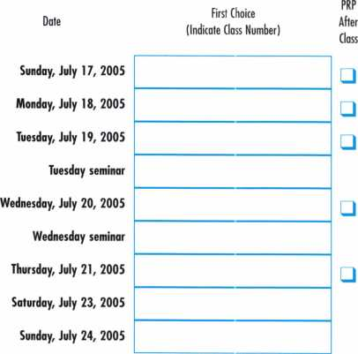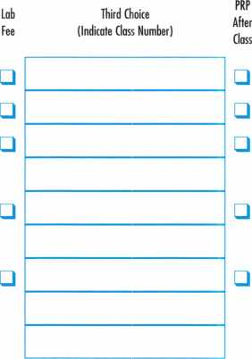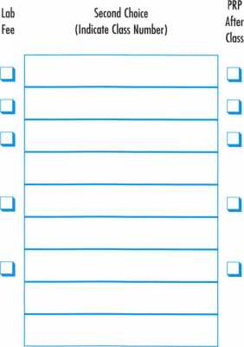

Students may elect to take the exam for the PRP elective designated at the end of the class for an additional fee. PRP Certified  
class exams will take place immediately following the end of class from 5-5:30 pm with 20-30 minutes of actual exam time  
allowed. The single elective exam option is available to pre-registered ALOA members only.

Proficiency Registration Pro**gra**m

**SUBMIT THIS FORM WITH REGISTRATION FORM 1**

Proof of the PRP certification assures your customer that he/she is dealing with a professional that has the  
education and technical competence to provide safe and efficient service. The PRP separates you from those  
who claim to be professionals but do not have your knowledge or training.

If you plan to participate in the PRP, include the proper PRP fee on the convention registration form, com-  
plete the PRP registration form.

Note: The PRP Resource Guide and the Safe Technician's Reference Manual can be ordered on page 20.

CANDIDATE (please type or print):

|  |  |  |  |
| --- | --- | --- | --- |
| Last Name: | First Name: |  | Ml: |
| Address: | | | |
| City: | State: | Zip Code: |  |
| Work Phone: | Home Phone: |  |  |
| Social Security Number: | | | |

Have you ever taken the PRP/STPRP before? □ Yes □ No

MEMBERSHIP STATUS:

Application will not be accepted at the member rate without valid current membership number.

* ALOA Member Number
* SAVTA Member Number
* Non-member

EVALUATION ALOA 2005 CONVENTION

Level Testing For:

* CRL □ CPL □ CML □ CPS □ CMST

In the listings at right, place a check mark to the left of your choices. Below are descriptions of  
each level and its requirements.

CRL Level: L 00 + two (2) Electives. Choose the Mandatory and two (2) Electives.

CPL Level: CRL + twelve (1 2) Electives. If you pass the CRL in one try choose any twelve (12)  
Electives. Otherwise, choose any nine (9) Electives. Do not choose any Electives you have pre-  
viously passed.

CML Level: CPL + nine (9) Electives. Choose any nine (9) Electives. Do not choose any  
Electives passed previously for CRL or CPL.

Re-Take CRL Level: If you did not pass the Mandatory, you must choose the Mandatory.  
You may also take one (1) or two (2) Electives if you did not pass one (1) or two (2) Electives,  
but you may not take extras.

Re-Take Other Level: If you passed the Mandatory, choose any nine (9) Electives.

CPS Level (S-00): Because of the time required this cannot be taken with any other selec-  
tion.

CMST Level (S-01): The first level (S-00) of the STPRP (CPS) must be passed before taking  
the second level (S-01) of the STPRP.

**IMPORTANT: PHOTO ID REQUIRED  
FOR ADMITTANCE TO EXAM ROOM.**



**Friday, July 22, 2005 • 5:30-10pm**

|  |
| --- |
| Note: Application will be returned if choices are not indicated. |
| Select/CAT#/Elective Name  □ L-00: Mandatory Categories |
| □ L-03: Domestic Auto |
| □ L-04: Foreign Auto |
| □ L-05: Door Closers |
| □ L-07: Life Safety Codes |
| □ L-08: Cylinder Servicing, High Security |
| □ L-l 1: Cylinder Servicing,Special Application |
| □ L-l 2: Cylinder Servicing, Tubular Key |
| □ L-l3: Basic Electricity |
| □ L-l 6: Exit Hardware & Alarms |
| □ L-20: Locks, Keyless Mechanical |
| □ L-21: Locks, Lever Other Than Safe Deposit |
| □ L-22: Locks, Motorcycle |
| □ L-24: Locks, Safe Combination Type |
| □ L-25: Locks, Safe Deposit |
| □ L-26: Locks, Time |
| □ L-28: Lockset, Installation |
| □ L-31: Master Keying, Advanced |
| O L-32: Safe Installation |
| □ L-33: Safe Opening and Servicing |
| □ L-34: Vault Installation and Service |
| □ L-38: Interchangeable Core, Small Format |
| □ L-39: Interchangeable Core, Large Format |
| □ L-40: Electro-mechanical Access Control |
| □ L-41: Hardware, Door-Related |
| O L-42: Alarms |
| □ L-43: Locks, Detention |
| □ S-00: CPS |
| □ S-01: CMST |

**WARNING:**

**This PRP Registration must be received at ALOA no later than June 21, 2005.**

Hyatt Hotel Reservation Form

**Mail this FORM with your CHECK or credit card number to:**

**Hyatt Regency O'Hare • 9300 W. Byrn Mawr Avenue • Rosemont, Illinois 60018**

GUEST (please type or print):

Last Name:

Address:

City:

Phone:

E-mail address:

HOTEL INFORMATION

Name of Persons sharing accommodations:

First Name:

Ml:

State: Zip Code:

Fax:

**DAILY RATES**

$135 Single/Double, + 12.5% occupancy tax

Arrival Date Departure Date # of nights: Room Type:

1 st available/No preference Q Non-smoking room Q Smoking Accessible Room

PAYMENT METHOD

* Check Number

I authorize the Hyatt Regency O'Hare to charge my account for one night's deposit and all applicable taxes.

* Charge: □ ZZ □ 13 □ ^

Card Account Number:

Card Expiration Date:

Print Name:

Signature:

CUT OFF DATE: JUNE 24, 2005

Reservations requested after the cut off date and/or after the  
room block is filled are subject to availability and may not be  
available at the group rate.

**ALOA 2005**

**Annual Security Expo  
and Convention  
Rosemont, Illinois  
July 17-24, 2005**

**To make reservations,**

we request that you either:

Send a check or money order covering  
the first nights stay to 9300 W. Byrn Mawr Avenue  
• Rosemont, Illinois 60018 to be received no later  
than thirty (30) days prior to arrival.

**OR**

Reserve hotel room using a major credit card.  
The credit card is charged at the time of booking.  
Credit card guarantees and deposits will be  
refunded only if cancelled (7) days or more  
prior to arrival.

**ROOM RATES/TAXES**

In order to take advantage of the special  
ALOA 2005 Convention rates, be sure to  
book your reservation by June 24, 2005.

After that date, the official ALOA 2005 blocks  
will be released

and the hotels may charge significantly higher rates.  
All rates are per room night and are subject to a  
1 2.5% tax (subject to change). The rates at the  
Hyatt are for Single/Double occupancy.

The hotel may charge for additional occupants.

**DEPOSITS**

The Hyatt hotel requires a credit card guarantee or  
check deposit for one nights room and tax with  
each reservation request. Requests received without  
a credit card guarantee or check deposit will be  
returned. Please fill out the credit card information  
entirely or mail a check payable to the Hyatt  
Regency O'Hare 9300 West Byrn Mawr Avenue,  
Rosemont, Illinois 60018.

**DO NOT SEND THIS  
FORM TO ALOA.**

PLEASE USE ONE FORM PER ROOM.

MAKE COPIES AS NEEDED.

FORMS MUST BE COMPLETELY FILLED OUT.

**FOR HOTEL USE ONLY**

Please Fax Confirmation Number back to Guest.

*Confirmation Number*

Just  
a Few

of Our Titles...

Learn About Basic Electricity 29.95

Spacing and Depths, vol 1 19.95

Spacing and Depths, vol 2 19.95

Filing for Dollars 29.95

Antique Padlocks 29.95

VATS Made Simple (Revised) 29.95

Guide to Transponders 79.00

2000 Transponder Update 45.00

Bread & Butter 85.00

Locks and Lockmakers of America 19.95

Learn About Electronic Locking Devices 29.95

The Best of Locksmithing, vol 1 19.95

Logical Lock Diagnostics 29.99

How to Pick Lever Locks 19.95

Fundamentals of Master Keying 55.00

Guide to Electronic Locksmithing 39.95

Security Solutions Locksmith Marketing Program 89.95

The Ultimate Techtips Collection 39.95

PRP Resource Guide 25.00

Locksmithing from Apprentice

to Master 27.00

Wafer Lock Reading 19.95

Door Lock Encyclopedia 39.95

Lock Repair Manual 14.95

Interchangeable Core Cylinders 34.95

Picking & Impressioning 45.00

The Lure of the Lock 29.95

High Security Safes, vol 1 175.00

High Security Safes, vol 2 175.00

Safeman's Guide, vol 13 9.95

Safe Deposit Depth and Space Manual 99.00

Safe Technician's Reference Manual 155.00

Gun Safes 1 10.00

Modern Safe Opening 59.95

Dave McOmie on Vault Doors, vol 1, Bank Vaults 1 10.00

Dave McOmie on Vault Doors, vol 2, Fire and Plate Vaults 1 10.00

Modern Safe Locks 95.00

Drilling Safes 95.00

Safe Deposit Box Service 39.95

Foreign Car Impressioning Book 29.95

Impressioning Ford and GM Side Bar Locks 29.95

Automotive Lock Servicing Update #1: GM 10-Cut Locks 29.95

Automotive Lock Servicing Update #2: GM 10-Cut Locks 29.95

**The ALOA Bookstore will be ready to serve you on the 2005 convention show floor.  
Don't miss your chance to pick up some great books at a great price.**



Travel Fast & Easy  
with Avis.

Avis takes care of you for business or pleasure.  
Our special meeting rates and discounts makes  
it easy for you to incorporate leisure fun into  
your plans.

Your special low Avis rates are good from one week before to one  
week after your meeting so you can take in the sights and explore.  
"We try harder" to help you enjoy your meeting with great rates and  
time saving services.

Call 1-800-331-1600 and reserve your Avis car for this meeting.

Be sure to mention this special meeting Avis Worldwide Discount  
(AWD) number: B466699

Associated Locksmiths of America  
Convention and Security Expo  
July 17-24, 2005  
AWD# B466699

AV'S

NVetry

barder-

Avis features GM cars.

©2000 Avis Rent A Car System, Inc

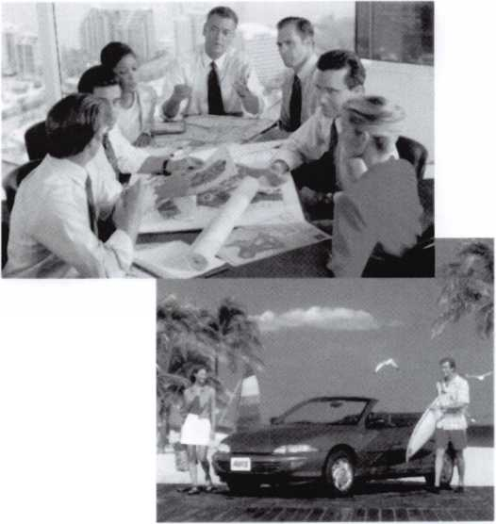

MtfVmtKSHIP APPLICATION

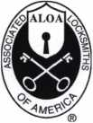

Welcome to the Associated Locksmiths of America, Inc., an association for persons involved in the security industry as locksmiths, security consultants, educators, manufacturers and distributors.

To apply for membership, please complete this application and submit it with the dues for the current year, and your business card, company letterhead, or other suitable proof of employment.

All of the following questions MUST be answered before this application may be processed. Please type or print.

TYPE OF MEMBERSHIP

Please check only one.

* ACTIVE MEMBERSHIP Individuals actively engaged in supplying, servicing, or installing security hardware for a period of not less than two years.
* APPRENTICE MEMBERSHIP Individuals who are in initial train­ing and meet all the requirements for Active Membership except for the length of time in the security industry.
* ALLIED MEMBERSHIP Individuals whose position in the security industry relates to the aims, policies and promotion of the locksmith and his/her craft.

APPLICATION AND FEES

A $50 application fee, appropriate annual dues, and your business card, company letterhead, or suit­able proof of employment must accompany this application. Your second year's dues will be prorated based on the date your application was received by ALOA.

FINAL CHECKLIST

Dollars

* Application Fee WAIVED ANNUAL DUES STRUCTURE
* Active/Allied Member 155.00 U.S. + U.S. Territories

(PR, VI, Guam)

(DUES: 130.00 +

LEGISLATIVE ASSESSMENT FEE:25.00)

* Active/Allied Member 1 30.00 Non U.S. Resident or

Non U.S. Territories

* Apprentice Member 80.00

U.S. and International

OTHER FEES

* Canadian Air Mail 20.00
* Overseas Air Mail 50.00

Total Enclosed

**Return to**

**ALOA**

**3003 Live Oak Street  
Dallas, TX 75204-6185  
FAX: (214)827-1810**

CANDIDATE (PLEASE TYPE OR PRINT)

|  |  |  |  |
| --- | --- | --- | --- |
| Name □ Mr. □ Mrs. □ AAs. | | | |
| Business Name | | | |
| Mailing Address | | | |
| City | State | Zip Code | Country |
| Work Phone | Home Phone |  | Fax |
| Email Address | Website |  |  |
| Date of Birth | Social Security Number |  |  |
| Directory Address (if different than mailing address) | | | |
| City | State | Zip Code | Country |

□ Do Not List in Directory

PROFESSIONAL INFORMATION

1. Are you a...

* Sole Owner □ Corporate Officer
* Partner □ Employee O Student

1. Are you currently employed in the security industry?

O no O yes, years

1. How did you learn locksmithing or security work?

4. ALOA Sponsor (not required)

Sponsor's ALOA Number

Please note, your application will be processed with a 90- day probation period.

5. Names and Phone #'s of two industry-relat­ed references (required):

*Name*

*Phone* #

*Name* Phone #

6. IMPORTANT: Have you ever been convicted of a crime? □ No □ Yes

If yes, please give details on a separate sheet. All crimes are reported to the Membership Department for review.

METHOD OF PAYMENT

□ Check □ MasterCard □ Visa □ Discover □ American Express

|  |  |
| --- | --- |
| Card Number | Expiration Date |
| Please print name as it appears on card |  |

Cardholder's Signature

I understand and consent that in the course of reviewing this application ALOA may review publicly available information for the purpose of verifying the information submitted and do a background check.

I certify that all statements are true and, if accepted as a member, I agree to abide by the rules, regulations, and Bylaws of ALOA, and further agree to adopt the Code of Ethics of ALOA as my own, and adhere to it to the best of my ability. Should my membership be discontinued, I agree to return my mem­bership card, and cease use of all ALOA insignia.

Signature

Date

Revised 12/04

**Sweet T)ome Chicago Gangster Right**



A delightful evening has been planned for this year's ALOA Banquet. Plan on  
being a part of this blast from the past with music and dancing featuring the  
Jim Mahannah Band. This will be a truly memorable dining and entertain-  
ment experience that will take you back to Chicago in the Roaring 20s.  
You will remember this evening for years to come. The Dinner Banquet will be

held in the Grand Ballroom of the Hyatt Regency O'Hare.

Attire- Business Casual or come dressed as your favorite Mob Boss or Flapper girl.  
Seating is limited, so purchase your tickets early to ensure your space.

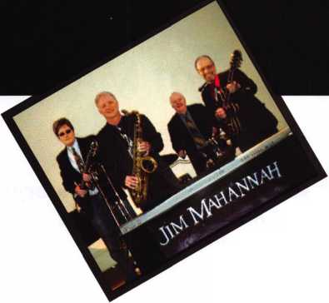

**Las Vegas,2006**

The **POWER** of MANY

Celebrating 50 years of the ALOA  
Convention and Security Expo  
**Mark your calendars now for the half-century celebration!**

July 9-16, 2006 • Las Vegas, Nevada

Security Expo July 13-15

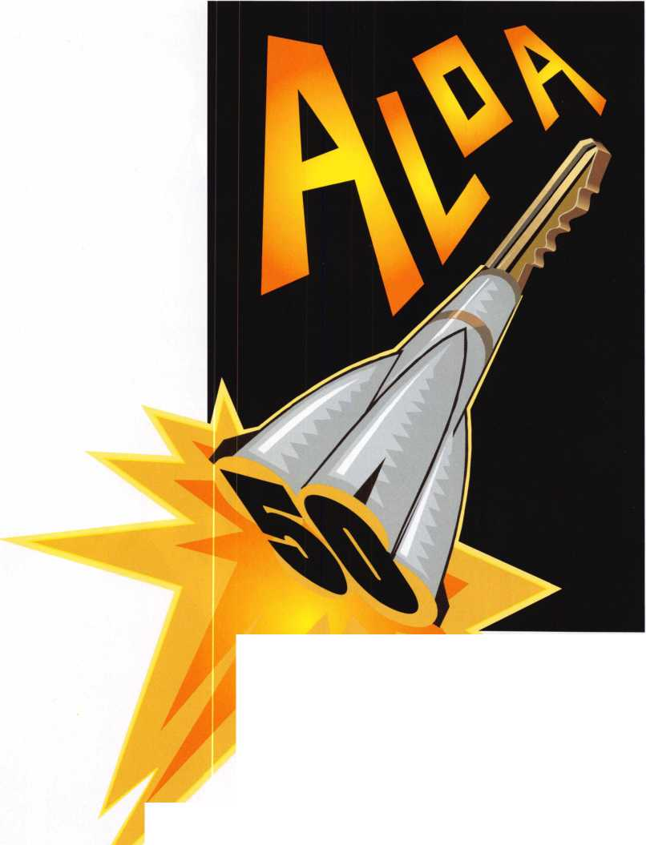

**Claim Vour Ticket Now!**

**Your indiuidual success as a locksmith is uihat the annual RLOH conuention is all about.**

**Make a secure inuestment in your future!**

**Request your complete registration packet today and take aduantage of the best selection of classes and trauel accommodation ualues.**

**Classes for RLOR 2005:**

TRADITIONAL LOCKSMITHING CLASSES:

Fundamentals of Locksmithing (5 days)

Basic SFIC, Corbin Russwin, Schlage and Yale 1C hands on

Master Keying Methods & Formats (2 days) Advanced Topics in Master keying Exit devices & Exit Alarms Servicing Aluminum Storefront Doors Complete Door and Door Closers Hollow Metal Door & Frame Servicing Medeco Biaxial Factory Certification Investigative Locksmithing (3 days)

Forensic Locksmithing Life Safety Codes and ADA Detex Advantex

Studying for and Passing the PRP Professional Bypass Techniques Mechanical Push Button Lock Manipulation Comprehensive Interchangeable Core (2 days) Simplex Unican Certification Servicing Schlage Commercial Products American Padlock Certification Master Pro Series Certification Mul-T-Lock

Medeco Keymark Certification Medeco New Product Update Primus/Everest Certification Rekey Project Management ABUS Padlock Certification ASSA High Security Locks Product ABLOY PROTEC High Security Locks

Electrified Closers and Door Controls

HPC Codes & Code Machine Concepts

Key Systems & Automated Key Production

Yale Cylinders & Master-keying Certification

Fire Door Hardware

Van Lock/VanTech 21

PDQ Revolution Mortise Lock Program

SAFE & VAULT LOCKSMITHING CLASSES:

Basic Safe Penetration Kaba Mas Series Locks

Kaba Mas-FF-L-2740A Approved Lock Certification Safe Combination Lock Servicing & Troubleshooting Combination Lock Manipulation (2 days)

S&G Group 2/2m Certification

S&G Electronic Lock Certification

LaGard Electronic Lock Certification (2 days)

AUTOMOTIVE LOCKSMITHING CLASSES:

GM Steering Column Service/Repair (2 days)

Basic Automotive Lock Service Intermediate Automotive Lock Service Advanced Automotive Lock Service Motorcycle Locksmithing 21 st Century Car Opening Transponders 2002 Automotive Key Generation STRATTEC 2003 13 Methods of Car Opening 2002-2003 Kaba llco Automotive Update Transponders 2002/2003 Automotive Picking Techniques

Auto Opening Techniques 2002

ELECTRONIC LOCKSMITHING CLASSES:

Electronic Safe Lock Servicing

Alarm Design and Development (2 days)

Comprehensive Access Control [2 days)

Basic Electricity Introduction to Access Control Basic Electricity

Electronic Access Control Entry Level Installer (2 days)

AMSEC Electronic Access Control Certification

Folger Adam Electric Door Controls

l-Que Elec. Access Control Certification

Introduction to Access Control with Cyberlock

Videx Cyberlock Advanced Training

Proximity Access Control by SecuraKey

Alarm Lock Trilogy Certification

Complete Guide to Electric Strikes

Millenium Entry Systems

The SafeWizard™ Access Control System

LOCKSMITH BUSINESS CLASSES:

What is my time worth? OR How much should I charge? Financial Management for Locksmiths (2 days)

Business Planning Advanced Shop Management Increase Your Revenues by 25% This Year Making $ Selling Cash/Handling Safes Instructor Training (3 days)

Improving Security in Your Business Community Replacing Lost Keyless Entry Remotes-An Untapped Market for Automotive Locksmiths

**For more information, contact the Associated Locksmiths of America by using  
this form, fan, email or check out our uiebsite at mujiu.aloa.org.**

□ Register me for Exhibits Only (members: FREE when received before 6/21/05, nonmembers: $10) O Send me more information

Name

Company

I

^ Address I City ^ Telephone

State

Zip

\

I

l

l

Fax

Email



**HL0H 2005**

Sweet Home Chicago

Mail, Fax, or Email the above information to: Associated Locksmiths of America • 3500 Easy Street

Dallas, Texas 75247 • Fax: 214-827-1810 • Email: [convention@aloa.org](mailto:convention@aloa.org) • Phone: 214-827-1701 or 1-800-532-2562



Associated Locksmiths of America, Inc.  
ALOA 2005

International Convention  
and Security Expo

3500 Easy Street  
Dallas, Texas 75247  
(800) 532-2562 phone  
(214) 827-1810 fax

[www.aloa.org/convention](http://www.aloa.org/convention)

**SPONSORS:**

AMSEC

ASSA High Security Locks  
ClearStar Security Network  
Corporate Safe Specialists  
IR Security & Safety  
KABA, KABA ILCO, KABA MAS  
Lucky Line Products  
Medeco

STRATTEC, INC.

Videx

YSG Door Security Consultants

PRSRT. STD.

US POSTAGE  
PAID

DALLAS, TX  
PERMIT NO. 7274

GKL Products

Buy it once & use it... again & again...

*Repair Sagging Doors in Seconds!*

Fixes Bent & Worn Hinges Instantly!

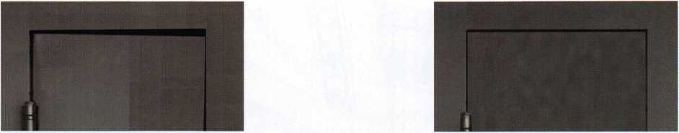

Note Door Hitting Frame

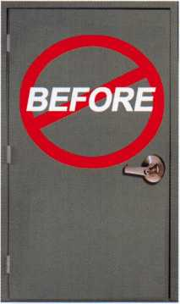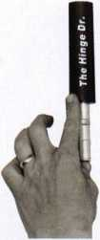

From this to this

Door is Fixed!!

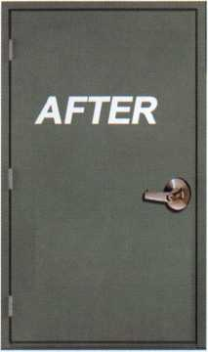

fnseconds.

[www.hingedoctor.com](http://www.hingedoctor.com)

*No more backaches*

P* *from pulling & rehanging doors!*

*The Hinge Lkis Here!!!*

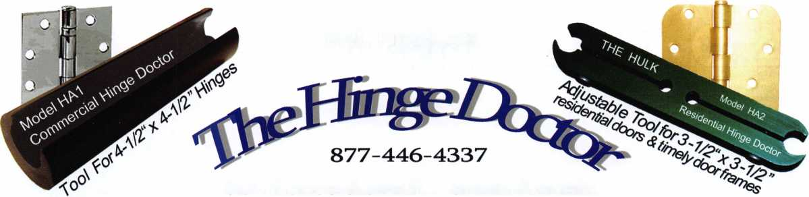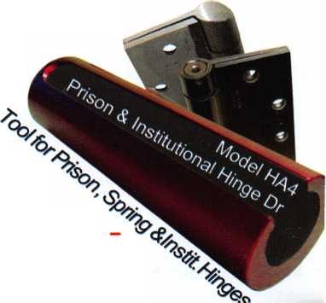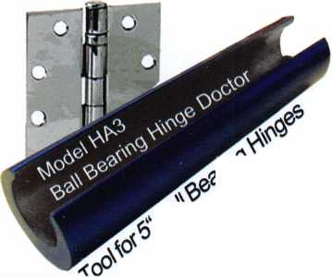

Save Time, Make Money

By: Jon B. Griswold, CML



24

Keynotes • June 2005

Have you ever looked for something and couldn’t find it...gone to the place where you thought it should be and it wasn’t there? We have so much on our minds each day that we can’t seem to remember anything. Ask us the pin size for a Schlage #1 cut or the number of change keys in a 5-pin master key system and we can recite either request without missing a beat. Simple repetition, doing the same thing over and over again; why can’t the same apply for those missing items? Looking for misplaced items wastes time and costs money. Why not minimize the lost time and put that money back in our pockets?

The #1 reason for lost time is communication. For exam­ple, when a customer calls, do you get full and complete information, including a phone number? If they ask for a rekey, do you find out the quantity of locks as well as the type? How about the keyway—are they operating properly? Was it confirmed that they are in the location that needs work? Taking a service request is the single most important part of the job. I have worked for locksmiths that have used scraps of paper for notes. On more than one occasion I have gone to the wrong town because all I had to direct me was a street address. A mini­mum of 5 minutes needs to be spent asking ques­tions, gathering information, and most of all, writing it down. If there isn’t an outline of ques­tions to be asked, consider the benefits of having one on file. It may be the biggest time saver and stress reducer a company could have.

What about the inventory on the service truck? Is there an accurate quantity count? Are there sup­plies that need to be replenished? Knowing what is on the truck minimizes trips back to the shop or distributor, and eliminates rescheduling appointments while waiting for a part order to arrive. An inventory checklist for every service vehicle will help determine if a technician in the field can be dispatched to the location. If materials are needed, does it make more sense to restock a vehicle at the shop then dispatch it to the loca­tion? A significant savings in fuel costs and over­time can be achieved by eliminating extra trips between a jobsite and the shop.

In addition to a supply inventory, a tool inventory is a must for every service truck. Ideally, every truck should have the same stock of tools. Realistically, the tool stock is reflective of the technician who drives that vehicle, depend­ing on their specialty. Knowing what the inventory is on each truck makes it easier and more efficient to schedule a job. Service, installation, and repair tools for the common types of locks, as well as drill bits, holes saws, and screw­drivers should be the basic foundation for every possible situation. The time that is saved by having the inventory needed at hand far outweighs the extra money spent on supplying extra tools.

What about the technicians? They should be provided with everything they need for the task to make their workday easier. Most technicians think this means tools such as drills, screwdrivers, and templates. While this is true, that is only a part of the bigger picture. Training is beneficial to our profession on many different levels. Every shop should have a program that starts with the initial service call and

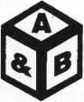

SAFE CORPORATION

Viking Stainless

Fire & Burglary Protection  
State of the Art Composite Fill

Strong • Functional • Attractive

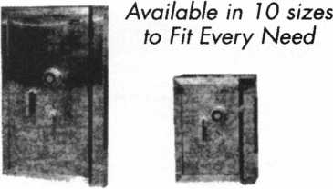

See us at [www.a-bsafecorp.com](http://www.a-bsafecorp.com)

1*-*800*-*253-1267

Fax 856-863-1208

CALL FOR YOUR CATALOG TODAY

Keynotes • June 2005

service.

UJLDL2J

LUL2JUU

UJUDQD

C*X°)(J5L>

C_i

Need

Use ALOA s Fax On

Just call 310-575-5074 and

1. ALOA Index of Documents
2. Becoming a Locksmith (Ipg)
3. Locksmith Career Summary (3pg) Locksmith School List (2pg)

5. ACE Class Schedule (8pg)

3. Certification lnformation(3pg)

7. PRP Category List (Ipg)

3. ALOA Membership Application(2pg)

1. ALOA List of Benefits (Ipg)
2. Scholarship Application Form (Ipg)
3. ALOA Video Library Order Form (1 pg)
4. ALOA Membership Items Order Form (Ipg)
5. Safe & Vault Technicians Association Member Application/Subscription Form (2pg)
6. ALOA Chapter Roster (3pg)
7. Legislative Action Network (2pg)
8. Legislative Action Network Newsletters (Ipg)
9. Various State Laws (lOpg)
10. Industry Position Pager (Ipg)
11. Current Legislative Action Network Newsletters (Ipg)
12. Board of Directors Nomination Form (2pg)
13. ALOA Convention Registration
14. ALOA Board Expense Reimbursement & Request Form

310**-**575-5074

ends with a completed job ticket. For example, the techni­cian should be provided with a dispatch ticket that has accurate information on it, such as phone numbers and complete addresses. There should also be a stock of invoices and price lists of products and services available as well. All invoices should be completed onsite for accuracy for servic­es rendered. In addition, each technician should be provid­ed with a list of contact information for technical help out in the field. In the end, all completed invoices should look the same. This will also be helpful in eliminating downtime by making trips back to the shop to make a call or search for a phone number.

These are just a few of the things I have learned in the field that has saved me time and money. Being prepared both in the shop and out on a service call is invaluable. For exam­ple, when rekeying knobsets such as the Schlage F series, I always turn the key toward the latch when removing the knob. When the knob is reinstalled, I don’t have the possi­bility of taking it off a second time because I installed it incorrectly the first time. Or, when rekeying a set of store­front doors, I lay out the faceplate and collars so I know what goes where on which side of the door. I also mark each cylinder to differentiate the outside from the inside. Whenever possible, I always leave the parts I remove from the door or lock together on the hinge side of the door so I am not looking for stray parts. And as always, I make sure my tools are on the side of the door I’m working on, because a long time ago I let a door close behind me and was locked inside with no way out. These experiences helped me to develop a way to perform a particular job and execute it the same way every time and it has been stress reducing and time saving.

Many of us are small shop owners with 1 or 2 service trucks and operate with limited cash flow. We wear multiple hats and it’s no wonder we can’t remember everything that goes on in a given day. We need those constant reminders and a good support team to help run the business. We need accu­rate record keeping from everyone, not just the accounting department. It can be the difference between scraping by and being profitable. Get organized and make more money. And the time saved can be spent recreationally, not making another run to the shop.

2

mMM Keynotes • June 2005

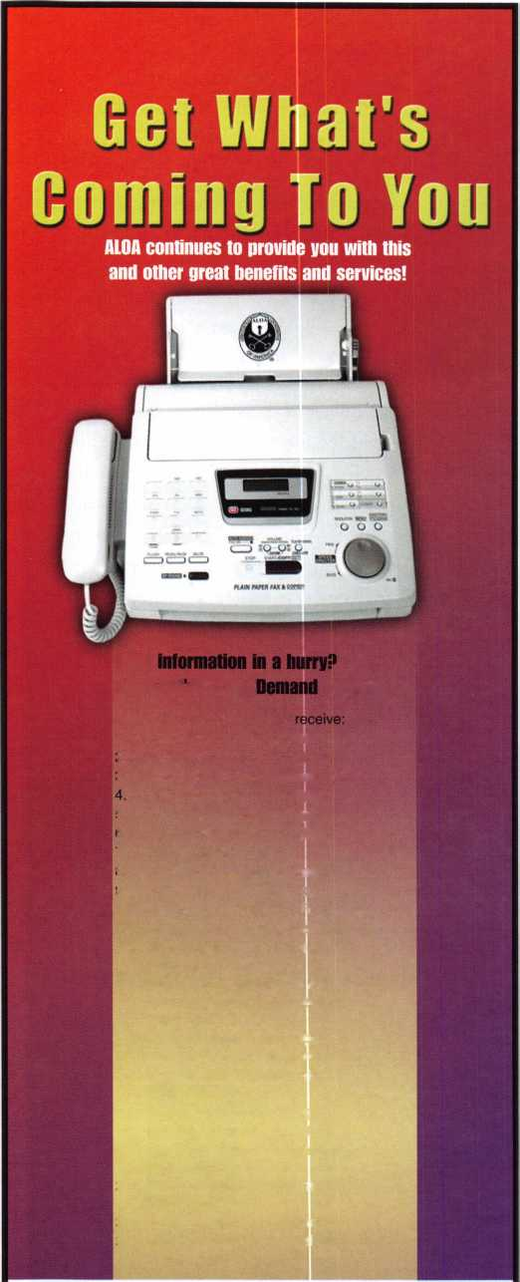

IN THE WAR ON CRIME, YOU DON'T NEED A PADLOC YOU NEED AN ARSENAL.

You’re constantly fighting crime on many fronts. That’s why we manufacture a complete line of commercial padlocks, each one tough enough to be called a Master Lock. It’s the name trusted the world over for quality padlock security. Whether you’re battling theft, unauthorized entry or the elements, we can arm you with a solid solution for any industrial application, even safety lockout. So make our commercial line your IE11P ^ mta first line of defense. For more information, contact your local

distributor, or call 1-800-308-9244.

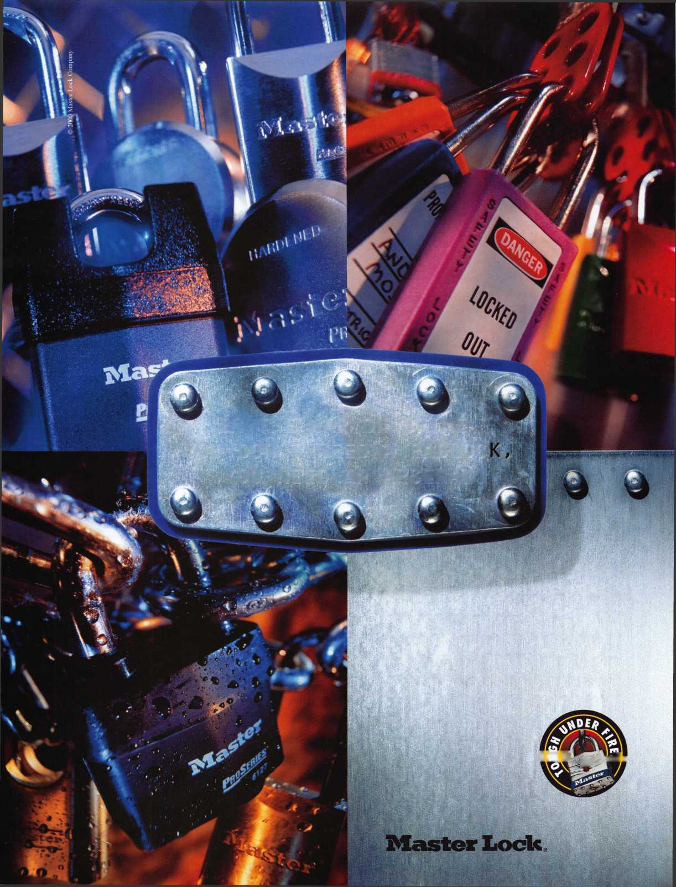

Review:

New Safe Locks

By: Greg Perry, CML, CPS

A couple of new safe locks have hit the market in the last  
few years. The newest is the LaGard 3370 lock. Corporate  
Safe Specialists is now importing a lock manufactured by  
Rench. Both locks are designed and marketed to the low  
end of the cost spectrum. Safe manufacturers are always  
looking for ways to trim costs and these locks fill the desire  
for inexpensive harware. It is this author’s opinion that  
both locks should be considered “throw-away” locks. If they  
need service or have a problem, the cost in time to service  
them is greater than the cost of the lock. The locks cost us  
around $25.00 and retail for $40.00 to $50.00. Most of us  
charge at least that amount to service a safe lock. (Some  
charge more.) If you find one of these locks needing serv-  
ice, replace it with the same lock or install a better quality  
lock so it can be serviced in the future.

Looking at the 3370 LaGard lock reveals a new design for  
LaGard. First, they designed it to be installed quickly, with-  
out removing the back cover. The mounting screws go  
through the back cover and lock case, similar to their elec-  
tronic locks. The spline key is installed into the drive cam  
through the back cover and a round black plastic disc cov-

ers it. The lock is actually  
sealed with the warantee

label over the top of the single screw that holds the cover in place. This can be seen in photo 1, peeking out just above the bar code on the label. Let’s remove the label and screw for a look inside in photo 2. The first thing to notice is the addition to the lever/fence assembly. It’s the black-plastic arm over the top of the wheel pack that interacts with the tab on the drive cam to make this lock manipulation resist­ant. The next thing to notice is the different bolt detent. It is the plastic-chisel-pointed piece that goes into the side of the bolt. It can be seen in photos 3 and 4. Also seen in photos 3 and 4 is the new-style relock spring. Previous LaGard locks have a triangular-shaped spring that blocks the bolt on the front side of the lock or closest to the face of the door. This new style blocks the bolt on the backside. It is also in a slightly different location. If you need to drill for this relock I might suggest 1 15/16” towards the bolt and 1/2” CCW or down on a RH mounted lock. The next difference is the lack of a retainer to keep the wheel pack together. The wheels and flies seen in photo 5 are the same as other current LaGard mechanical locks. Looking at pho­tos 5, 6, and 7 show the new style lock case. It is a com­pletely different design. The case looks different, it’s not a solid case the way we are used to seeing safe locks. It was redesigned with uniform thickness, cost and casting in

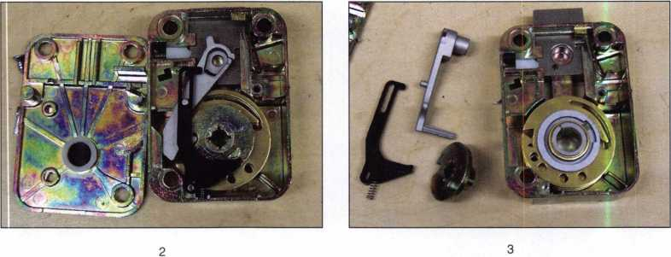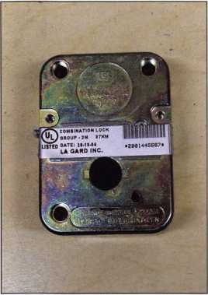

Keynotes • June 2005

**REACHING** NEW **HEIGHTS**

Albuquerque, New Mexico

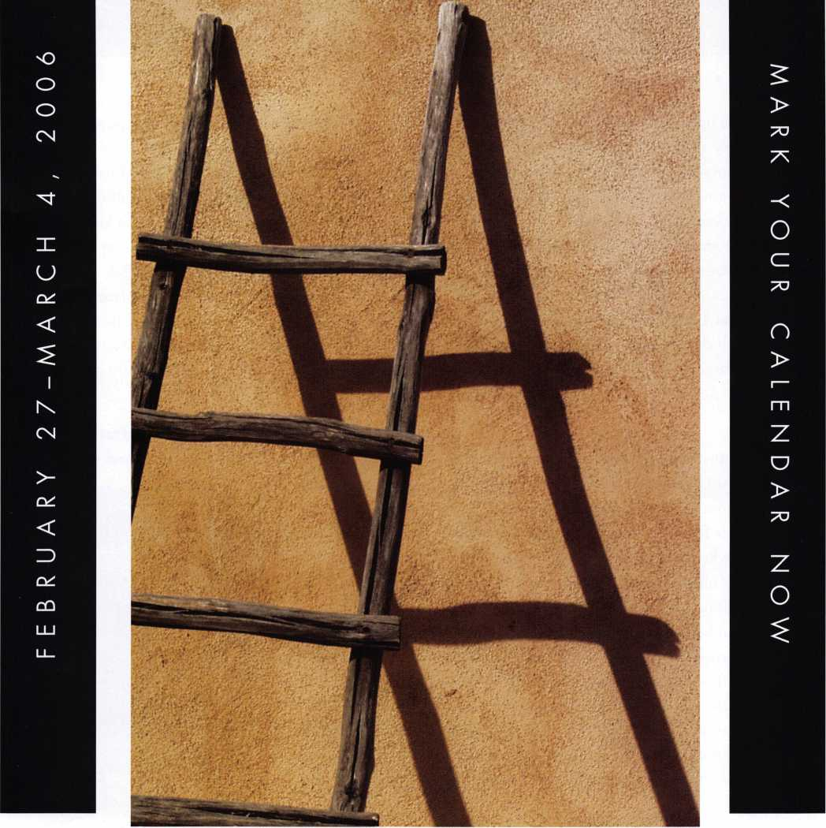

When it comes to learning about the latest in safes and vaults, time is of the essence. SAFETECH 2006 features an all-new menu of classes, covering every safe topic on the globe. Don't miss out!

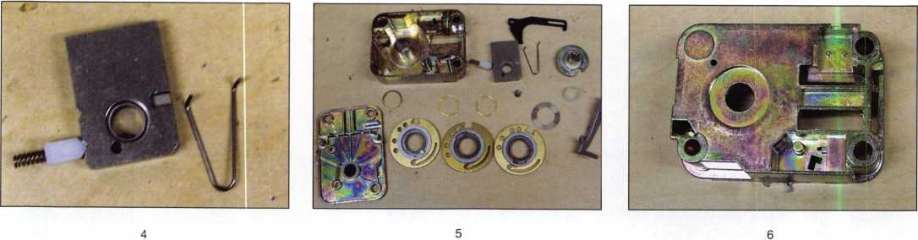

mind. Some of the open areas we can utilize for opening when drilling. They are located on either side of the bolt 1 1/16” to 1 1/8” towards the bolt and 5/16” up or down. The holes give us a nice view of the number 2 and 3 wheels with a 90-degree scope. The number 1 wheel is hid­den by the casting and would require an oblique (or back­ward) view from your scope. A different, perhaps more useful hole in the case is located 7/8” away from the bolt 1/2” CCW or 1” at 17 on a RH-mounted lock. From these holes you can then transfer to drop in. If you want to drill at drop in, the standard 7/8” at 97 for right-hand lock this works, but its nice to have the option of using other drill points.

The Rench Lock (imported by Corporate Safe Specialists) seen in photos 8 to 10 looks like another knock off of the Sargent and Greenleaf 6740 with a few differences. The drive cam and lever/fence assembly are made of die cast or “pot” metal. The wheels and flies are different. The flies have two tabs; one tab on top and a second on the bottom. The tab on the bottom of the fly travels in a cutout in the wheel hub that can be seen in photo 10. In this photo, the fly is standing on edge over the top of a wheel. The wheel without the fly is fly-side up. The second wheel with the fly is bottom or drive-pin side up. Another difference is the relock. This lock uses a sideways pivot to block the bolt if the back cover is knocked off. The interesting thing is the cover screws are on the wrong side of the pivot. Generally,

the cover breaks at the screws if someone punches the spin-  
dle into the lock. Unless the cover is knocked off com-  
pletely the relock will not block the bolt. I haven’t tried it,  
but maybe the cover screws will strip out of the case before  
the cover breaks. The relock on this lock is located 1 3/8”  
towards the bolt and 1/2” CCW or down on an RH-  
mounted lock. This lock will drill nicely 7/8”. At 97 how-  
ever, there is a part of the casting in the place most safe-  
crackers drill to scope and view the wheel pack 1” at 91. If  
you need or prefer to drill a scope hole, use 1” to 1 1 /8”  
anywhere around 65. Then, transfer back to drop in, since  
the fence can not be seen from here.

These locks will end up on a lot of safes. Having a little  
knowledge about them before you find them in the field

can save you time  
and should pre-  
pare you to be  
ready with a  
replacement. They  
have the same  
footprint as most  
Group 1 or Group

1. type locks.

Remember, the  
factory designed  
these locks to be  
replaced.

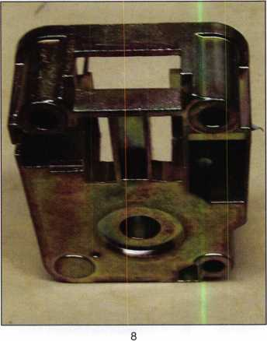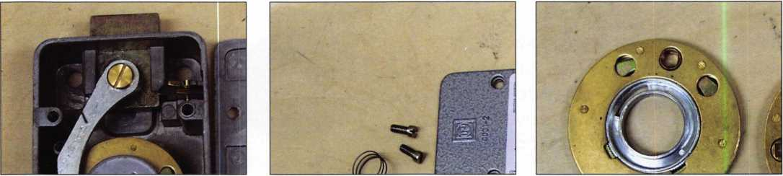

8

9

10

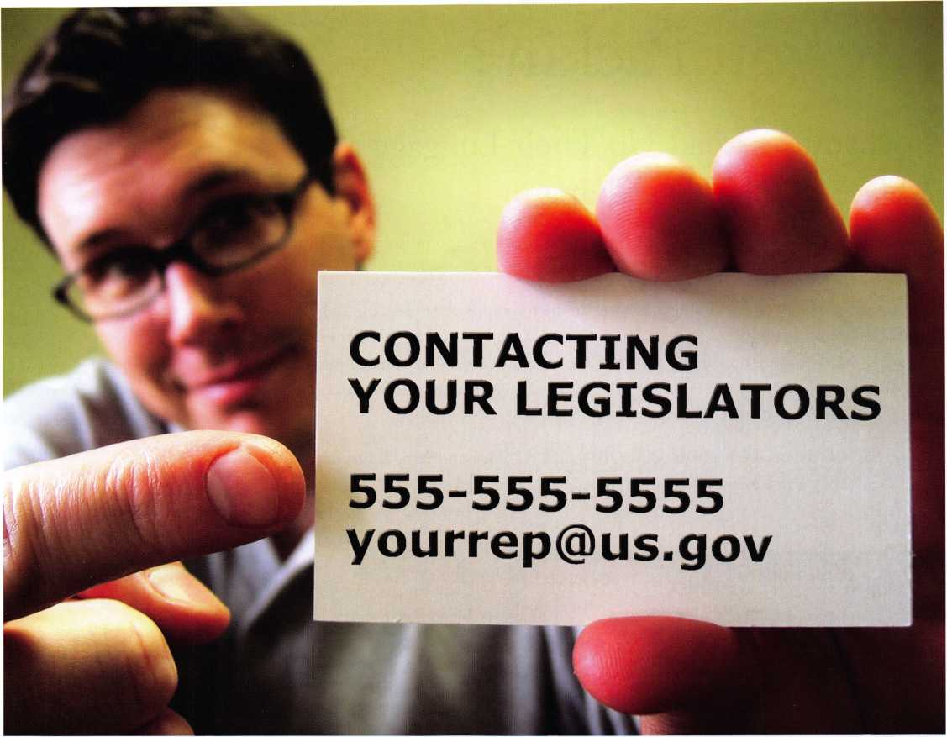

Your ALOA Board of Directors has concluded that the most important activity of the association is legislation. The policy states, "A membership that is informed and consulted about legislative activity that may affect it". To keep you informed and make it easier for you to be involved in legislative activities, we have sent you a special legislative card. This card has the telephone numbers of your elected representatives at the state and federal level. The card was created using your business address. In some cases, your "voting" address may be in a different district making the information on the card incorrect. In the event that it may be necessary for the membership to contact lawmakers, this card will help. You may, of course, find this contact information useful for other purposes not related to the ALOA legislative work.

**ALOA Legislative Affairs - Working for You!**

Are you Packin’?

Locksmiths Load Up Their Luggage as ALOA 2005 Takes Shape

Pack your bags for the 2005 ALOA Convention and Security Expo in Rosemont, Illinois—

a big little city located just a train-ride away from downtown Chicago.

Chicago offers plenty of fine dining and entertainment options. Attendees can shop at  
the world-famous Magnificent Mile. Eat at Morton’s of Chicago or Harry Carry’s  
Legendary Steakhouse. Another big draw to Chicago is a visit the Navy Pier or catch-  
ing ball game. The options are endless at ALOA 2005, the single-most important event  
in the locksmithing industry.

World-class instructors are ready to deliver top-notch ALOA Continuing Education  
(ACE) classes on a vast menu of security topics. Plus, a stroll through ALOA’s Security

Expo will give attendees a veritable who’s who in the

**New!** Keedex Stainless Steel Armored Door Loops

AVAILABLE FROM YOUR KEEDEX DISTRIBUTOR

MADE IN U.S.A.



"Ideas That Work"

ALL

STAINLESS STEEL  
DESIGN

FLEXIBLE STAINLESS

STEEL CONDUIT

STAINLESS STEEL  
END PIECES

STAINLESS STEEL  
MOUNTING SCREWS

COSTS NO MORE  
THAN MOST DOOR  
LOOPS THAT HAVE  
PLASTIC END PIECES

Call or write today  
for yourfree catalog!

Keedex, Inc.

12931 Shackelford Lane  
Garden Grove, CA 92841  
714-636-5657 • Fax: 714-636-5680  
e-mail: [info@keedex.com](mailto:info@keedex.com)

[www.keedex.com](http://www.keedex.com)

world of lock and security manufacturing, with hot deals to be had at every new turn. The latest and greatest are there for the taking at the 49th annual ALOA show, the biggest expo in the locksmith industry.



Keynotes • June 2005

Many visitors and Chicagoans alike say that the best way to really see the city's magnificent profile is on a 90- minute Chicago River architectural cruise. For only $55.00, a specially-trained architectural guide, will explain how, in the 19th Century, this modern city grew from a trading post to become the world's fastest growing metropolis. ALOA attendees will travel on the same river route over which two centuries ago passed Father Marquette, Louis Jolliet and Jean Baptiste Point du Sable. Visitors have marveled at how the early Chicago architects overcame forces of nature and technology to create the first modern buildings in the nineteenth century. The Chicago School, Prairie School, International Style and Postmodern movements influenced all modern architec­ture. The tour will also include an extraordinary palette of great structures including Lake Point Tower, Wrigley Building, IBM Building, NBC Tower, Tribune Tower, Civic Opera House, Sears Tower, Marina City, Board of Trade, and scores more.

After the river tour, the guide will conduct a close-up motor coach inspection of buildings both seen and not seen on the river tour. Following the motor coach tour,

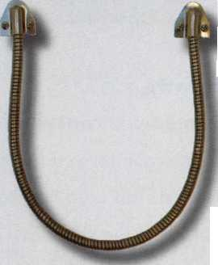

t. * in

■ I

ii

**The RLOR**

**Conuention**

**and Security E«po July 17-24, 2005**

SUJEET

Get Ready for RLOB 2005,

a powerful resource to explore innouation and form industry alliances. This year we’ue thought of everything from an exciting location, comfort­able accommodations and a conuention center that is equipped to handle your euery need.

Located just minutes from downtown  
Chicago, Rosemont, Illinois is the  
perfect “business village”, designed specifically  
to make your stay convenient, comfortable  
and above all, successful!

The 49th Annual RLOR Conuention and Security Expo  
offers top-notch classes, workshops, networking  
opportunities and cutting-edge technology.

Rnd don’t miss out on the fine dining and enter-  
tainment options that Chicago has to offer. Shop  
at the woild-famous Magnificent Mile. Eat at  
Morton’s of Chicago or Hairy Caray’s Italian  
Restaurant. Uisit the Navy Pier or catch a ball  
game. The options are endless when you register  
today for the single-most important event in  
the locksmithing industry.

Baby, you knoLU you want to go!



**RLOR 2005**

Sweet Home Chicago



**HLOH 2005**

Sweet Home Chicago

TOP

EDUCHTION

CLRSSES

**WORKSHOPS**

**SEMINARS**

July 17-24

SECURITV

EKPO

July 22-24

DON’T MISS THESE EUENTS!

* Kick Off Party and Ruction
* RLOR Golf Tournament
* Tours
* Banquet
* Networking

guests will be dropped off on the corner of Rush Street and Superior Street where there are several restaurants to enjoy lunch. The guide will then direct guests in the right direction. At 2:00 p.m. the motor coach will pick guests up where they were dropped off.

The ever-popular ALOA Open Golf Tournament will be held at the Chalet Hills Golf Club on Thursday, July 21, 6:30AM-3PM. The tournament is a show tradi­tion, featuring a beautiful location, the chance to see old friends, and a perfect moment for members to show off their swing. Transportation will depart from the Hyatt O’Hare at 6:30am and return at 3pm. The registration fee of $150 includes transportation, green fees, golf cart, and beverages throughout the course, lunch and prizes for all players. Yale Security Group, Inc. once again will serve as the main sponsor of the Tournament, joined this year by Amsec, Lucky Line Products and Strattec Inc. Proceeds will benefit the ALOA Scholarship Foundation.

A delightful evening has been planned for this year's ALOA

Banquet. Plan on being a part of this blast from the past with  
music and dancing featuring the Jim Mahannah Band. This will

be a truly memorable dining and entertainment experience that will

take you back to Chicago in the Roaring 20s. You will remember this

evening for years to come. The Dinner Banquet will be held in the Grand  
Ballroom of the Hyatt Regency O'Hare. Attire- Business Casual or come  
dressed as your favorite Mob Boss or Flapper girl. Seating is limited, so pur-  
chase your tickets early to ensure your space.

**34**

Keynotes • June 2005



**MADE IN THE USA**

**HINGES:**

Heavy duty, adjustable solid steel block hinges

**ADDITIONAL**

**FEATURES**

Light gray finish Adjustable shelving Mounted on 4 rubber feet (removable). Pre­drilled boltdown hole.

**OPTIONS**

Electronic digital pushbutton locks. Additional shelving available.

**THE LAST GREAT ★★★ AMERICAN FIRE SAFE**

**BODY & DOOR:**

Thick outer and  
inner steel plates  
encase high  
density fire barrier  
material.

**BOLTWORK:**

1. way boltwork  
   with 6 massive  
   1” diameter solid  
   steel bolts

UL-listed high security Group II combination lock. Drill-resistant steel hardplate.

**RELOCKER:**

Independent

spring-loaded

relocker

**UL Class 350 1 Hour Fire & Impact Rated - 3 Sizes Available**

**DEFIANT SAFE COMPANY Dallas, Texas**

PATRIOT

1-800-225-2984

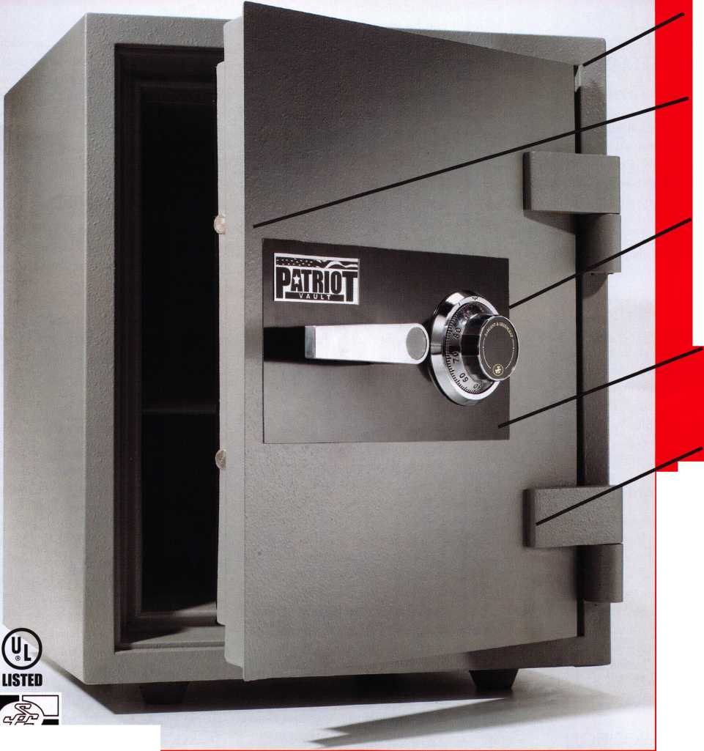

**Classifieds**

EMPLOYMENT

EXPERIENCED LOCKSMITH NEEDED

Harbison Lock & Key, 25-year-old commer­cial/residential locksmith company is seek­ing a qualified technician to join their team in servicing Homewood, AL and surround­ing municipalities. This is a full-time posi­tion. Pay is commiserate with experience. We offer paid health/dental insurance, paid holidays and paid vacation. FOR MORE INFORMATION CALL 205-870- 9920 or visit our website, [www.harbison- lock.com](http://www.harbison-lock.com).

EXPERIENCED LOCKSMITH

Needed for outside service work - Commercial, Residential and Auto. Top pay, plus paid vacation, insurance, sick leave, holidays and retirement plan. 2 locations, 5 service trucks. Send resume to Bill - Bill's Lock and Safe, Inc., PO Box 1041, No. Little Rock, AR. 721 15, 1-800-374-4604 Fax: 1-501-376-0046

LOCKSMITH WANTED

Immediate opening at one of Columbus Ohio's largest locksmith companies. If you are a locksmith with three years of com­mercial experience and want to work 8:30 to 5:00, come join our team! We are a full-service security center. Excellent benefits include 401 K, health insurance, paid vaca­tion, sick leave, and continuing education. Contact Bill or Tim at Golden Bear Lock and Safe, Inc. 614-733-5625, fax 614-733- 0004, or email [goldenbearlock@cs.com](mailto:goldenbearlock@cs.com).

LOOKING FOR POSITION

I am a junior locksmith who is currently working for the Federal Government as a Computer Specialist. I am planning to retire from the Federal Government and would like to work for a lock company or a

lock shop that specializes in the installation of computerized electronic locks, such as VIDEX. I can be immediately productive for my new employer by doing the computer programming and some standard customer installation. My long-term goal is to become a journeyman locksmith. I live in Northern California. My first preference would be the San Francisco/San Jose peninsula. My second preference would be the San Joaquin Valley or Sacramento. I can, however, relocate anywhere in the world. Phone James Feinstein at 650-793-5363 or 800-0165.

POSITION WANTED

Japanese locksmith seeks position in U.S., preferably in Los Angeles. Eight years experience in Codes and Code Equipment, Various Cylinders Servicing (For example, GOAL V-l 8 Cylinder), Key Blank Identification, Key Duplication, Key Impressioning (KABA Cylinder),

Professional Lock Opening Techniques (Disk Cylinder, Pin Cylinder, Rotary Disk Cylinder, Lever Tumbler, Tubular Key Cylinder, KABA, Me deco, and others), Lockset Functions, Lockset Servicing,

Lockset Installation, Master Keying,

Cabinet, Furniture and Mailbox Locks, Automobile (Benz, BMW, Porsche 928, Citroen, and and many Japanese models), Door Closers, Basic Electricity, Keyless Mechanical Locks (Nagasawa Keylex series), Safe Combination Locks (I can do manipulation and often use a sidescope), Safe Opening and Servicing, Detention Locking Systems, Security Camera and Security System Contact:

164-0012 2-19-7-302 Hon-cho, Nakano- ku, Tokyo, Japan - Tamotsu Yoshioka E-mail

[nbj_yoshioka@ybb.ne.jp](mailto:nbj_yoshioka@ybb.ne.jp)

LOCKSMITH WITH INTEGRITY NEEDED

Experienced Locksmith needed immediately.

20+ year-old company with hundreds of com­mercial accounts seeks qualified individuals will­ing to re-locate to Tulsa, OK. Experience in all aspects of the field desired. Salary+benefits. Send Resume to Tulsa Lock and Key, Inc.

10318 E 21 st, Tulsa, OK - 74129. Or email to [tulsalock@cox.net](mailto:tulsalock@cox.net).

LOCKSMITH WANTED

Elgin Key & Lock Co. in Elgin Illinois is seeking an experienced locksmith with at least one year of experience in automotive locks, access control, commercial & resi­dential hardware, safes and door-closer applications. Benefits include health insur­ance & HSA, vacation pay and a Simple IRA plan. Please contact Clark Houghtby at 847-742-7006 or fax resume to 847-742- 1315

LOCKSMITH NEEDED

If you are a competent technician with abil­ity to please customers and make a good impression, you may be our next addition. We are a 40-year-old company rapidly expanding and in need of technicians able to service all types of physical locking hardware. We offer very competitive salary packages as well as benefits includ­ing 401k, profit sharing, paid vacation and medical reimbursement. We cover all facets of the security industry so the oppor­tunity to cross train in electronic access control CCTV etc. exists for the right appli­cant. Submit resume and/or contact info by email, regular mail or fax. [paulbran- don@lockguys.com](mailto:paulbran-don@lockguys.com), fax 253-839-3443, THE LOCK SHOP, 30819 Pacific Highway South - Federal Way, WA 98003

WANTED TO BUY/SELL

FOR SALE

A-l Auto key punch set with case (MS 10) $400.00 Keedex Vats interrogator mini $40.00 Kent-Moore Vats key interpreter $75.00 Try out keys Aero-lock TO-1, TO- 2, TO-3, TO-4 $50.00 each Try out keys Baxter #35,

36, and 74 $50.00 each A1 GM 10 cut service kit $25.00 HPC general code book 1A $40.00 Reed Code Book set, vols. 1-14 with index $400.00 Reed Code Book #5: Padlocks $50.00 Baxter code books: 1, 5,

11, 19, 20, 22, 23, 24, 27, 28, 29, 30, 31, 34, 35, 36, 37, 38 Updated through 2003 $400.00 for the set ASP Auto Cap Assortment #A0-002 $80.00 (plus extra caps) Don-jo 8X34 Kick plates 6 US32D and 4 US3 $120.00 for lot High tech car opening set with manuals through 2002 $75.00 Inventory of dead bolts, lock sets, etc. Listing sent upon request. All shipments F.O.B. Narvon, PA All other inquiries: Byron Rohrbach 2543 School House Lane Narvon, PA 17555 Phone 717 445- 1240 email: [BARLOCKS@peoplepc.com](mailto:BARLOCKS@peoplepc.com)

BUSINESS FOR SALE

Lock and Safe company in North Central TX. Fully stocked van, computer, HPC code max machine along with several others. Business in same area since 1976. Will help through owner transition And introduce to commercial accounts, call 903-340-5958

FOR SALE

Mounted Samples for Sale Locknetics CM5190MGKx626 mounted on oak asking $100.00. ILCO's Learn Lok - Mortise Lock Complete with Programming Cards Asking $100.00. Both samples together $175.00. Contact: Kishjohn@softhome.net- Telephone: 412400-5900

BUSINESS FOR SALE

35 years in same location. Need one qualified lock­smith, maybe two. Only locksmith in three counties. We are busy, busy. Owner must retire due to age and health. Everything is paid for - building equipment and van. Beautiful West Texas weather and people. Priced to sell. Call or phone Dean Tedford, 432-336-3278

LOCKSHOP FOR SALE

Successful shop in gorgeous Port Angeles, Washington for sale. For more details about this great opportunity and for contact information, go to [http://home.com- cast.net/~bystra/Lockshoplnfo.html](http://home.com-cast.net/~bystra/Lockshoplnfo.html)

SAFE DEPOSIT BOX LOCKS,

PARTS AND MORE

Wholesale prices. Reconditioned and new locks. All manufacturers; Diebold, Herring Hall & Marvin, llco, Lefebure, Mosler, S & G, Security Corp & Precision. Also available new replacement locks. We have a large stock of parts - doors, bond boxes, hinges, key blanks, full sections and more. Call WBI (954) 484-2404

BUSINESS FOR SALE

Mom-and-Pop Locksmith/Glass and Screen Business for sale in Golden Valley, Arizona. Health forces retirement. Golden Valley is in fast growing Mohave County and located between Kingman, Arizona and Laughlin, Nevada. Our Dodge Ram Van and garage-shop are both well equipped with $65,000 plus in equipment.

Our inventory is included in the asking price of $48,900. Home and property can be sold as a pack­age deal with business. Home is a 3-bedroom, 2-bath. Home and garage on 1.17 acres. Lot has enclosure,

2/3 fenced. All reasonable offers will be considered. Call 928-565-2294 or email at [lmburks@ctaz.com](mailto:lmburks@ctaz.com).

FOR SALE

Key Machines 1200 Blitz, HPC 3333, PCH 14, 11 Sets Tryout Keys, 16 Determinators Sets, Pics, Entry Sets, Much More/Inventory 602-291-3500 [chevieman@aol.com](mailto:chevieman@aol.com) - package only.

Classified Advertising Policy

Classified advertising space is provided free of charge to ALOA members and for a fee of $2.00 per word, $40.00 minimum for non members. Classified ads may be used to advertise used merchandise and overstocked items for sale, "wanted to buy" items, business opportunities, employment opportunities/positions wanted and the like. Members or non members wishing to advertise services or new merchandise for sale may purchase a "Commercial Classified Ad" for a fee of $4.00 per word with a minimum of $100.00. Each ad will run for two issues. For blind boxes there is a $10.00 charge for members and non members. All ads must be submitted in writing to the Advertising Sales Department via fax at 817-645-7599 or through an email to [adsales@aloa.org](mailto:adsales@aloa.org) by the fifteenth of the month two months prior to issue date. ALOA reserves the right to refuse any classified adver­tisement that it deems inappropriate according to the stated purpose of the classified advertising section.



Distributor

**1 st In Hardware, Inc.**

Phone: 866-397-9900 Fax: 866-646-0045 www. 1 stinhardware.com

**ADI Inc.**

Phone: 631-692-1000 Fax: 631-692-301 1

**Accredited Lock Supply Co.**

Phone: 800-652-2835 Fax: 201-865-0030 [www.acclock.com](http://www.acclock.com)

**Ace Lock & Security Supply**

Phone: 800-223-5625 Fax: 908-688-2442 [www.acelock.com](http://www.acelock.com)

**Andrews Wholesale Lock Supply**

Phone: 717-272-7422 Fax: 717-274-8659 [www.andrewslock.com](http://www.andrewslock.com)

**Boyle & Chase Inc.**

Phone: 800-325-2530 Fax: 800-205-3500 [www.boyleandchase.com](http://www.boyleandchase.com)

**Chinrose International**

Phone: 503-357-7553 Fax: 503-357-5522 [www.chinrose.com](http://www.chinrose.com)

**Clark Security Products**

Phone: 888-784-1311 Fax: 619-718-7333 [www.clarksecurity.com](http://www.clarksecurity.com)

**Cook's Building Specialties**

Phone: 505-883-5701 Fax: 505-883-5704

**Dire's Lock & Key Company**

Phone: 303-294-0176 Fax: 303-294-0198

**Direct Security Supply, Inc.**

Phone: 800-252-5757 Fax: 800-452-8600

**Discount Key Machines.Com/Busch**

Phone: 800-332-8724 Fax: 407-363-4666

**Doyle Security Products**

Phone: 800-333-6953 Fax: 612-521-0166 [www.doylesecurity.com](http://www.doylesecurity.com)

**Dugmore and Duncan, Inc.**

Phone: 888-384-6673 Fax: 888-329-3846

**E. L. Reinhardt Co., Inc.**

Phone: 800-328-1311 Fax: 651-481-0166 [www.elreinhardt.com](http://www.elreinhardt.com)

**Ewert Wholesale Hardware**

Phone: 800-451-0200 Fax: 708-597-0881

**Fairway Supply, Inc.**

Phone: 214-350-0021 Fax: 214-352-4299 [www.fairwaysupply.com](http://www.fairwaysupply.com)

**Foley-Belsaw Company**

Phone: 800-821-3452 Fax: 816-483-5010 [www.foley-belsaw.com](http://www.foley-belsaw.com)

**Fried Brothers Inc.**

Phone: 800-523-2924 Fax: 215-592-1255 [www.fbisecurity.com](http://www.fbisecurity.com)

**Hans Johnsen Company**

Phone: 214-879-1550 Fax: 214-879-1530

**Hardware Agencies, Ltd.**

Phone: 416-462-1921 [www.hardwareagencies.com](http://www.hardwareagencies.com)

**IDN Incorporated**

Phone: 817-421-5470 Fax: 817-421-5468 [www.idn-inc.com](http://www.idn-inc.com)

**Instant Hardware Delivery, Inc**

Phone: 800-355-1107 Fax: 800-663-8518

**Intermountain Lock & Supply**

Phone: 800-453-5386 Fax: 801-485-7205 [www.intermountainlock.com](http://www.intermountainlock.com)

**International Electronics, Inc**

Phone: 800-343-9502 Fax: 617-821-4443

**Jo Van Distributors**

Phone: 416-752-7249 Fax: 416-752-7282 [www.jovanlock.com](http://www.jovanlock.com)

**Lockmasters, Inc.**

Phone: 859-885-6041 Fax: 859-885-7093 [www.lockmasters.com](http://www.lockmasters.com)

**Locks Company**

Phone: 800-288-0801 Fax: 305-949-3619

**Locksmith Ledger International**

Phone: 770-886-0800 Fax: 770-889-7703 [www.lledger.com](http://www.lledger.com)

**M. Zion Company**

Phone: 212-349-8677 Fax: 212-964-0495 [www.mzion.com](http://www.mzion.com)

**McDonald Dash Locksmith Supply**

Phone: 800-238-7541 Fax: 901-366-0005 [www.mcdonalddash.com](http://www.mcdonalddash.com)

**Monaco Lock Co.**

Phone: 800-526-6094 Fax: 800-845-5625 [www.monacolock.com](http://www.monacolock.com)

**Omaha Wholesale Hardware**

Phone: 800-238-4566 Fax: 402-444-1664 [www.omahawh.com](http://www.omahawh.com)

**RA-Lock Company**

Phone: 972-775-6301 Fax: 972-775-6316 [www.ralock.com](http://www.ralock.com)

**Security Distributors Inc**

Phone: 800-333-6953 Fax: 612-524-0166

**Security House**

Phone: 905-669-5300 Fax: 905-660-6313 [www.securityhouselock.com](http://www.securityhouselock.com)

**Security Lock Distributors**

Phone: 800-847-5625

Fax: 800-878-6400

[www.securitylockdistributors.com](http://www.securitylockdistributors.com)

**Shin-An Enterprise Inc.**

Phone: 718-225-5380 Fax: 718-819-0723

**Southern Lock and Supply Co.**

Phone: 727-541-5536 Fax: 727-544-8278 [www.southernlock.com](http://www.southernlock.com)

**Stone & Berg Wholesale**

Phone: 800-225-7405 Fax: 800-535-5625

**The Locksmith Store Inc.**

Phone: 847-364-5111 Fax: 847-364-5125 [www.locksmithstore.com](http://www.locksmithstore.com)

**Timemaster Inc.**

Phone: 859-259-1878 Fax: 859-255-0298 [www.time-master.com](http://www.time-master.com)

**Top Notch Distributors, Inc.**

Phone: 800-233-4210 Fax: 800-854-4146 [www.topnotch.bz](http://www.topnotch.bz)

**Turn 10 Wholesale**

Phone: 800-848-9790 Fax: 800-391-4553

**U.S. Lock Corp.**

Phone: 800-925-5000 Fax: 800-338-5625 [www.uslock.com](http://www.uslock.com)

**Wilson Safe Company**

Phone: 215-492-7100 Fax: 215-492-7104 [www.wilsonsafe.com](http://www.wilsonsafe.com)

Manufacturer

**A & B Safe Corporation**

Phone: 800-253-1267 Fax: 856-863-1208 www. a-bsafecorp. com

**ABUS Lock Company**

Phone: 800-352-2287 Fax: 602-516-9934 [www.abus.com](http://www.abus.com)

**Access Security Products Ltd.**

Phone: 905-337-7874 Fax: 905-337-7873 [www.access-safe.com](http://www.access-safe.com)

**Adams Rite Mfg Company**

Phone: 800-872-3267 Fax: 800-232-7329 [www.adamsrite.com](http://www.adamsrite.com)

**Adesco Safe Mfg. Company**

Phone: 800-694-9340 Fax: 562-408-6427 [www.adesco.com](http://www.adesco.com)

**Adrian Steel Company**

Phone: 800-677-2726 Fax: 517-265-5834 [www.adriansteel.com](http://www.adriansteel.com)

**All Five Tool Company, Inc.**

Phone: 860-583-1691 Fax: 860-583-4516 [www.all5tool.com](http://www.all5tool.com)

**American Lock Company**

Phone: 708-534-2000 Fax: 708-534-0531 [www.armericanlock.com](http://www.armericanlock.com)

**American Security Products**

Phone: 909-685-9680X1083 Fax: 909-685-9685 [www.amsecusa.com](http://www.amsecusa.com)

**ASSA ABLOY Americas**

Phone: 800-438-1951 Fax: 800-338-0965

Keynotes • June 2005

|  |  |  |  |  |  |
| --- | --- | --- | --- | --- | --- |
|  | ass | o | c i a t | CD |  |
|  | m | e m | b e r s |  |  |
| Best Metaline Inc. | HPC, Inc. |  | M.A.G. Manufacturing |  | Trine Access Technology |
| Phone: 714-441-0098 | Phone: 847-671-6280 |  | Phone: 714-891-5100 |  | Phone: 718-829-2332 |
| Fax: 714-441-0977 | Fax: 847-671-6343 |  | Fax:714-892-6845 |  | Fax: 718-829-6405 |
| Bianchi USA, Inc. | [www.hpcworld.com](http://www.hpcworld.com) |  | [www.magmanufacturing.com](http://www.magmanufacturing.com) |  | [www.trineonline.com](http://www.trineonline.com) |
| Phone: 800-891-2118 | HY-KO Products Co. |  | MUL-T-LOCK USA, Inc. |  | UCA Inc |
| Fax: 216-803-0202 | Phone: 330-467-7446 |  | Phone: 800-562-3511 |  | Phone: 972-312-0599X12 |
| Buddy Products  Phone: 800-886-8688 | Fax: 330-467-7442  Hammerhead Industries, Inc. | | Fax: 973-778-4007 [www.mul-t-lock.com](http://www.mul-t-lock.com) |  | Fax: 972-692-7056 [www.ibuttonlock.com](http://www.ibuttonlock.com) |
| Fax: 312-733-8356 | Phone: 805-658-9922 |  | Medeco Security Locks |  | Victor E-lok, Inc. |

[www.buddyproducts.com](http://www.buddyproducts.com)

**CCL Security Products**

Phone: 800-733-8588 Fox: 847-537-1800

**COMPX Security Products**

Phone: 864-297-6655 Fox: 864-297-9987 [www.compxnet.com](http://www.compxnet.com)

**D&D Technologies (USA), Inc.**

Phone: 714-677-1300X292 Fox: 714-677-1299 [www.ddtechusa.com](http://www.ddtechusa.com)

**DETEX Corp.**

Phone: 800-729-3839 Fax: 830-620-6711 [www.detex.com](http://www.detex.com)

**DORMA Architectural Hardware**

Phone: 717-336-3881 Fax: 717-336-2106 [www.dorma-usa.com](http://www.dorma-usa.com)

**Datakey Electronics**

Phone: 952-746-4066 Fax: 866-289-4212 [www.datakeyelectronics.com](http://www.datakeyelectronics.com)

**Don-Jo Manufacturing, Inc.**

Phone: 978-422-3213 Fax: 978-422-3467 [www.don-jo.com](http://www.don-jo.com)

**Door Controls International**

Phone: 800-742-3634 Fax: 800-742-0410 [www.doorcontrols.com](http://www.doorcontrols.com)

**ESP Lock Products Inc.**

Phone: 800-434-8960 Fax: 978-562-9859

**FireKing Security Products**

Phone: 800-457-2424 Fax: 800-896-6606 [www.fkisecuritygroup.com](http://www.fkisecuritygroup.com)

**Framon Manufacturing Company Inc.**

Phone: 989-354-5623 Fax: 989-354-4238 [www.framon.com](http://www.framon.com)

Fax: 805-658-8833 [www.gearkeeper.com](http://www.gearkeeper.com)

**Ingersoll Rand SSA**

Phone: 317-613-8025 Fax: 317-613-8068 [www.schlagelock.com](http://www.schlagelock.com)

**Jet Hardware Mfg., Co.**

Phone: 718-257-9600 Fax: 718-257-0973 [www.jetkeys.com](http://www.jetkeys.com)

**KABA ILCO Corp.**

Phone: 252-446-3321 Fax: 252-446-4702 [www.kaba-ilco.com](http://www.kaba-ilco.com)

**KEY-BAK/West Coast Chain Mfg.**

Phone: 909-923-7800 Fax: 909-923-0024 [www.keybak.com](http://www.keybak.com)

**Keri Systems Inc.**

Phone: 408-451-2520 Fax: 408-441-0309 [www.kerisys.com](http://www.kerisys.com)

**Knaack Manufacturing Co.**

Phone: 800-456-7865 Fax: 815-459-9097 [www.weatherguard.com](http://www.weatherguard.com)

**LAB Security**

Phone: 800-243-8242 Fax: 860-583-7838 [www.labpins.com](http://www.labpins.com)

**La Gard Inc.**

Phone: 310-325-5670 Fax: 310-325-5615 [www.lagard.com](http://www.lagard.com)

**Lock America, Inc. dba L.A.I. Group**

Phone: 714-373-2993 Fax: 714-373-2998 [www.laigroup.com](http://www.laigroup.com)

**Lucky Line Products, Inc.**

Phone: 858-549-6699 Fax: 858-549-3241 [www.luckyline.com](http://www.luckyline.com)

Phone: 540-380-5000 Fax: 540-380-5010 [www.medeco.com](http://www.medeco.com)

**ROFU International Corp.**

Phone: 253-922-1828 Fax: 253-922-1728 [www.rofu.com](http://www.rofu.com)

**Rutherford Controls Int'l Co.**

Phone: 757-427-1230 Fax: 757-427-9549 [www.rutherfordcontrols.com](http://www.rutherfordcontrols.com)

**STRATTEC Security Corp.**

Phone: 414-247-3415

Fax:414-247-3692

[www.strattec.com](http://www.strattec.com)

**Sargent & Greenieaf, Inc.**

Phone: 800-826-7652X201 Fax: 859-885-3063 [www.sargentandgreenleaf.com](http://www.sargentandgreenleaf.com)

**Sargent Manufacturing Co.**

Phone: 800-727-5477 Fax: 888-863-5054 [www.sargentlock.com](http://www.sargentlock.com)

**Schwab Corp.**

Phone: 765-447-9470 Fax: 765-447-8278 [www.schwabcorp.com](http://www.schwabcorp.com)

**Securitron Magnaiock Corp.**

Phone: 775-355-5625 Fax: 775-355-5636 [www.securitron.com](http://www.securitron.com)

**Security Door Controls**

Phone: 805-494-0622 Fax: 805-494-8861 [www.sdcsecurity.com](http://www.sdcsecurity.com)

**Security Solutions**

Phone: 405-376-1600 Fax: 405-376-6870 [www.securitysolutions-usa.com](http://www.securitysolutions-usa.com)

**Townsteel, Inc.**

Phone: 626-858-5080 Fax: 626-858-3393 [www.townsteel.com](http://www.townsteel.com)

Phone: 949-916-1200  
Fax: 949-916-1300  
[www.victorelok.com](http://www.victorelok.com)

**Videx Inc.**

Phone: 541-758-0521  
Fax: 541-752-5285  
[www.videx.com](http://www.videx.com)

Service

Organization

**Allstate Insurance Company**

Phone: 800-859-0247 Fax: 847-326-7509 [www.allstate.com](http://www.allstate.com)

**Cross Country Automotive Services**

Phone: 800-541-2262 Fax: 781-393-0256 [www.argosi.com](http://www.argosi.com)

**Massglass & Door Service**

Phone: 888-742-8837 Fax: 805-497-2255 [www.massglass.com](http://www.massglass.com)

**Webster Safe & Lock Co., Inc.**

Phone: 901-332-2911 Fax: 901-332-2878 [www.webstersinc.com](http://www.webstersinc.com)

Keynotes • June 2005

**3**



e g i s I a p d a t e

The following is an update on legislation concerning locksmiths that ALOA is following (as of 5/20/05):

IN H 1361 AUTHOR: Brown C(D)

* TITLE: Locksmith Registration
* INTRODUCED: 01/13/2005
* DISPOSITION: Failed-Adjourned
* LOCATION: House Public Safety and Homeland Security

SUMMARY:

Requires locksmiths to be registered; requires the state police department to administer the registration pro­gram and conduct a national crimi­nal history background check for each registration applicant.

STATUS:

* 01/13/2005 INTRODUCED.
* 01/13/2005 To HOUSE Committee on PUBLIC SAFETY AND HOMELAND SECURITY.

MD H 207 CROSSFILED WITH: MD S 105

* AUTHOR: Hubbard (D)
* TITLE: Maryland Security Systems Training Board
* INTRODUCED: 01/24/2005
* DISPOSITION: Failed - Adjourned
* LOCATION: HOUSE

SUMMARY:

Establishes the Maryland Security Systems Training Board; requires the Secretary of State Police to adopt regulations to implement training requirements for security systems technicians developed by the Maryland Security Systems Training Board; provides for the composition of the Board and the terms, removal, and compensation of the members of the Board; authorizes the Board to set specified fees; requires the Board to set training requirement.

STATUS:

* 01/24/2005 INTRODUCED.
* 01/24/2005 To HOUSE Committee on ECONOMIC MAT­TERS.
* 02/21/2005 From HOUSE Committee on ECONOMIC MATTERS: Reported unfavorably.

MO S 186 SPONSOR:

Loudon (Rj

TITLE: Electrical Industry

Licensing Board

* INTRODUCED: 01/18/2005
* DISPOSITION: Failed - Adjourned
* LOCATION: Senate Financial and Governmental Organization, Veterans'

Affairs and Elections Committee

SUMMARY:

* Establishes the Missouri Electrical Industry Licensing Board and describes their powers and duties.

STATUS:

* 01/18/2005 INTRODUCED.
* 01/24/2005 To SENATE Committee on FINANCIAL, GOV­ERNMENTAL ORGANIZATIONS, AND ELECTIONS.

MS S 2356 AUTHOR: Mettetal (D)

* TITLE: Burglar Alarms
* INTRODUCED: 01/13/2005
* DISPOSITION: Failed
* LOCATION: Died
* SUMMARY:
* Burglar alarms; license and regu­late installation.

STATUS:

* 01/13/2005 INTRODUCED.
* 01/13/2005 To SENATE Committee on BUSINESS AND FINANCIAL INSTITUTIONS.
* 02/01/2005 Died in committee.

NJ A 3943 SPONSOR:

Johnson (D)

* TITLE: Electronic Security Systems
* PREFILED: 03/14/2005
* INTRODUCED: 05/02/2005
* DISPOSITION: Pending
* LOCATION: Assembly Regulated Professions and Independent Authorities Committee

SUMMARY:

Exempts certain businesses from licensing requirements for those engaged in burglar alarm, fire alarm and electronic security system instal­lations.

STATUS:

* 03/14/2005 FILED.
* 05/02/2005 INTRODUCED.
* 05/02/2005 To ASSEMBLY Committee on REGULATED PRO­FESSIONS AND INDEPENDENT AUTHORITIES.

TN S 2024 SAME AS: TN H 1731

* AUTHOR: Cooper (D)
* TITLE: Locksmith Licenses
* INTRODUCED: 02/16/2005
* LAST AMEND: 04/28/2005
* DISPOSITION: Pending
* LOCATION: HOUSE

SUMMARY:

Requires locksmiths to be licensed; requires licenses to be obtained from the commissioner of commerce and insurance.

STATUS:

* 02/16/2005 INTRODUCED.
* 02/23/2005 To SENATE Committee on GOVERNMENT OPERATIONS.
* 03/30/2005 From SENATE Committee on GOVERNMENT OPERATIONS: Recommend pas­sage.
* 04/28/2005 In SENATE. Amendment No. 1 (SA0172) adopted on SENATE floor.
* 04/28/2005 In SENATE. Amendment No. 2 (SA0173) adopted on SENATE floor.
* 04/28/2005 In SENATE. Amendment No. 3 (SA0304) adopted on SENATE floor.
* 04/28/2005 In SENATE. Amendment No. 4 (SA0407) adopted on SENATE floor.
* 04/28/2005 In SENATE. Amendment No. 5 (SA0408) adopted on SENATE floor.
* 04/28/2005 In SENATE. Read third time. Passed SENATE.

★ ****y0 HOUSE.

m

m Keynotes • June 2005

t i v e

TX H 2243 AUTHOR:

Jackson (R)

* TITLE: Regulation of Locksmiths and Locksmith Companies
* INTRODUCED: 03/08/2005
* LAST AMEND: 05/16/2005
* DISPOSITION: Pending
* LOCATION: SENATE

SUMMARY:

Relates to the regulation of locksmiths

and locksmith companies under the

Private Security Act.

STATUS:

* 03/08/2005 INTRODUCED.
* 03/14/2005 To HOUSE Committee on LICENSING AND ADMINISTRATIVE PROCEDURES.
* 04/06/2005 From HOUSE Committee on LICENSING AND ADMINISTRATIVE PROCEDURES: Reported favorably with substitute.
* 04/14/2005 Committee report printed and distributed.
* 04/29/2005 Amended on HOUSE floor.
* 04/29/2005 Passed HOUSE. *****To SENATE.
* 05/03/2005 To SENATE Committee on BUSINESS AND COMMERCE.
* 05/16/2005 From SENATE Committee on BUSINESS AND COMMERCE: Reported favorably with substitute.
* 05/16/2005 Committee report printed and distributed.

TX S 1365 AUTHOR:

Armbrister (D)

* TITLE: Alarm Systems
* INTRODUCED: 03/10/2005
* DISPOSITION: Pending
* LOCATION: Senate Intergovernmental Relations Committee

SUMMARY:

* Relates to the regulation of alarm systems and alarm systems compa­nies.

STATUS:

* 03/10/2005 INTRODUCED.
* 03/21/2005 To SENATE Committee on INTERGOVERN­MENTAL RELATIONS.

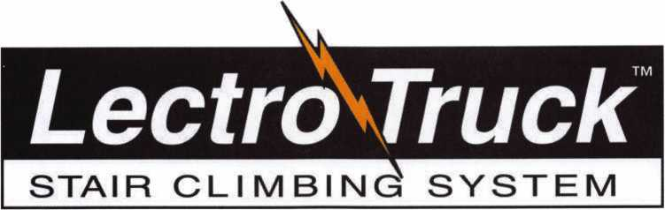

Three strong “grab points” to

make handling the stair  
climber easier.

Detachable battery pack  
makes swapping batteries

**simple.**

Lectro-Truck nameplate means you get 35 years of product experience.

Break-back bar enables the user to be able to move the heaviest of loads.

Electric Brake stops the drive screw from spinning - no matter how heavy the load.

1-1/2 Hp motor provides the lifting power you need to move up to 1500 pounds.

10” extension handle to give the user extra leverage on taller loads.

**Heavy duty, aluminum** construction makes the unit lighter, yet durable.

3/4” drive screw will not bow - even with loads of up to 1500 pounds.

Two adjustable strap bars allow the user to adjust specifically to each load.

Built-in steel tripod makes **moving products down** hallways easy.

24” or 30” toe plate width to **accommodate individual** customer’s needs.

**Model LTA6512E**

Mention this advertisement, and you are eligible for the trade show discount  
that we will have in effect at the ALOA Expo in Chicago July 22-24, 2005.

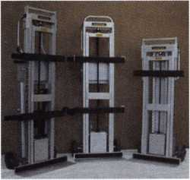

Call us at:

1-800-619-0625

or visit us on the internet at:

[www.lectrotruck.com](http://www.lectrotruck.com)

Innovative Moving Systems, Inc.  
310 South 10th Street  
P.O. Box 700169  
Oostburg, Wl 53070

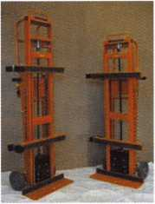

**See us at the ALOA Security Expo - Booth 501**

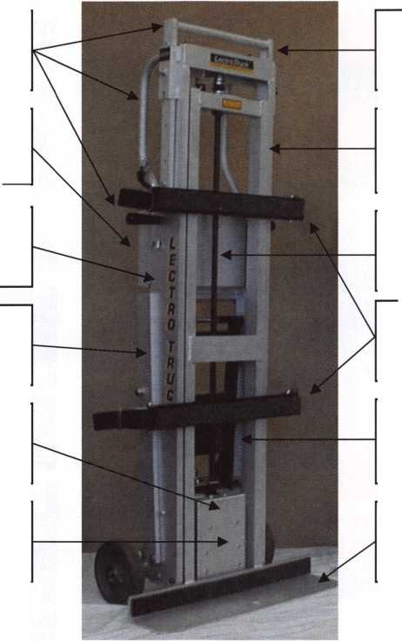

keynotes

buyer's Marketplace



**FIRST)**

STERS

we stock The

Auditcon® 2 Series

Lockmasters is proud  
to stock the NEW  
Auditcon® 2 Series  
from Kaba Mas, fea-  
turing the NEW 252  
& 552 Models.

**Features:**

Faster Power-Up

Improved Servicability & Uploadable Programming

Field Replaceable Picoflex Connector

For SFIC

**IC CoreThumbturn For all Best® style cores**

**TolJFree 1 (866) 839-6286 Tree shipping on orders of 10 or more**

**(within the 48 United States)**



**^6.0.D. orders accepted for  
Institutional customers**

**FULLER 330*. LOCC, inc.**

|  |  |  |
| --- | --- | --- |
| kI£9W a & b |  | Broken/Cracked |
| SAFE C0RP. |  | door jamb?? |
| A & B Chest |  | Don't replace. |
| Model WS-0 |  |
| f Equipped with dual key, |  | Don't rebuild!! |
| combination or |  |
| ||U electronic locking  t slot optional  A & B SAFE CORPORATION |  | "Kwik Jam" |
| 171 S. Delsea Dr. |  |  |
| Gtassboro, NJ 08028-6237 |  |  |
| 856-863-1186 Fax 856-863-1208 |  | [www.PEBent.com](http://www.PEBent.com) |
|  | |  |



Keynotes • June 2004

Punch SARGENT Blanks  
to Factory Specifications.

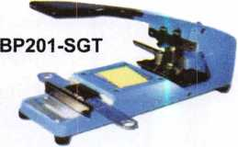

Try it hands on @ALOA

Available Exclusively from:

**Locksmithing, UNL. LLC  
302-575-0993**

**[www.locksmithingunl.com](http://www.locksmithingunl.com)**

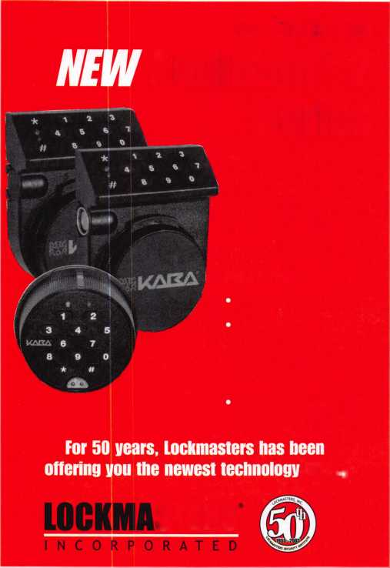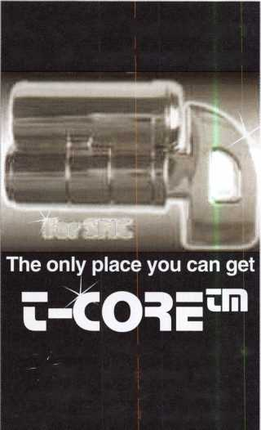

call me.

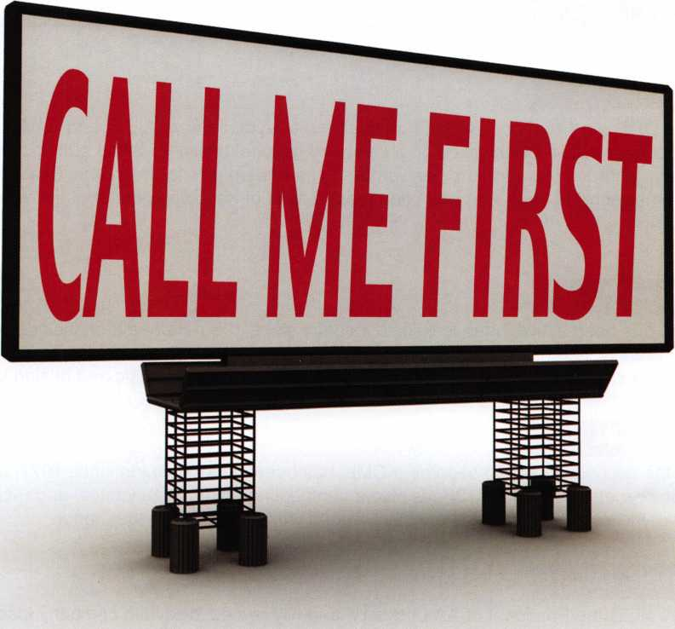

which one catches your attention?

Bigger is sometimes better. And when someone is in need of your services, you want to take every opportunity to make your name prominent in the minds of searching consumers.

Introducing a new advertising solution from ALOA. At our new public locksmith search site, findalocksmith.com, you can now purchase an ad for your business that will shine brightly on the results page whenever someone searches for a locksmith in your zip code. The initial cost is only $30.00, and each additional zip code you add is only $5 extra. Don't miss this great opportunity!

Call Kim Hammond at 817-645-6778 for details.

Spaces for each zip code are limited. Call to reserve yours now!

about the authors

**Greg Perry, CIVIL, CPS**

Greg Perry, CML, CPS is a Certified ACE Instructor, a long-time member of ALOA and SAVTA and has taught access control and safe lock classes on a local and national basis. He is the author of the SafeData CD Rom database reference program and has written numerous articles for Keynotes, Safe and Vault Technology and other publications. Greg has been the recipient of Keynotes’ Author of the Year Award twice (in 2002 and 2003).

**Eric Costley, CRL**

Eric Costley, CRL, has been active in the locksmith industry since 1980. He has a bachelor’s degree from Gardner-Webb University, and has worked in shops in Arizona, Noth Carolina and New York. He is currently employed by Bill’s Locksmithing in Elmira, New York. Eric’s hobbies include music and raising tarantulas.

**Claire Cohen, CML**

Claire L. Cohen, the second woman to become a CML, has been in locksmithing since 1977, and has been writing articles for Keynotes since 1987. She is also a contributing editor for Keynotes, and received the 2001 Keynotes Author of the Year Award. She is only the second woman to receive that honor.

**Jon B. Griswold, CML**

Jon B. Griswold, CML is the President of AA Lockserv, a family owned locksmith company located in Connecticut. He has over 25 years in the locksmith industry including working for a hollow metal distributor of doors and frames and as an outside sales rep for a wholesale locksmith company. He has been a contribut­ing editor for Keynotes and has written articles for Keynotes and other industry magazines.



Keynotes • June 2005

The Lock on Intelligence

Replace standard door lock  
cylinders with CyberLock  
cylinders in minutes.

**Install CyberLock**

**cylinders — without wiring —**

**in doors, safes, padlocks, and cabinets**

* **Schedule access times M**
* **Record all openings and attempts**
* **Replace mechanical cores with CyberLocks**
* **Update user permissions remotely**
* **Eliminate key control problems**

Get an access history for medicine or records cabinets

Secure storage units with the CyberLock padlock

**Cali Videx today for more information on the latest  
in access control for your entire operation.**

**541-758-0521 -[sales@videx.com](mailto:sales@videx.com) [WWW.videX.COm/iock3](http://WWW.videX.COm/iock3)**

|  |  |  |  |  |
| --- | --- | --- | --- | --- |
|  | " ^ Key Name | " Lock Name | Date/Time | ^Statu^^n |
| ► | Joe Wilson | I East Entrance | 103/20/2004 06:14:22 AM | Denied |
|  | Abby Chaney | | West Entrance | 103/20/2004 07:23:03AM | Key Authorized |
|  | Pete Sussman | Records Room | 03/20/2004 07:59:15 AM | Out of Schedule |
|  | John Michaels | i Computer Room | 03/20/2004 08:00:03 AM | Key Authorized |
|  | Evelyn Lellet | [West Entrance | 03/20/2004 08:12:16 AM | Key Author ized |
|  | Juanita 8ank$ | Computer Room | 03/20/2004 08:18:52AM |  |
|  | Andy Dumroofe | [Computer Room | 103/20/2004 08:27:12 | denied |

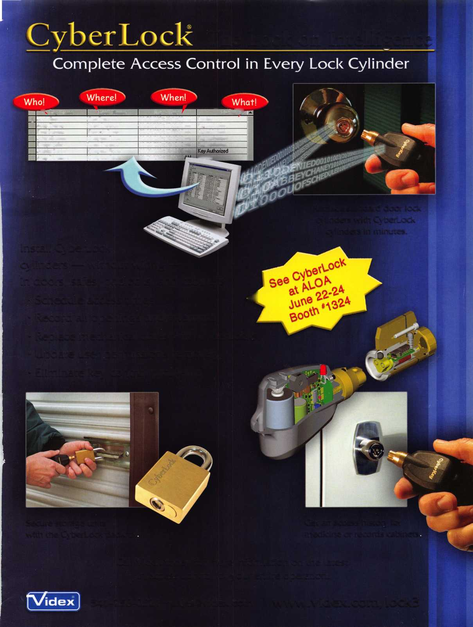

*colon flat*

*Spmgs*

*to lift...*

Prevents Surreptitious Entry at Airports.

Know when your bag has been searched by a TSA agent or violated by an unknown person.

*oko aocuiabk:*

Black Fire Engine Red

Pewter Purple Grape

Bright Nickel Construction Orange Brass Plated Cobalt Blue Hot Pink



**TRAVEL SENTRY**

**CERTIFIED**

Recognized by the TSA

Security Window

lock has been opened lock not opened



Security Products

301 West Hintz Road • Wheeling, IL 60090  
800.733.8588 • Fax: 847.537.1881 • [www.cclsecurity.com](http://www.cclsecurity.com)

